# Eclipse

## Liferay7 Portlet example:

<http://www.javasavvy.com/liferay-7-portlet-tutorial/>

<https://www.opensource-techblog.com/complete-liferay-guide>

We just created a portlet module with name “product” and folder structure will look like below:

* All web resources in Liferay 7 are created  under src/main/resources folder but where as  Liferay 6 creates in docroot/html folder
* Portlet configuration such as portlet.xml and liferay-portlet.xml configuration need to updated in @Component annotation under property attribute
* The rest of Portlet API sush doView, processAction and servceResource all are same and you can directly use the API in JSP’s and Portlet Controller

**@Component**

all portlet configuration goes into @**Component** annotation that used to deploy in OSGI container

**immediate** –  module will be deployed and should be started immediately instead of being lazy-loaded

**property** –    All java portlet properties should be  prefixed by: ***javax.portlet***                                                                                                      Liferay properties are  prefixed by:***com.liferay.portlet.***

**portlet.xml and liferay-portlet.xml   OSGI mappings :**you can find list of mappings on liferay site :[***https://dev.liferay.com/develop/reference/-/knowledge\_base/7-0/portlet-descriptor-to-osgi-service-property-map***](https://dev.liferay.com/develop/reference/-/knowledge_base/7-0/portlet-descriptor-to-osgi-service-property-map)

@Component(

immediate = true,

property = {

"com.liferay.portlet.display-category=category.sample",

"com.liferay.portlet.instanceable=true",

"javax.portlet.display-name=product Portlet",

"javax.portlet.init-param.template-path=/",

"javax.portlet.init-param.view-template=/view.jsp",

"javax.portlet.resource-bundle=content.Language",

"javax.portlet.security-role-ref=power-user,user"

},

service = Portlet.class

)

[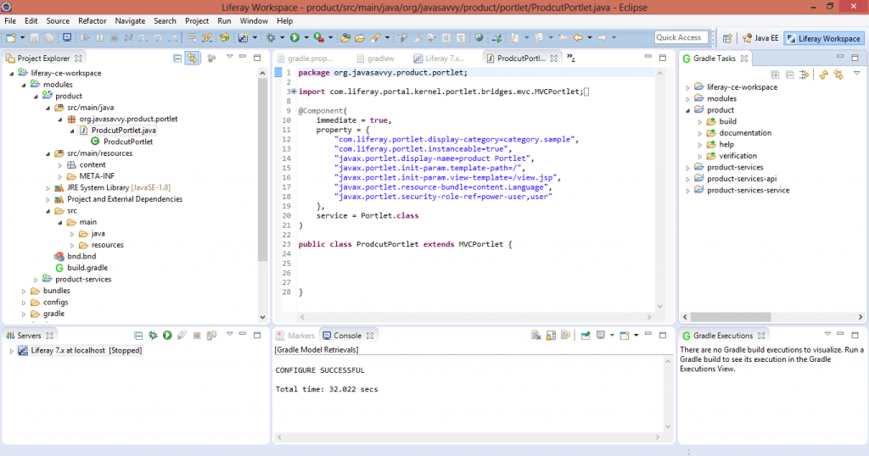](http://www.javasavvy.com/wp-content/uploads/2016/10/Liferay-7-gradle-task.png)

**Liferay 7 Portlet tutorial and gradle task**

Liferay provides bnd.bnd and build.gradle files to manage build and deployment process

**bnd.bnd**:   bnd file is MANIFEST configuration template file which used to auto create MANIFEST.MF,  so developers are not required to focus on MANIFEST file creation

It also used to activate Bundle with BundleActivator configuration if we are not going to use OSGI Declarative Services.

Bundle-SymbolicName: product

Bundle-Version: 1.0.0

**build.gradle:**  build.gradle  is used for dependency and build management for Liferay 7 modules.

Liferay 7 provides Gradle Build Task panel  to execute  build,deploy, clean, buildService task

The generated build artifacts can be copied to deploy or  /bundles/osgi/modules folder for manual deployment

For auto deployment, make sure that tomcat is created under liferay-workspace/bundle folder

[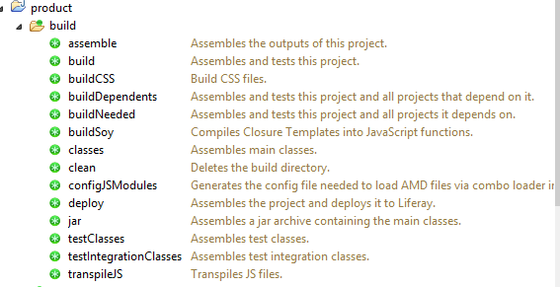](http://www.javasavvy.com/wp-content/uploads/2016/10/Gradle-Tasks.png)

**Liferay Gradle Tasks**

click on “deploy” target and you can see the logs that module is stated. The rest of portlet development is same as Liferay 6.

Now logon into Liferay portlet with test@liferay.com and add the portlet to page.  that’s all .. you have developed Liferay7 Portlet.

<https://portal.liferay.dev/docs/7-0/tutorials/-/knowledge_base/t/installing-liferay-ide>

## Liferay 7 development setup

### ****Step 1: Config server****

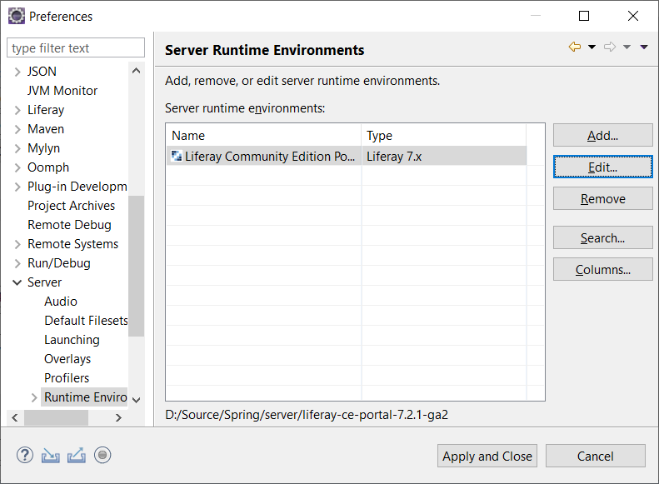

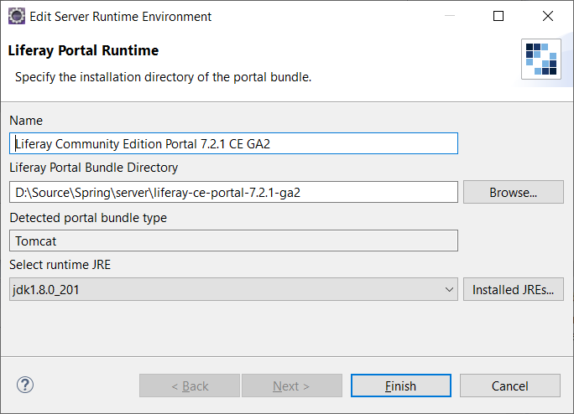

### ****Step 2: Liferay 7 Tomcat Setup in Eclipse****

Now, we will configure tomcat in Liferay. Click on **File->New-> Server;** Select Liferay 7.x and  click on **Next**.  Update  the tomcat server  location with download tomcat and Lieray bundles directory with in liferay home(which you extracted  liferay-ce-portal-tomcat-7.0-ga3)

[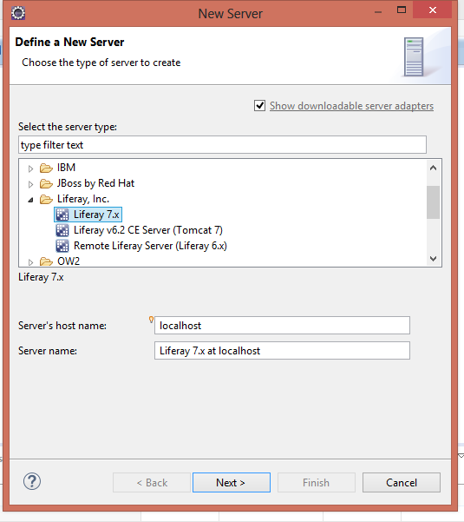](http://www.javasavvy.com/wp-content/uploads/2016/10/3.NewServer.png)

Set timeouts start = 9000

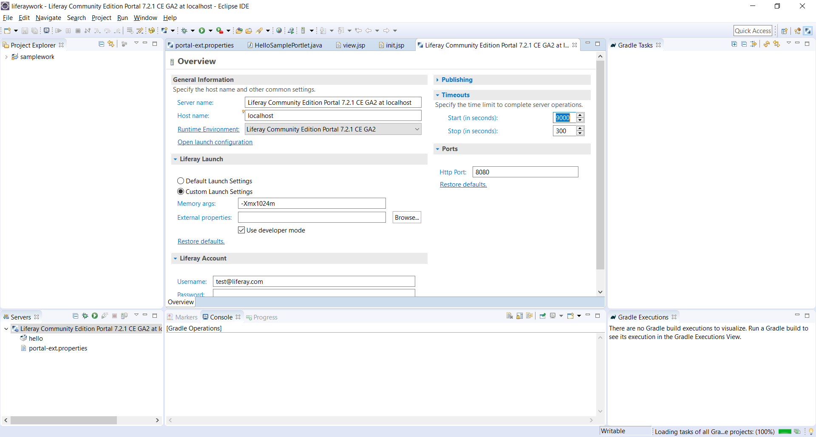

Step 3: Create Liferay Workspace

[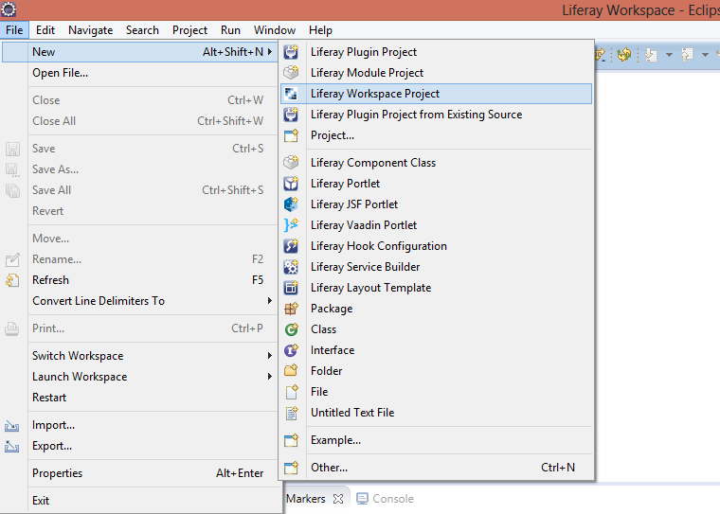](http://www.javasavvy.com/wp-content/uploads/2016/10/1.Newworkspace.png)

In eclipse, click **on  File-> New -> Liferay Workspace Project** and provide workspace name. It will download all required libraries from gradle repository.

[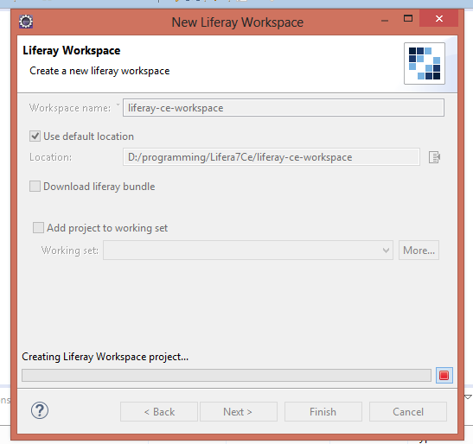](http://www.javasavvy.com/wp-content/uploads/2016/10/2.Wizard.png)

Step 4: Create Liferay Module

**Liferay new module wizard**:  Click **File-> New -> Liferay Module Project**

[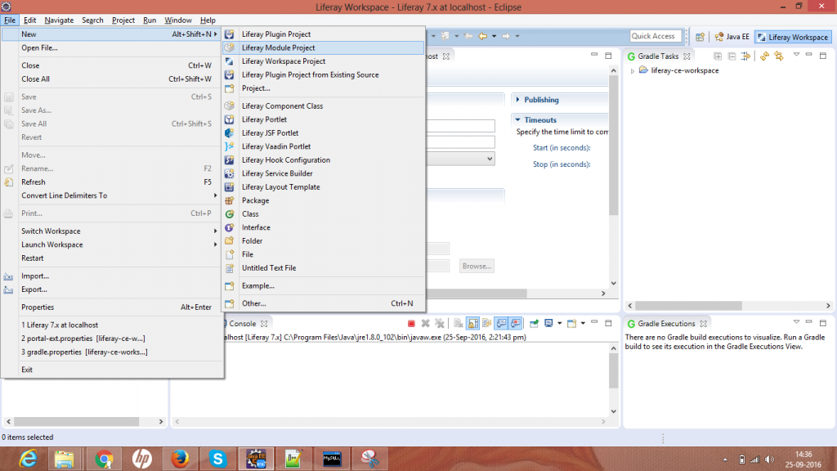](http://www.javasavvy.com/wp-content/uploads/2016/10/2.PortletWizard.png)

**Select Module configuration:**

  Liferay7 provides  “Project Template Name”  to create a modules. You can quicky create service builder, JSP fragment hook, MVC Portlet etc.  Here we select  module type as “MVC Portlet”. Select “**mvcPortlet**” and click on **Finish**.

[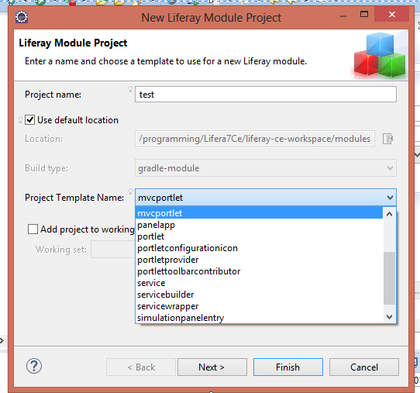](http://www.javasavvy.com/wp-content/uploads/2016/10/Liferay-wizard.png)

### ****Step 5 : Liferay 7 Bundles auto configuration****

In Liferay 7 community edition, module auto deployment path need to configure and can done in two ways

**Liferay tomcat runtime:**

Click on Liferay 7x

click on runtime

Update Liferay Portal bundle directory with liferay home directory as shown in below

[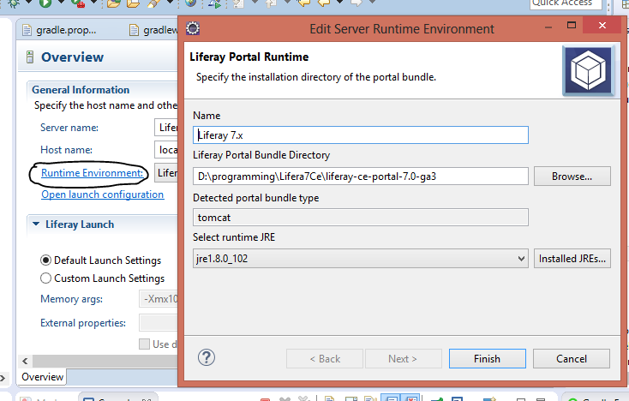](http://www.javasavvy.com/wp-content/uploads/2016/10/Liferay-7-auto-deployment.png)

gradle.properties

– open gradle.properties file in liferay-workspace folder and add the below property

liferay.workspace.home.dir=D:/programming/Lifera7Ce/liferay-ce-portal-7.0-ga3

Step 6: Liferay 7 Database configuration

Create database in mysql : create database lportal7\_ce character set utf8;

Create **portal-ext.properties** file and add below database properties and liferay home.

jdbc.default.url=jdbc\:mysql\://localhost:3307/lportal7\_ce?useUnicode\=true&characterEncoding\=UTF-8&useFastDateParsing\=false

jdbc.default.driverClassName=com.mysql.jdbc.Driver

jdbc.default.username=root

jdbc.default.password=root

liferay.home=D:/programming/Lifera7Ce/liferay-ce-portal-7.0-ga3

Copy the mysql to **tomcat\lib\ext** if not is not exist and start the server and you will get config page and complete the setup

If you user oracle

Step 7: Go go shell command

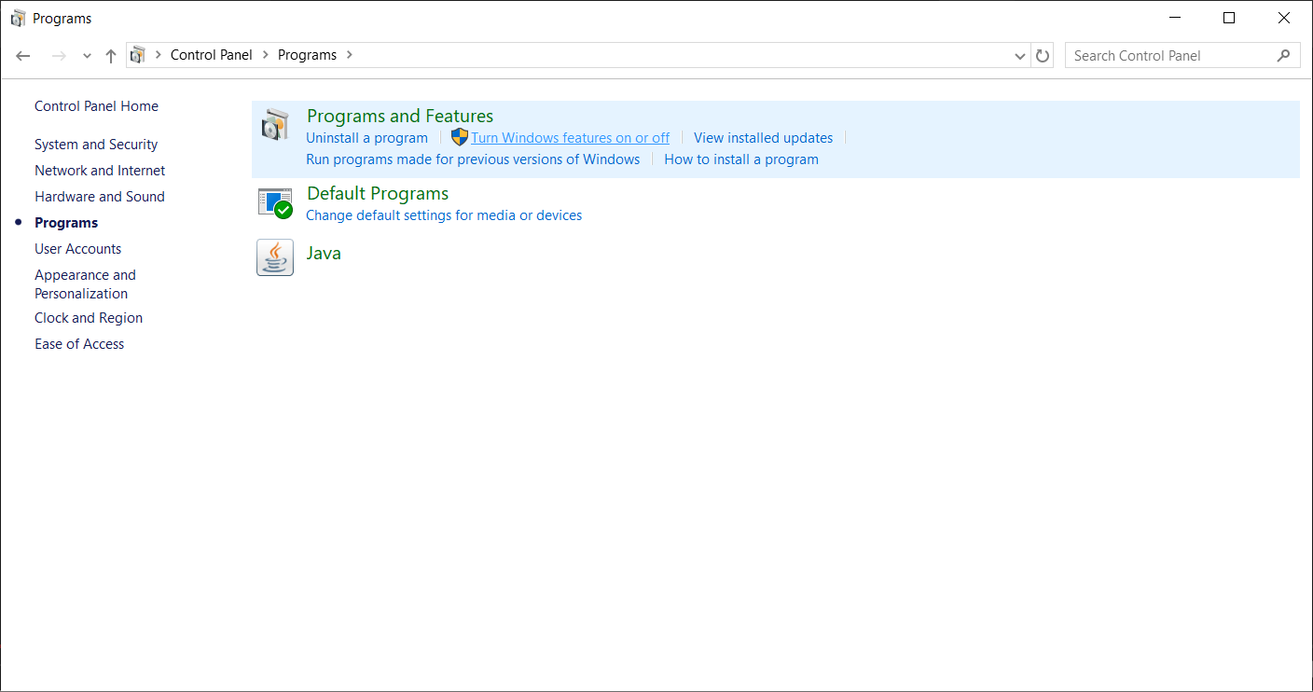

control panel/ turn on telnet

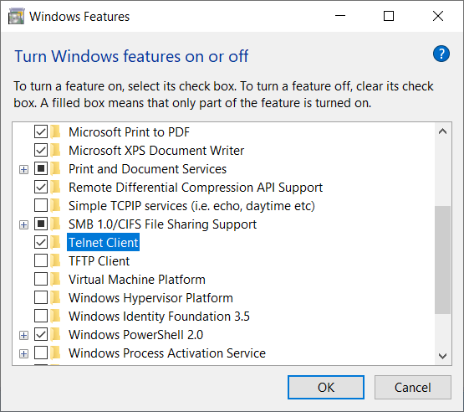

telnet localhost 11311

help

lb

stop 32

start 32

## 3. Liferay7 service builder

Create a module of type “Service Builder” and two sub modules are created.

* Api: This module holds all service builder interfaces such as sevice, modal
* Service: This module holds all implementation logic

Create a new service builder module in liferay7: Click  on **File->New->Liferay module project**

[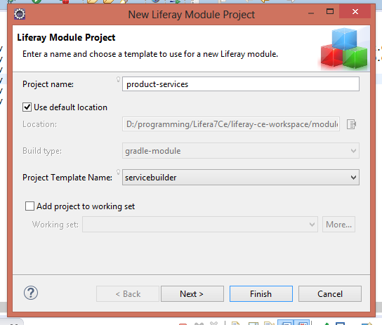](http://www.javasavvy.com/wp-content/uploads/2016/11/SB1.png)

Select Project Template as “serviceBuilder” and provide package name

[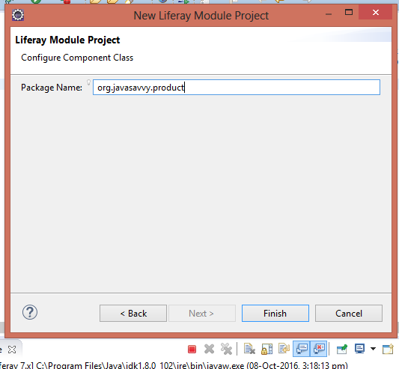](http://www.javasavvy.com/wp-content/uploads/2016/11/SB2.png)

It will generate two modules as shown in below

[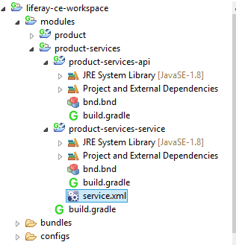](http://www.javasavvy.com/wp-content/uploads/2016/11/SB3.png)

Liferay Service builder generates module called “product-services”. It again will contain “product-services-api” and “product-services-service” sub modules.

**service.xml** file also will be created in product-services-service folder with sample entity“Foo”.

Remove the entity **Foo** and add Product

Now run the service builder from Gradle Tasks – **buildService**. You can also run from project explorer : Right click on **Product-Service->Liferay->Gradle->build-service**. It will generate the all service and implementation layer code.

[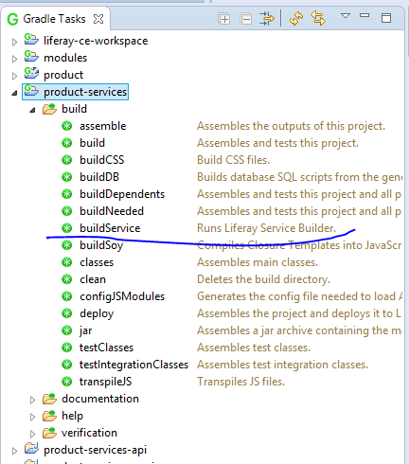](http://www.javasavvy.com/wp-content/uploads/2016/11/gradle-build-services.png)

product-services-api contains service interfaces and wrapper services like in Liferay6

* contains modal interfaces – Product.java
* service layer interface and LocalServiceUtil.java
* persistence layer interface classes and Utilities classes
* common exception classes

Now Service builder is generated and how to add service builder dependency in another module?

Now our UI code is in product module that requires“product-services” as dependency

open the build.gradle file in product module

add below gradle depency

dependencies {

compileOnly group: "com.liferay.portal", name: "com.liferay.portal.kernel", version: "2.0.0"

compileOnly group: "com.liferay.portal", name: "com.liferay.util.taglib", version: "2.0.0"

compileOnly group: "javax.portlet", name: "portlet-api", version: "2.0"

compileOnly group: "javax.servlet", name: "servlet-api", version: "2.5"

compileOnly group: "jstl", name: "jstl", version: "1.2"

compileOnly group: "org.osgi", name: "org.osgi.compendium", version: "5.0.0"

// ADD

compileOnly project(":modules:product-services:product-services-api")

}

## 4. Download JDK

* <http://www.oracle.com/technetwork/java/javase/downloads/index.html>

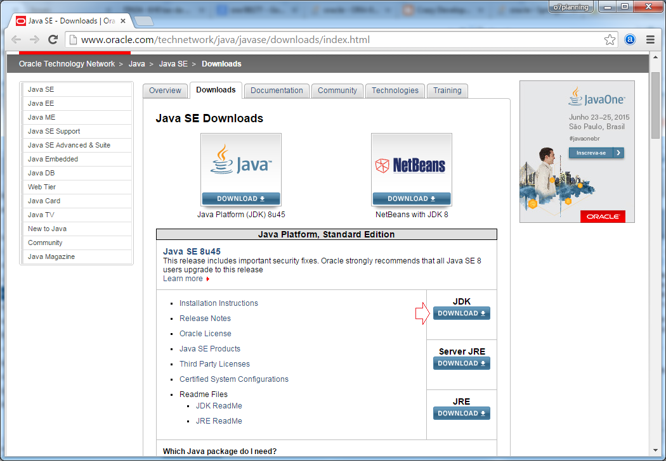

Bạn nên kiểm tra xem hệ điều hành của mình là 32bit hay 64bit để download bộ cài **JDK**phù hợp.

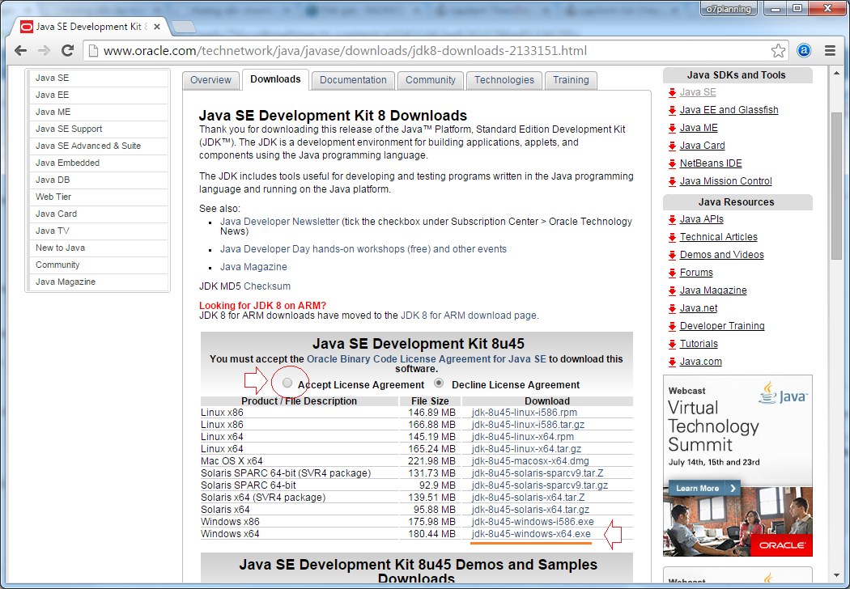

Kết quả download được:

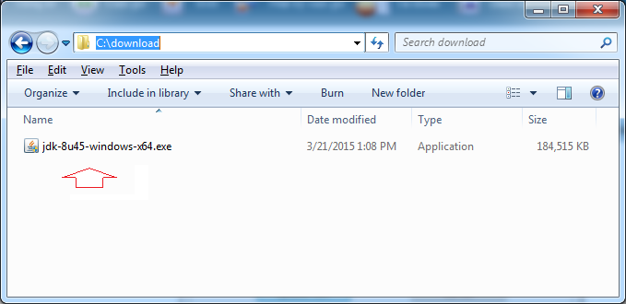

Cài đặt Java

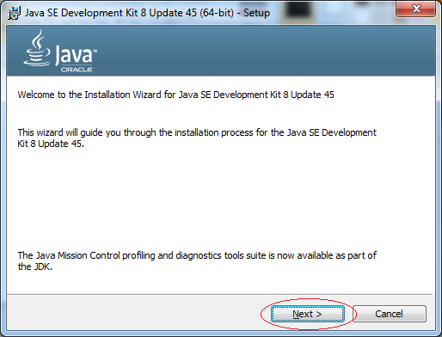

Nhập vào thư mục mà JDK sẽ được cài đặt ra, ở đây tôi đặt là:

* **C:\DevPrograms\Java\jdk1.8.0\_45\**

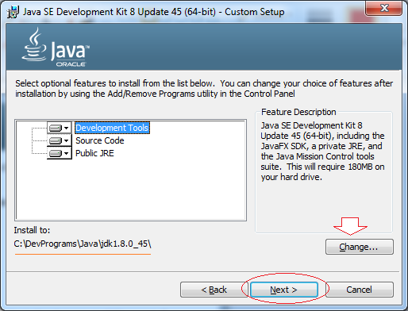

Ngay sau khi cài đặt xong JDK, bộ cài đặt sẽ tiếp tục hỏi bạn vị trí JRE sẽ được cài ra. Ở đây tôi chọn:

* **C:\DevPrograms\Java\jre.8.0\_45\**

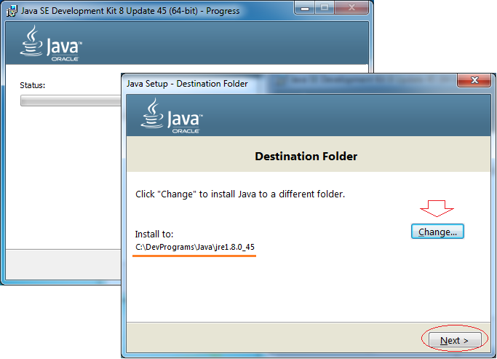

Java đã được cài đặt thành công.

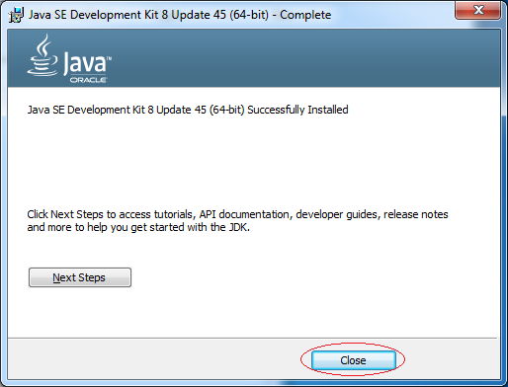

Kết quả bạn có được 2 thư mục:

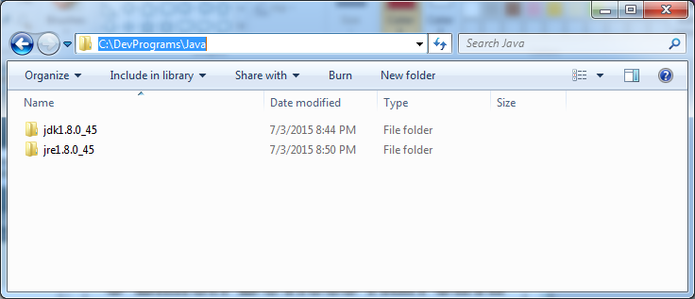

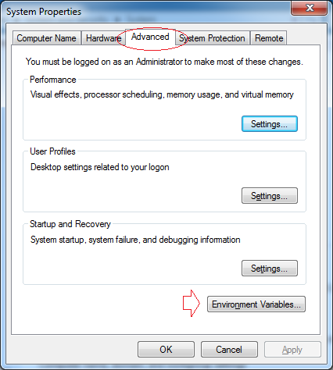

Nhấn ***New*** để tạo mới một biến môi trường có tên **JAVA\_HOME**.

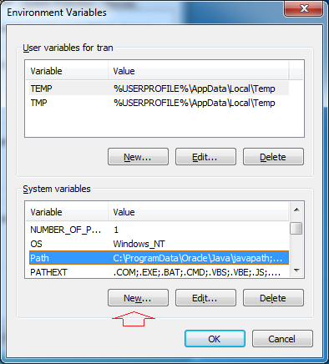

Nhập vào đường dẫn tới thư mục JDK.

* **Variable name:** JAVA\_HOME
* **Variable value:** C:\DevPrograms\Java\jdk1.8.0\_45

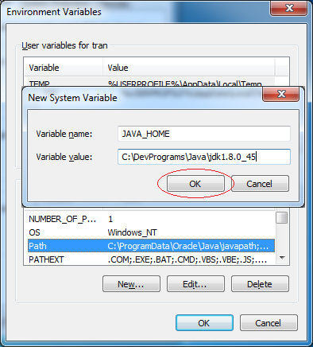

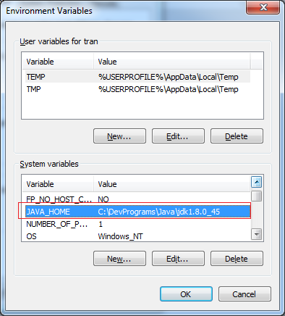

Tiếp theo sửa đổi biến môi trường ***path***

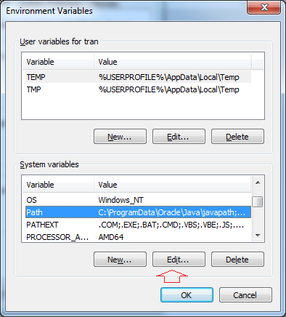

Thêm vào phía trước giá trị của biến môi trường ***path***:

* **%JAVA\_HOME%\bin;**

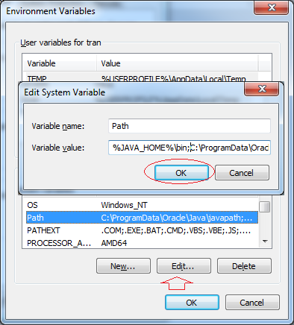

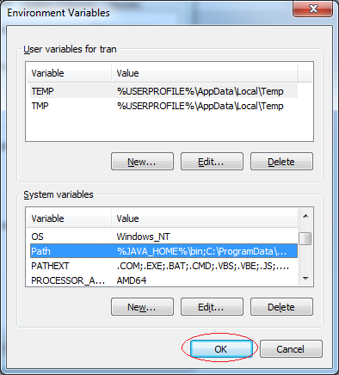

Bạn đã cài đặt và cấu hình Java thành công.

Check: java -version

Cách expand xem list file:

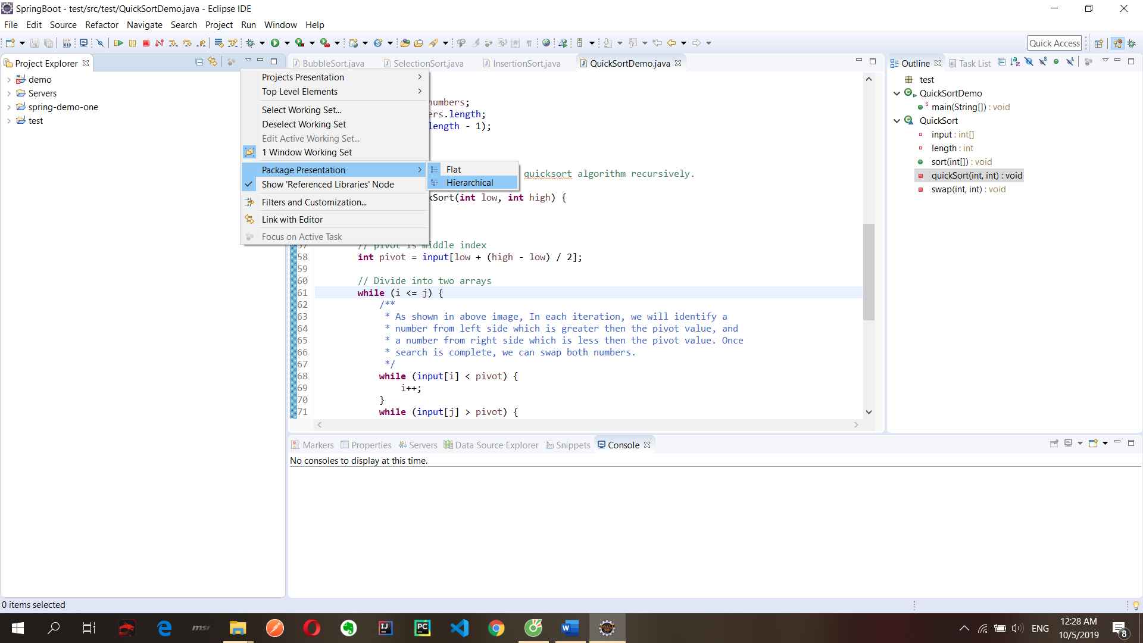

Quick diff

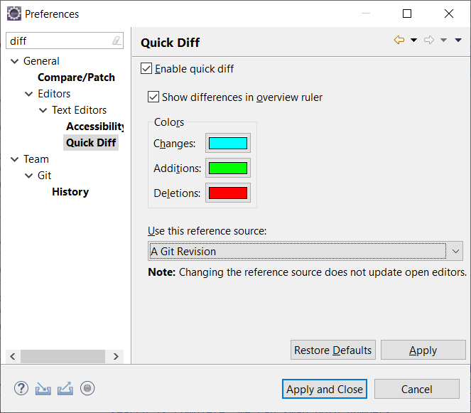

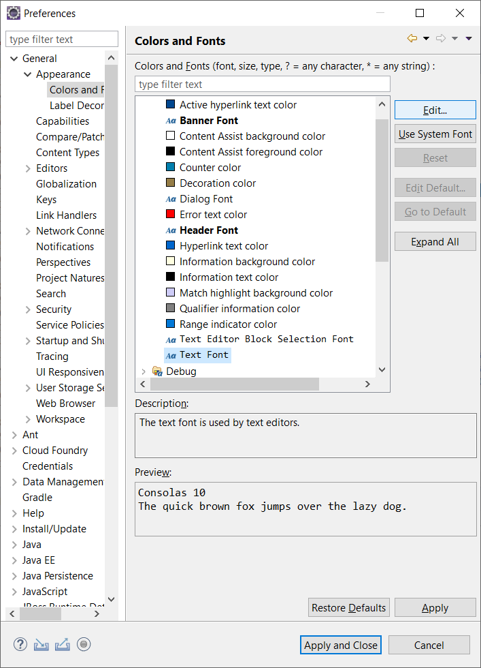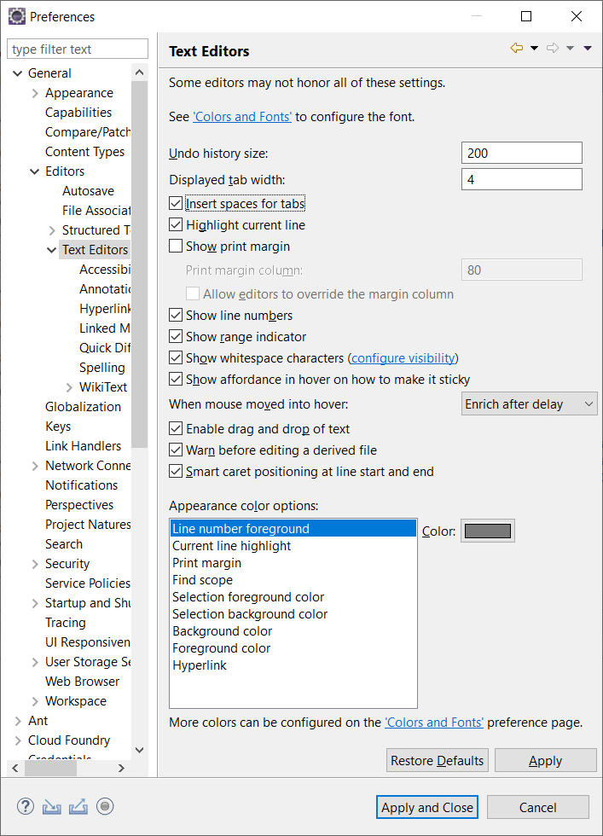

## More config

### ****Install a new software****

<https://portal.liferay.dev/docs/7-0/tutorials/-/knowledge_base/t/installing-liferay-ide>

1. In your browser, go to the [Liferay IDE](https://community.liferay.com/en_GB/project/-/asset_publisher/TyF2HQPLV1b5/content/ide-installation-instructions) page. Copy the URL to the update site you’re interested in (stable or milestone).
2. Select *Help* → *Install New Software*.
3. In the *Add* dialog, click the *Archive* button and browse to the location of the downloaded Liferay IDE Zip file.
4. You ’ll see the Liferay IDE components in the list below. Check them off and click Next.
5. Accept the terms of the agreements and click Next, and Liferay IDE is installed. Like other Eclipse plugins you’ll have to restart Eclipse to enable it.

**View Filter**

View => Filter

Filter to close project

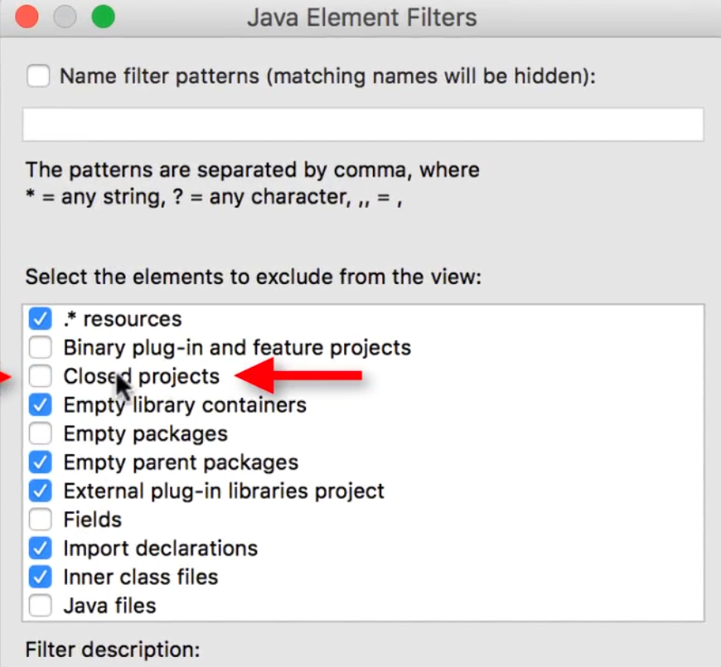

### ****View flat****

You can configure your workspace’s module presentation by switching between the default *Hierarchical* or *Flat* views. To do this, navigate to the Project Explorer’s *View Menu* (), select *Projects Presentation* and then select the presentation mode you’d like to display. The Hierarchical view displays subfolders and subprojects under the workspace project, whereas the Flat view displays the workspace’s modules separately from the workspace.

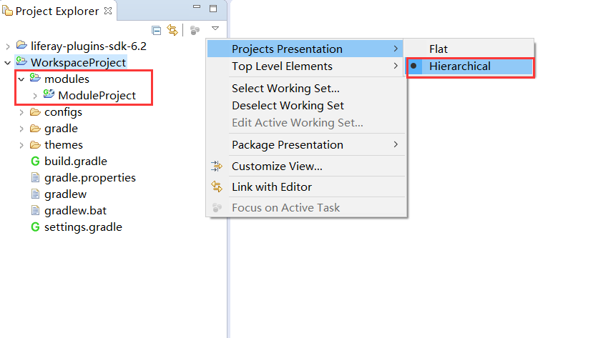

Import template format

<https://help.eclipse.org/2019-12/index.jsp?topic=%2Forg.eclipse.cdt.doc.user%2Ftasks%2Fcdt_t_imp_code_temp.htm>

To import a template

1. Click Window > Preferences.

2. Expand JAVA, expand Editor and click Templates.

3. Click Import.

4. Select the template file that you want to import.

5. Click OK.

The template list is updated to include the template that you imported.

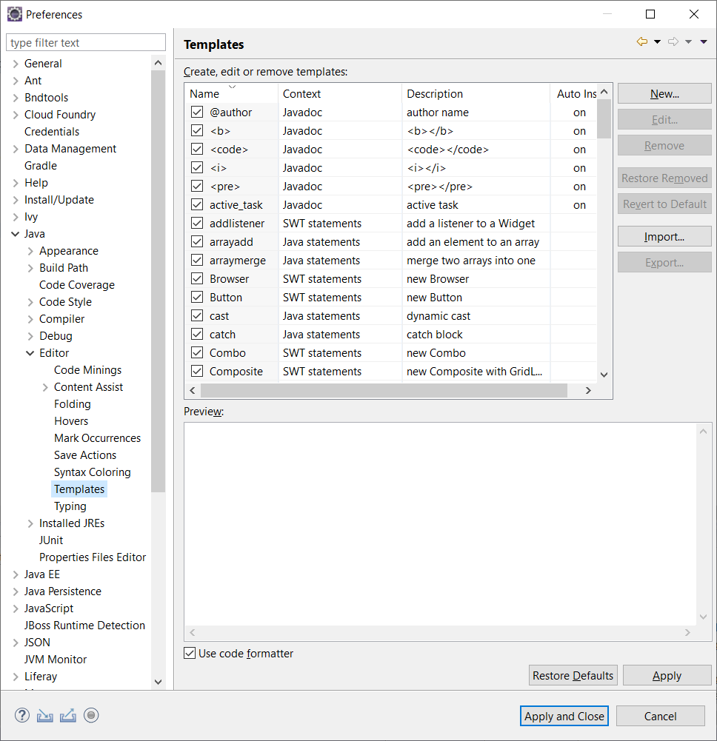

### [****Setting Proxy Requirements for Liferay IDE****](https://portal.liferay.dev/docs/7-0/tutorials/-/knowledge_base/t/setting-proxy-requirements-for-liferay-ide#setting-proxy-requirements-for-liferay-ide)

If you have proxy server requirements and want to configure your http(s) proxy to work with Liferay IDE, follow the instructions below.

1. Navigate to Eclipse’s *Window* → *Preferences* → *General* → *Network Connections* menu.
2. Set the *Active Provider* drop-down selector to *Manual*.
3. Under *Proxy entries*, configure both proxy HTTP and HTTPS by clicking the field and selecting the *Edit* button.

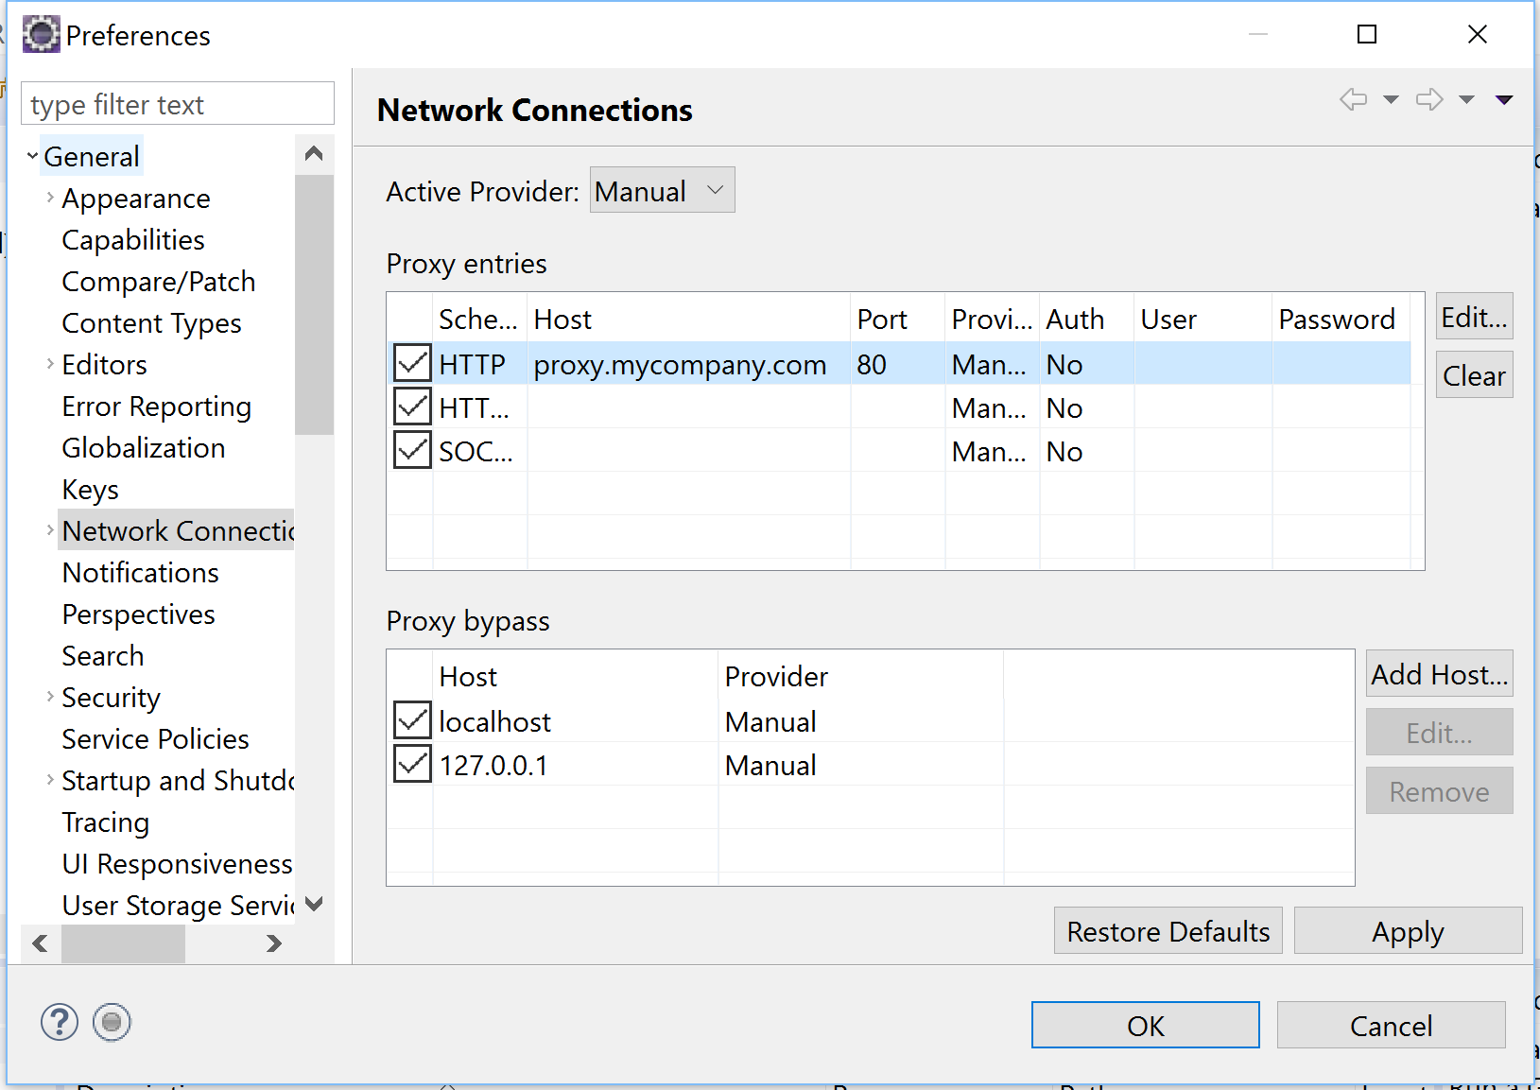

Figure 1: You can configure your proxy settings in IDE's Network Connections menu.

1. For each schema (HTTP and HTTPS), enter your proxy server’s host, port, and authentication settings (if necessary).

**Note:** Do not leave whitespace at the end of your proxy host or port settings.

1. Once you’ve configured your proxy entry, click *OK* → *OK*.

If you’re working with a Liferay Workspace in IDE, you’ll need to configure your proxy settings for that environment too. See the [Setting Proxy Requirements for Liferay Workspace](https://portal.liferay.dev/docs/7-0/tutorials/-/knowledge_base/t/setting-proxy-requirements-for-liferay-workspace) for more details.

Awesome! You’ve successfully configured Liferay IDE’s proxy settings!

[Updating Liferay IDE](https://portal.liferay.dev/docs/7-0/tutorials/-/knowledge_base/t/updating-liferay-ide#updating-liferay-ide)

If you’re already using Liferay IDE but need to update your environment, follow the steps below:

1. In Liferay IDE, go to *Help* → *Install New Software…*.
2. In the *Work with* field, copy in the URL http://releases.liferay.com/tools/ide/latest/stable/.
3. You’ll see the IDE components in the list below. Check them off and click *Next*.

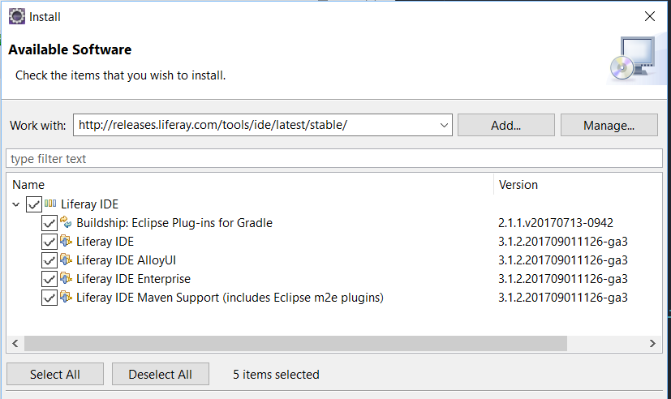

Figure 1: Make sure to check all the IDE components you wish to install.

1. Accept the terms of the agreements. Click *Next*, and IDE is updated. You must restart IDE for the updates to take effect.

You’re now on the latest version of Liferay IDE!

[Deploying Modules with Liferay IDE](https://portal.liferay.dev/docs/7-0/tutorials/-/knowledge_base/t/deploying-modules-with-liferay-ide#deploying-modules-with-liferay-ide)

Deploying modules in Liferay IDE is a cinch. Before deploying your module, make sure you have a Liferay server configured in IDE. To see how to do this, see the [Installing a Server in Liferay IDE](https://portal.liferay.dev/docs/7-0/tutorials/-/knowledge_base/t/installing-a-server-in-liferay-ide)

There are two ways to deploy a module to your Liferay server. You should start your Liferay server before attempting to deploy to it.

1. Select the module from the Package Explorer window and drag it to your Liferay server in the Servers window.

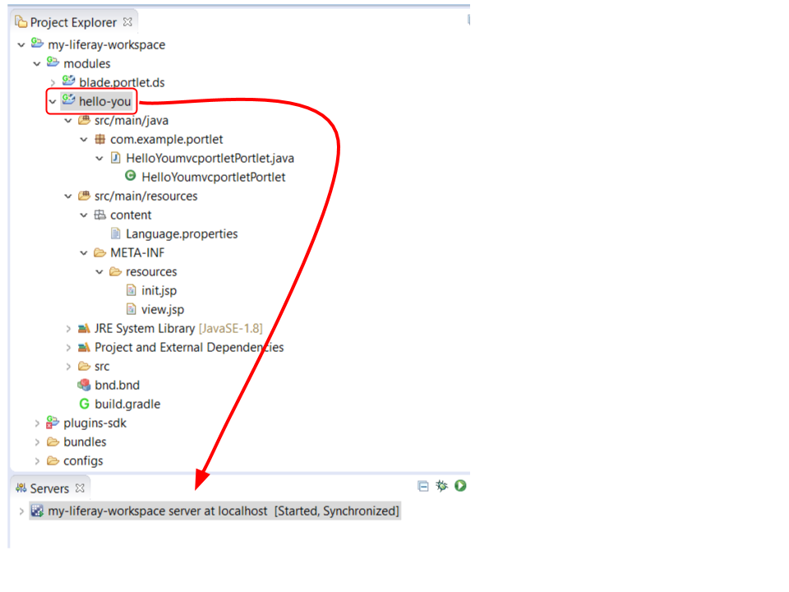

Figure 1: You can use the drag-and-drop method to deploy your module to Liferay Portal.

1. Right-click the server from the Servers window and select *Add and Remove…*. Add the module(s) you’d like to deploy from the Available window to the Configured window. Then click *Finish*.

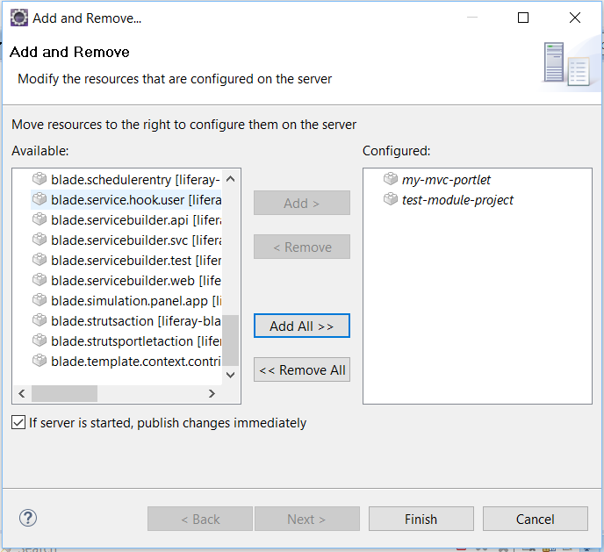

Figure 2: Using the this deployment method is convenient when deploying multiple module projects.

[Installing a Server in Liferay IDE](https://portal.liferay.dev/docs/7-0/tutorials/-/knowledge_base/t/installing-a-server-in-liferay-ide#installing-a-server-in-liferay-ide)

Installing a server in Liferay IDE is easy. In just a few steps you’ll have your server up and running. Follow these steps to install your server:

1. In the Servers view, click the *No Servers are available* link. If you already have a server installed, you can install a new server by right-clicking in the Servers view and selecting *New* → *Server*. This brings up a wizard that walks you through the process of defining a new server.
2. Select the type of server you would like to create from the list of available options. For a standard server, open the *Liferay, Inc.* folder and select the *Liferay 7.x* option. You can change the server name to something more unique too; this is the name displayed in the Servers view. Then click *Next*. If you’re creating a server for the first time, continue to the next step.

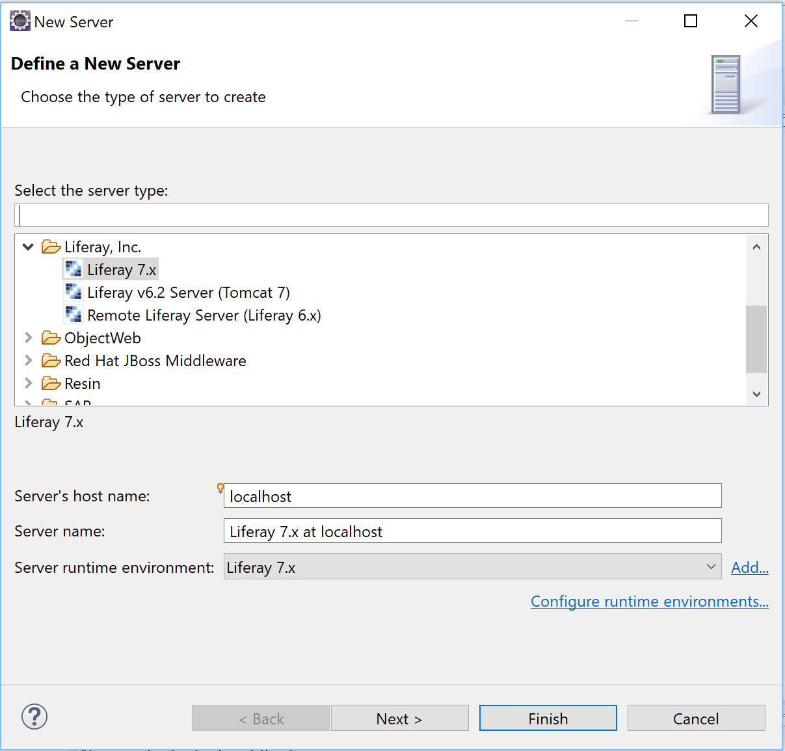

Figure 1: Choose the type of server you want to create.

**Note:** If you’ve already configured previous Liferay servers, you’ll be provided the *Server runtime environment* field, which lets you choose previously configured runtime environments. If you want to re-add an existing server, select one from the dropdown menu. You can also add a new server by selecting *Add*, or you can edit existing servers by selecting *Configure runtime environments*. Once you’ve configured the server runtime environment, select *Finish*. If you selected an existing server, your server installation is finished; you can skip steps 3-5.

1. Enter a name for your server. This is the name for the Liferay Portal runtime configuration used by IDE. This is not the display name used in the Servers tab.
2. Browse to the installation folder of the Liferay Portal bundle. For example, C:\liferay-ce-portal-7.0-ga4\tomcat-8.0.32.

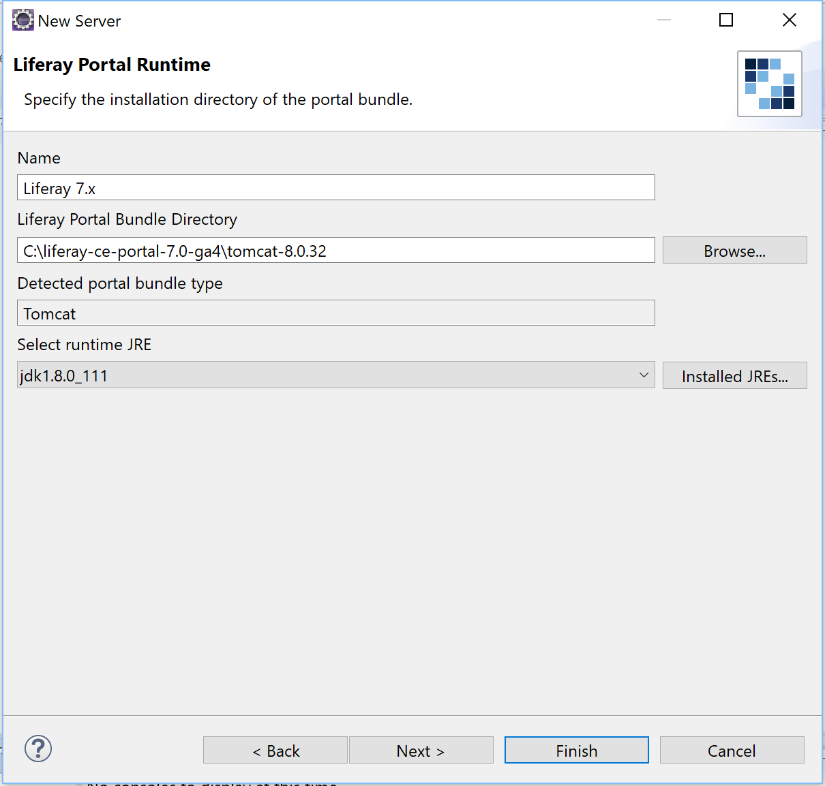

Figure 2: Specify the installation folder of the bundle.

1. Select a runtime JRE and click *Finish*. Your new server appears under the Servers view.

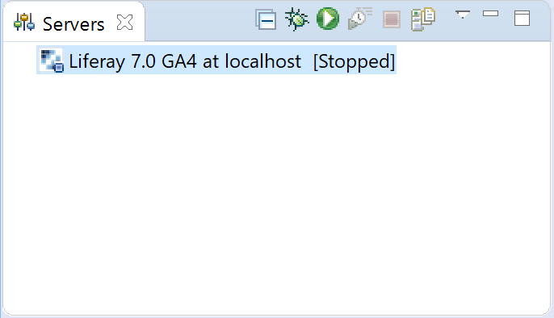

Figure 3: Your new server appears under the \*Servers\* view.

Your server is now available in Liferay IDE!

For reference, here’s how the IDE server buttons work with your Liferay Portal instance:

* *Start* (): Starts the server.
* *Stop* (): Stops the the server.
* *Debug* (): Starts the server in debug mode. For more information on debugging in Eclipse, see the [Eclipse Debugging](https://eclipse.org/community/eclipse_newsletter/2017/june/article1.php) article.

Now you’re ready to use your server in Liferay IDE!

[SEARCH CLASS HIERARCHY](https://portal.liferay.dev/docs/7-0/tutorials/-/knowledge_base/t/searching-product-source-in-liferay-ide#search-class-hierarchy)

Inspecting classes that extend a similar superclass can help you find useful patterns and examples for how you can develop your own app. For example, suppose your app extends the [MVCPortlet](https://docs.liferay.com/ce/portal/7.0-latest/javadocs/portal-kernel/com/liferay/portal/kernel/portlet/bridges/mvc/MVCPortlet.html) class. You an search classes that extend that same class in IDE by right-clicking the MVCPortlet declaration and selecting *Open Type Hierarchy*. This opens a window that lets you inspect all classes residing in the target platform that extend MVCPortlet.

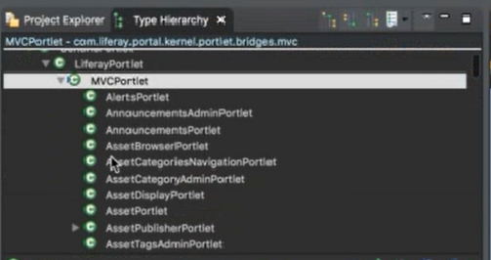

Figure 1: Browse the Type Hierarchy window and open the provided classes for examples on how to extend a class.

[SEARCH METHOD DECLARATIONS](https://portal.liferay.dev/docs/7-0/tutorials/-/knowledge_base/t/searching-product-source-in-liferay-ide#search-method-declarations)

Sometimes you want a search to be more granular, exploring the declarations of a specific method provided by a class/interface. Liferay IDE’s advanced search has no limits; Liferay Workspace’s target platform indexing provides method exploration too!

Suppose in the [MVCPortlet](https://docs.liferay.com/ce/portal/7.0-latest/javadocs/portal-kernel/com/liferay/portal/kernel/portlet/bridges/mvc/MVCPortlet.html) class you’re extending, you’d like to search for declarations of its doView method you’re overriding. You can do this by right-clicking the doView method declaration in your custom app’s class and selecting *Declarations* → *Workspace*.

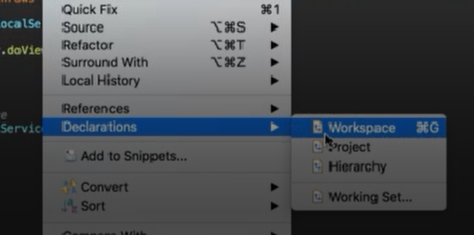

Figure 2: All declarations of the method are returned in the Search window

[Using Gradle in Liferay IDE](https://portal.liferay.dev/docs/7-0/tutorials/-/knowledge_base/t/using-gradle-in-liferay-ide#using-gradle-in-liferay-ide)

[Gradle](http://gradle.org/) is a popular open source build automation system. You can take full advantage of Gradle in Liferay IDE by utilizing [Buildship](https://projects.eclipse.org/releases/oxygen), which is a collection of Eclipse plugin-ins that provide support for building software using Gradle with Liferay IDE. Buildship is bundled with Liferay IDE versions 3.0 and higher.

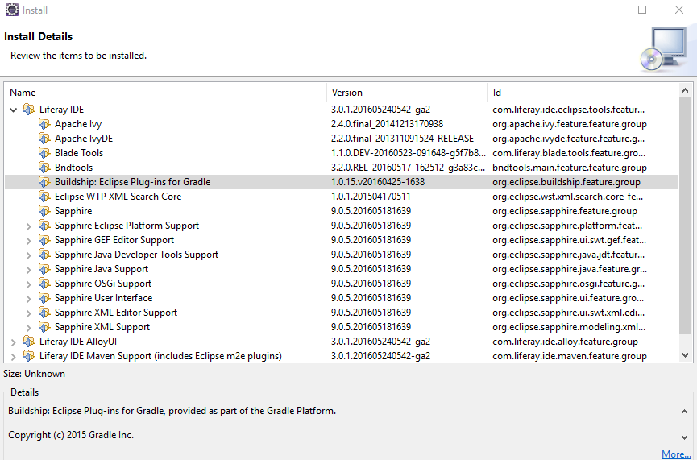

Figure 1: Navigate to \*Help\* → \*Installation Details\* to view plugins included in Liferay IDE.

The first thing you’ll learn about in this tutorial is creating Gradle projects in IDE.

[**CREATING AND IMPORTING GRADLE PROJECTS**](https://portal.liferay.dev/docs/7-0/tutorials/-/knowledge_base/t/using-gradle-in-liferay-ide#creating-and-importing-gradle-projects)

You can create a Gradle project by using the Gradle Project wizard.

1. Navigate to *File* → *New* → *Project…* and select *Gradle* → *Gradle Project*. Finally, click *Next* → *Next*.
2. Enter a valid project name. You can also specify your project location and working sets.
3. Optionally, you can navigate to the next page and specify your Gradle distribution and other advanced options. Once you’re finished, select *Finish*.

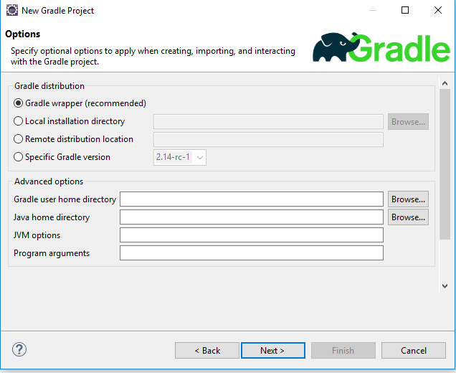

Figure 2: You can specify your Gradle distribution and advanced options such as home directories, JVM options, and program arguments.

You can also import existing Gradle projects in Liferay IDE.

1. Go to *File* → *Import…* → *Gradle* → *Gradle Project* → *Next* → *Next*.

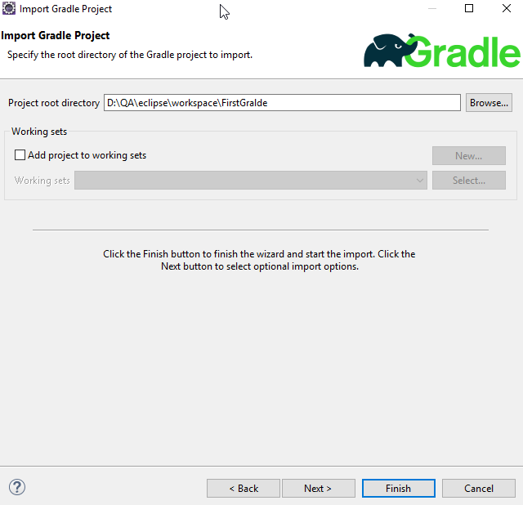

Figure 3: You can specify what Gradle project to import from the \*Import Gradle Project\* wizard.

1. Click the *Browse…* button to choose a Gradle project.
2. Optionally, you can navigate to the next page and specify your Gradle distribution and other advanced options. Once you’re finished, click *Next* again to review the import configuration. Select *Finish* once you’ve confirmed your Gradle project import.

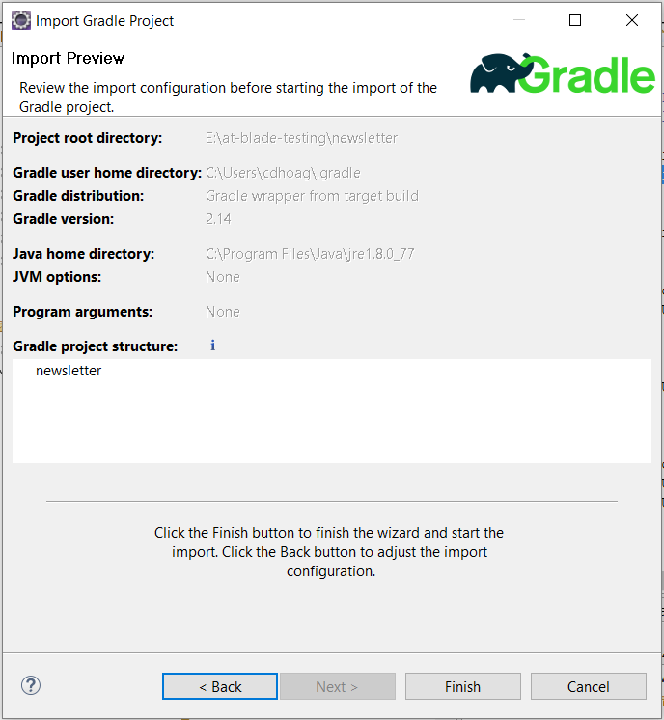

Figure 4: You can preview your Gradle project's import information.

Next you’ll learn about Gradle tasks and executions, and learn how to run and display them in Liferay IDE.

[**GRADLE TASKS AND EXECUTIONS**](https://portal.liferay.dev/docs/7-0/tutorials/-/knowledge_base/t/using-gradle-in-liferay-ide#gradle-tasks-and-executions)

Liferay IDE provides two views to enhance your developing experience using Gradle: Gradle Tasks and Gradle Executions. You can open these views by following the instructions below.

1. Go to *Window* → *Show View* → *Other…*.
2. Navigate to the *Gradle* folder and open *Gradle Tasks* and *Gradle Executions*.

Gradle tasks and executions views open automatically once you create or import a Gradle project.

The Gradle Tasks view allows you to display the Gradle tasks available for you to use in your Gradle project. Users can execute a task listed under the Gradle project by double-clicking it.

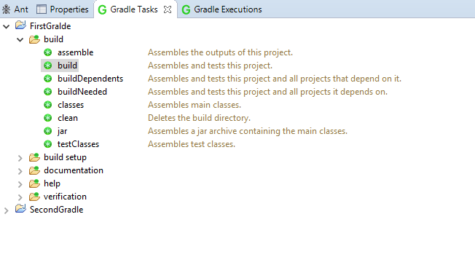

Figure 5: Navigate into your preferred Gradle project to view its available Gradle tasks.

Once you’ve executed a Gradle task, you can open the Gradle Executions view to inspect its output.

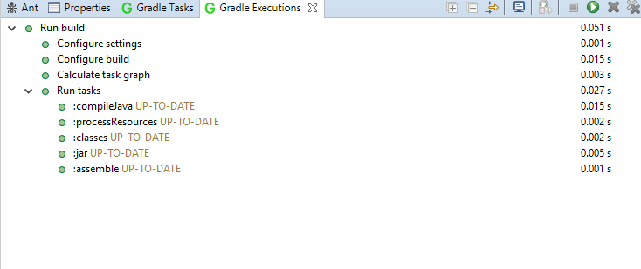

Figure 6: The Gradle Executions view helps you visualize the Gradle build process.

Keep in mind that if you change the Gradle build scripts inside your Gradle projects (e.g., build.gradle or settings.gradle), you must refresh the project so Liferay IDE can account for the change and display it properly in your views. To refresh a Gradle project, right-click on the project and select *Gradle* → *Refresh Gradle Project*.

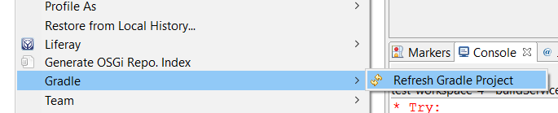

Figure 7: Make sure to always refresh your Gradle project in Liferay IDE after build script edits.

If you prefer Eclipse refresh your Gradle projects automatically, navigate to *Window* → *Preferences* → *Gradle* and enable the *Automatic Project Synchronization* checkbox. If you’d like to enable Gradle’s automatic synchronization for just one Gradle project, you can right-click a Gradle project and select *Properties* → *Gradle* and enable auto sync that way. This feature is available in Buildship version 2.2+, so make sure you have the required version.

Build gradle project

./gradlew cleanEclipse eclipse

Git

R Click/ Replace/ Head revision

CTRL ALT H: call hierarchi

ALT SHIFT T: Refactor

Install doma

https://doma.readthedocs.io/en/stable/getting-started-eclipse/

How to import and export projects on eclipse.

Here is a short video on "[How to import and export projects on eclipse.](https://youtu.be/fiuSckgjdmY" \t "_blank)"

<https://www.youtube.com/watch?v=fiuSckgjdmY&feature=youtu.be>

#### Import

[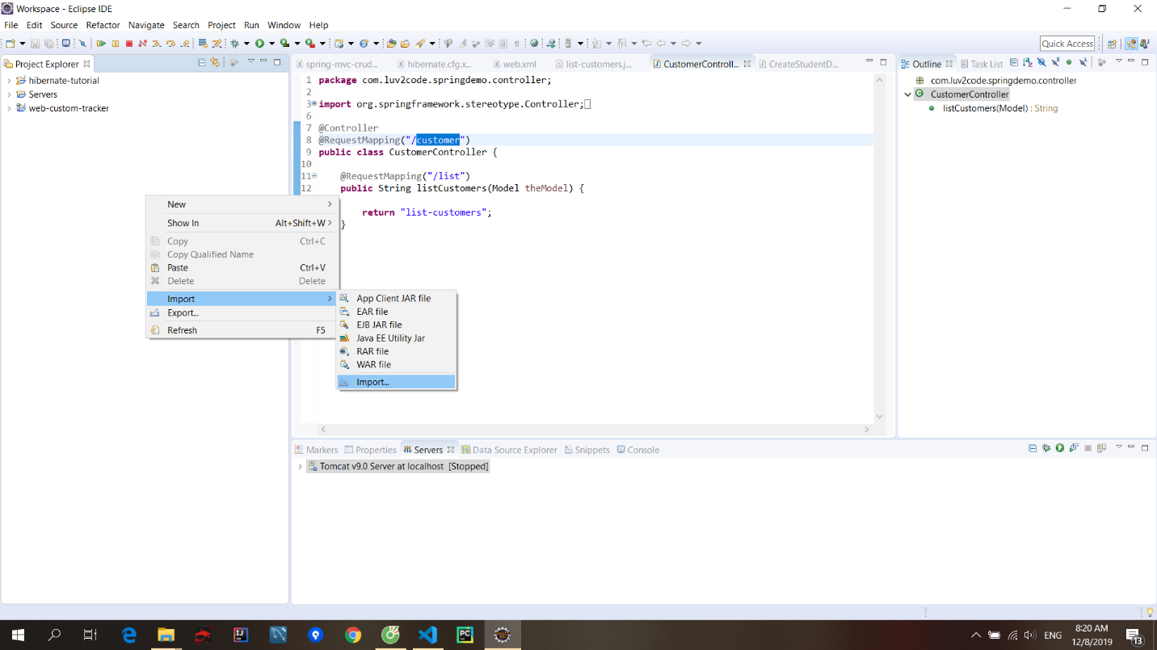](https://github.com/Duy-Phuong/java-fullstack/blob/master/root/img/2019-12-08-08-21-03.png)

[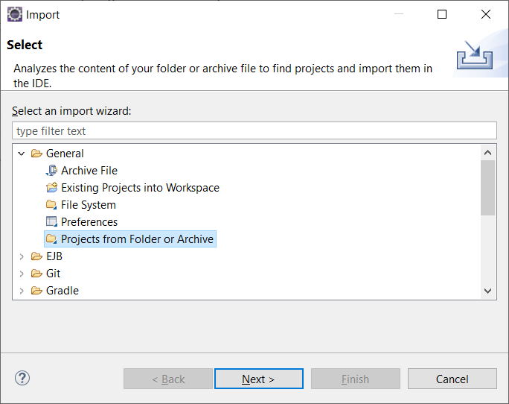](https://github.com/Duy-Phuong/java-fullstack/blob/master/root/img/2019-12-08-08-21-54.png)

File/ Open project from file system../ Directory

Đối với project không có file jar thì tạo thư mục lib nằm trong WEB-INF paste thư viện .jar vào, rồi vào Build path config add

#### Export

[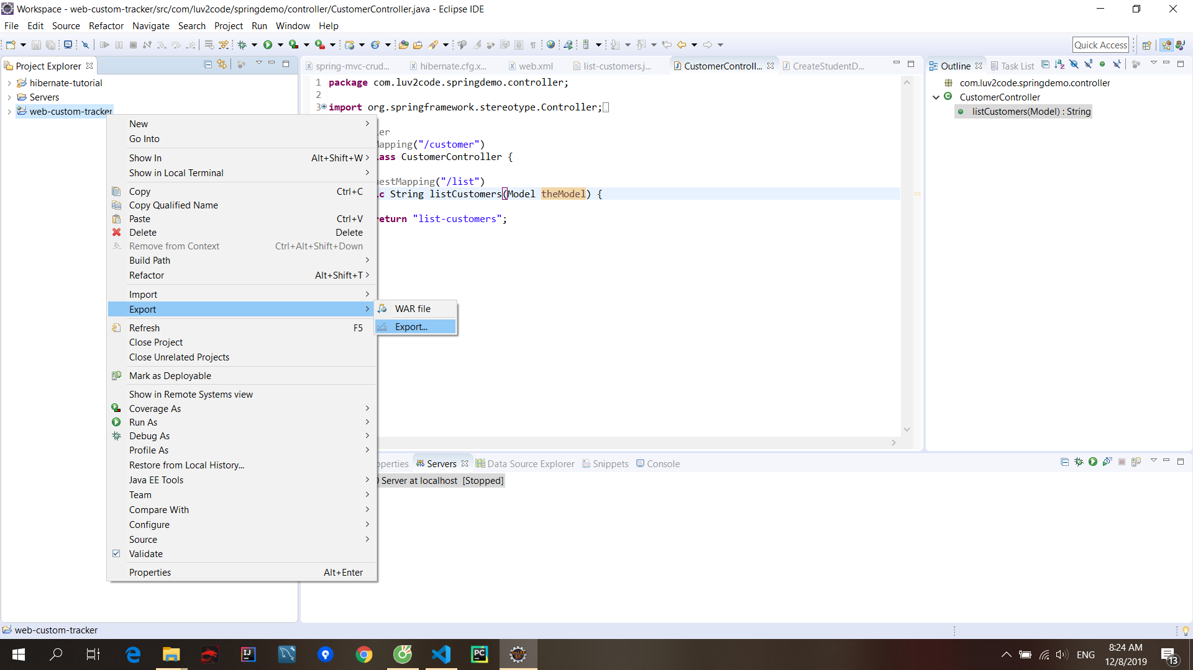](https://github.com/Duy-Phuong/java-fullstack/blob/master/root/img/2019-12-08-08-24-39.png)

[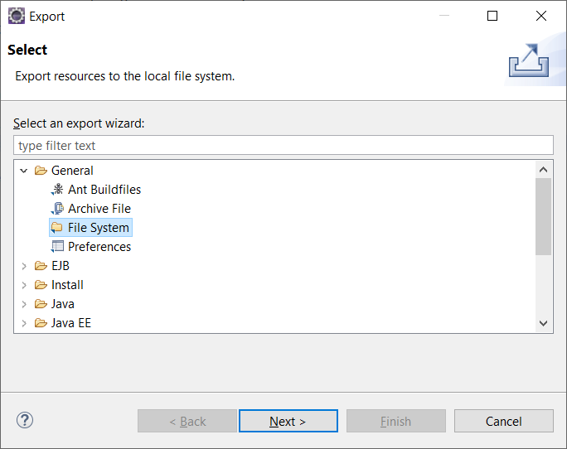](https://github.com/Duy-Phuong/java-fullstack/blob/master/root/img/2019-12-08-08-25-14.png)

[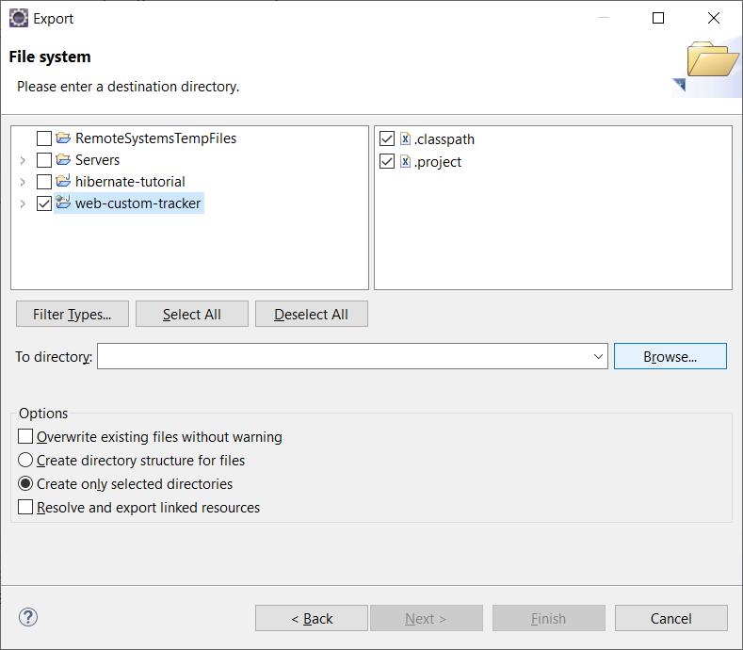](https://github.com/Duy-Phuong/java-fullstack/blob/master/root/img/2019-12-08-08-25-34.png)  
Finish

Videos install IDE

Here are few suggested videos for setup different IDE, Java on different operating systems. The following videos are on YouTube and StudyEasy is not associated the the video makers.

* **How to install Java JDK on Mac OS X ( with JAVA\_HOME )**

Link: <https://www.youtube.com/watch?v=y6szNJ4rMZ0>

* **How to Install Eclipse IDE on Mac OS X**

Link: <https://www.youtube.com/watch?v=gufMbpxzfWw>

* **How to Install Intellij IDEA on Mac OS X + Creating First Hello World Java Application**

Link: <https://www.youtube.com/watch?v=8BrZ7CMrNe8>

* **How to install Java JDK 10 on Ubuntu 18.04 LTS (Debian Linux)**

       Link: <https://www.youtube.com/watch?v=4RJ60fqeTN4>

* **How to Install Eclipse Oxygen on Ubuntu 16.04 / Ubuntu 18.04 (Linux)**

Link: <https://www.youtube.com/watch?v=EiGl2Ag35AI>

* **Installing Jetbrains Intellij IDEA on Ubuntu and Creating First Hello World**

Link: <https://www.youtube.com/watch?v=VBkjXV1aSRA>

Naming convention

Constant is UPPERCASE

Varrible is camelCase

Perspective

Other/ Java

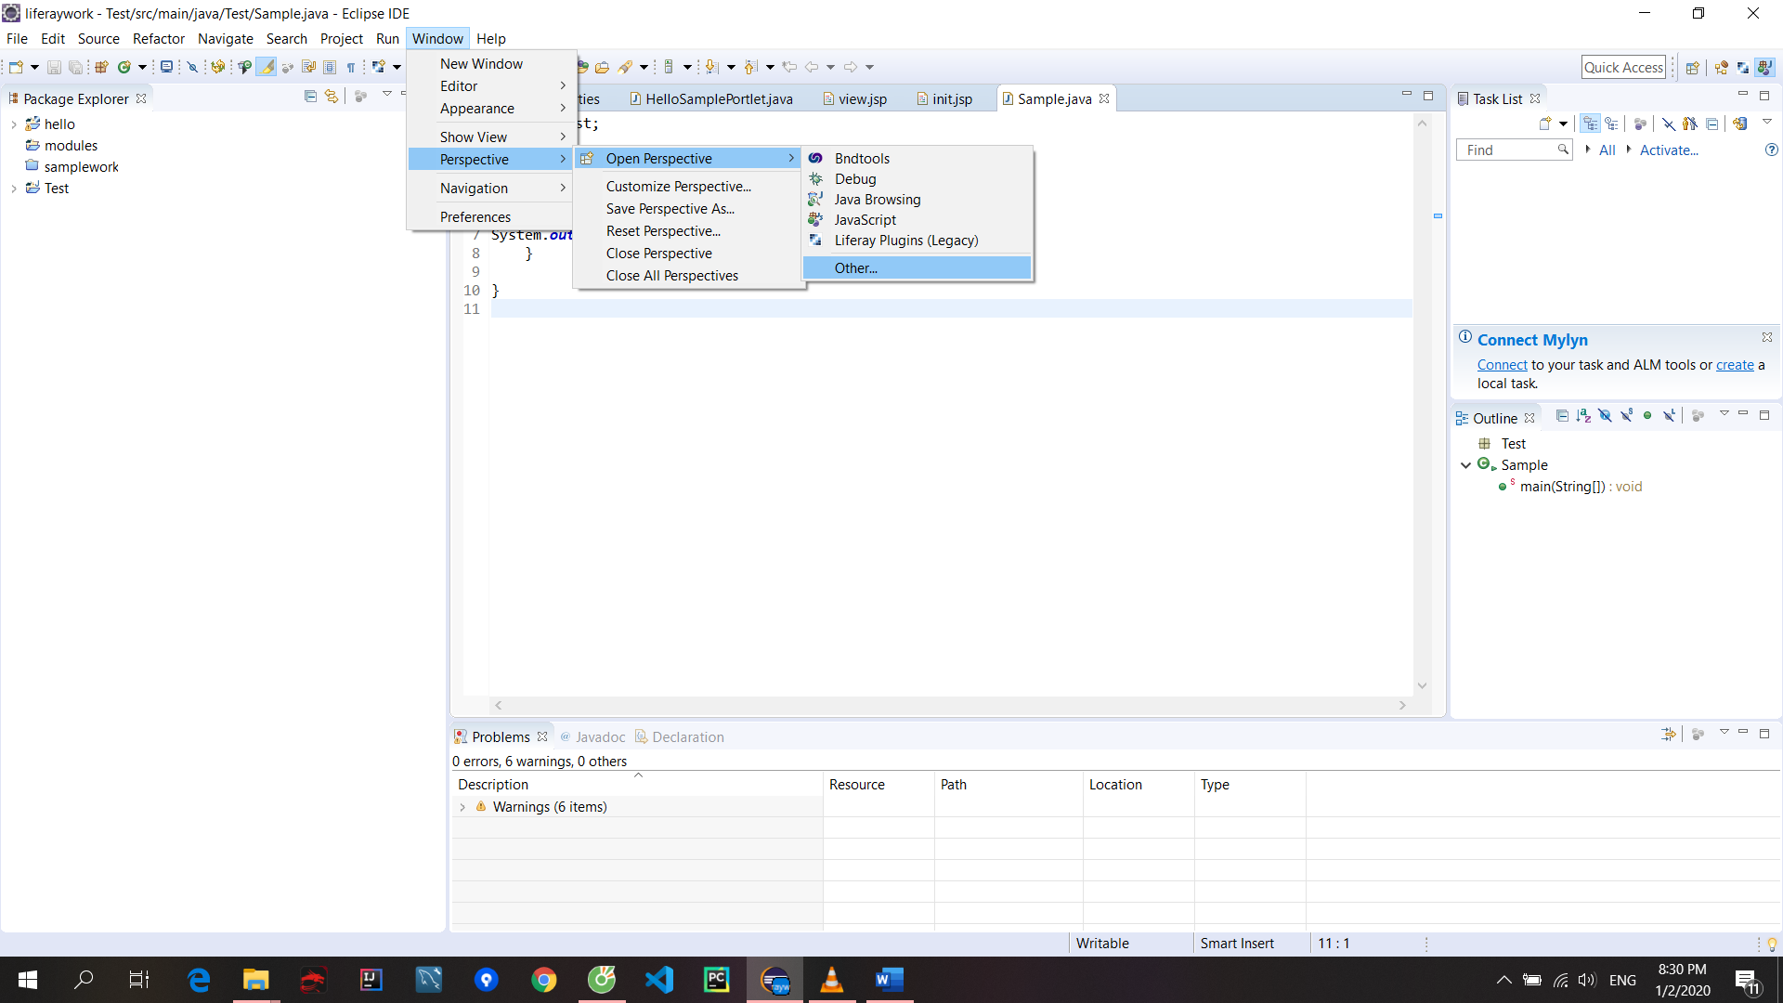

## Run and Debug

### ****Debug in eclipse****

F6: step

F8: run to breakpoint

Change value of variable

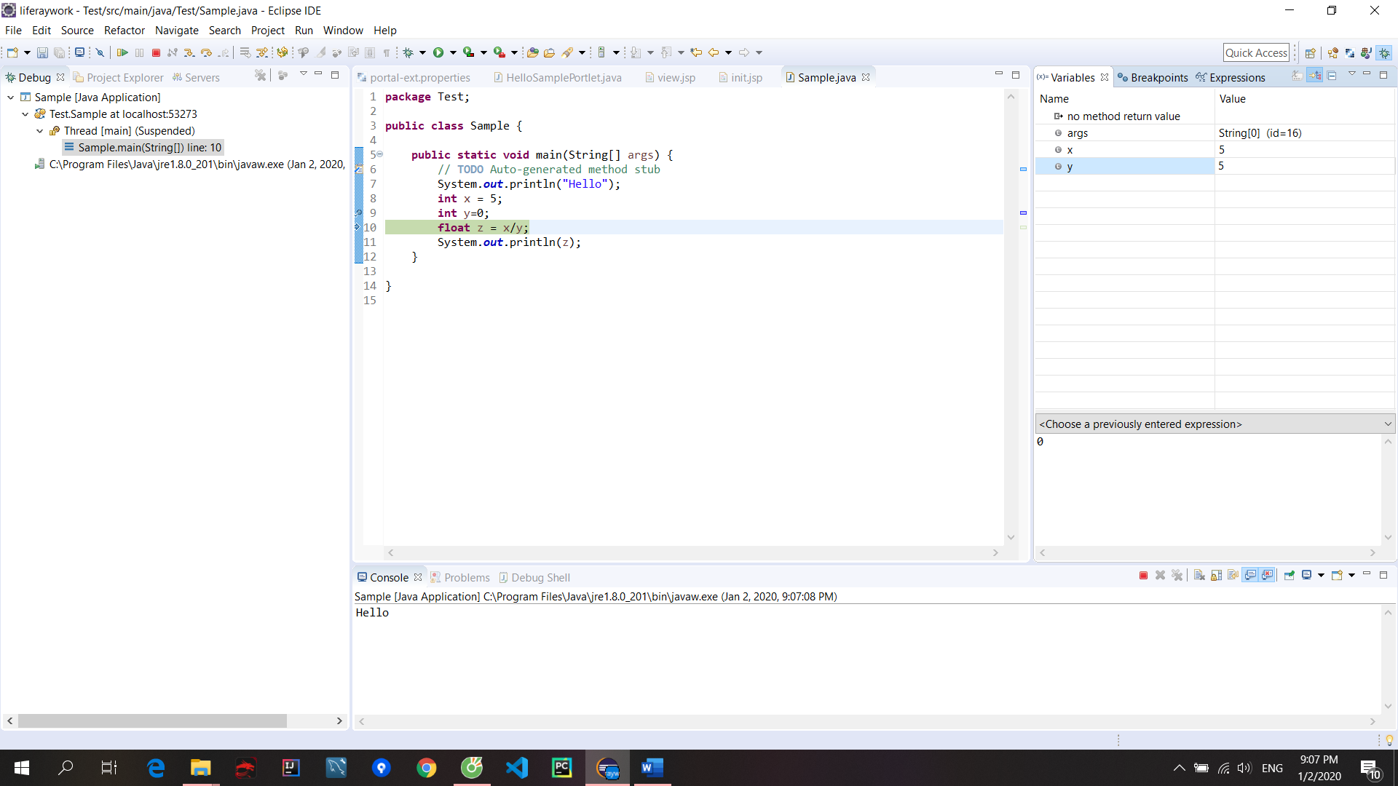

Nếu chạy nhiều class có thể xóa debug bằng cách:

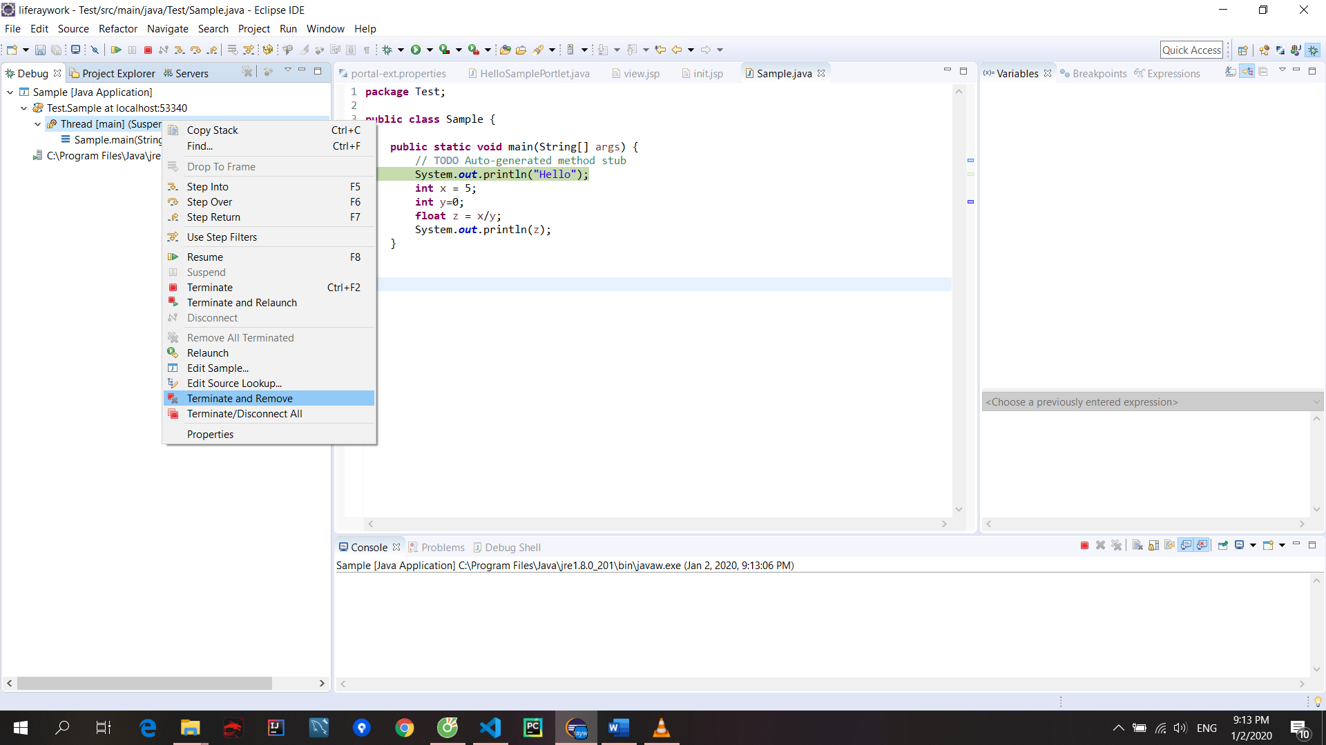

Có nút skip all breakpoint and resume để tiếp tục

### ****Edit step filter in eclipse****

Right click on debug tab/ Step filter

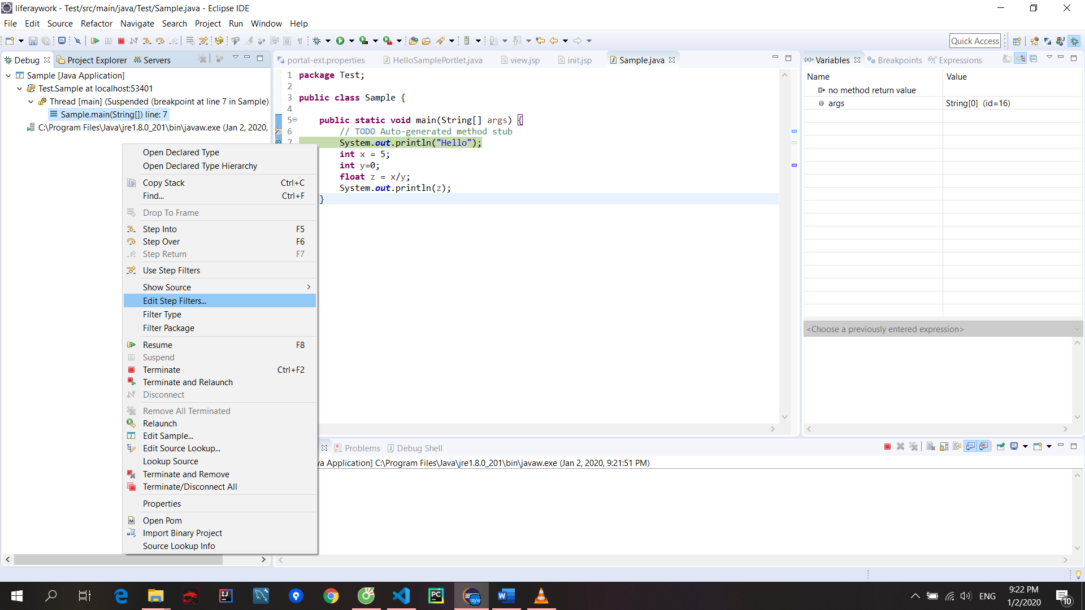

Click vào button này để khi click đúp thì highlight sẽ được hiển thị

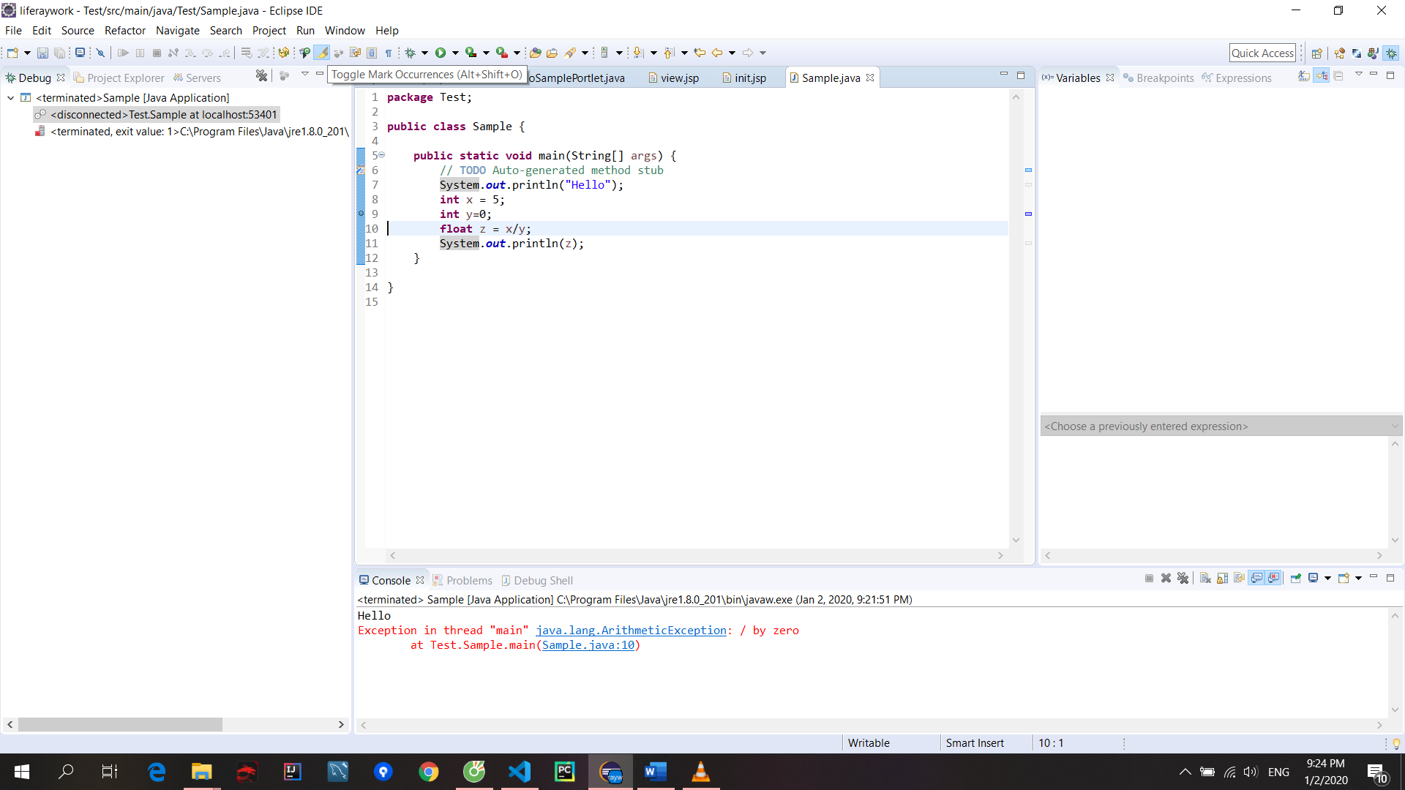

Button show space, select block

Watch variable

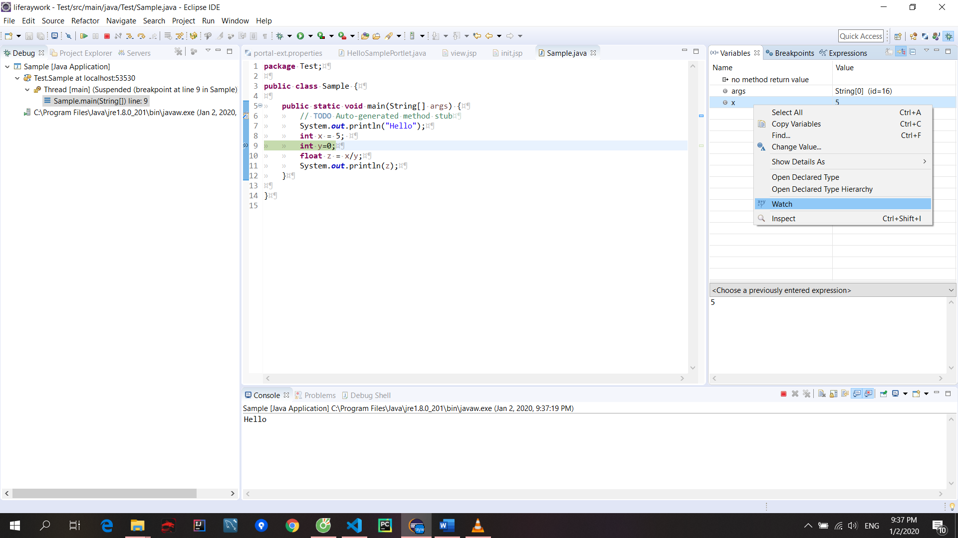

Có thể remove expression nào mà mình không muốn xem

## Git

### ****Add git****

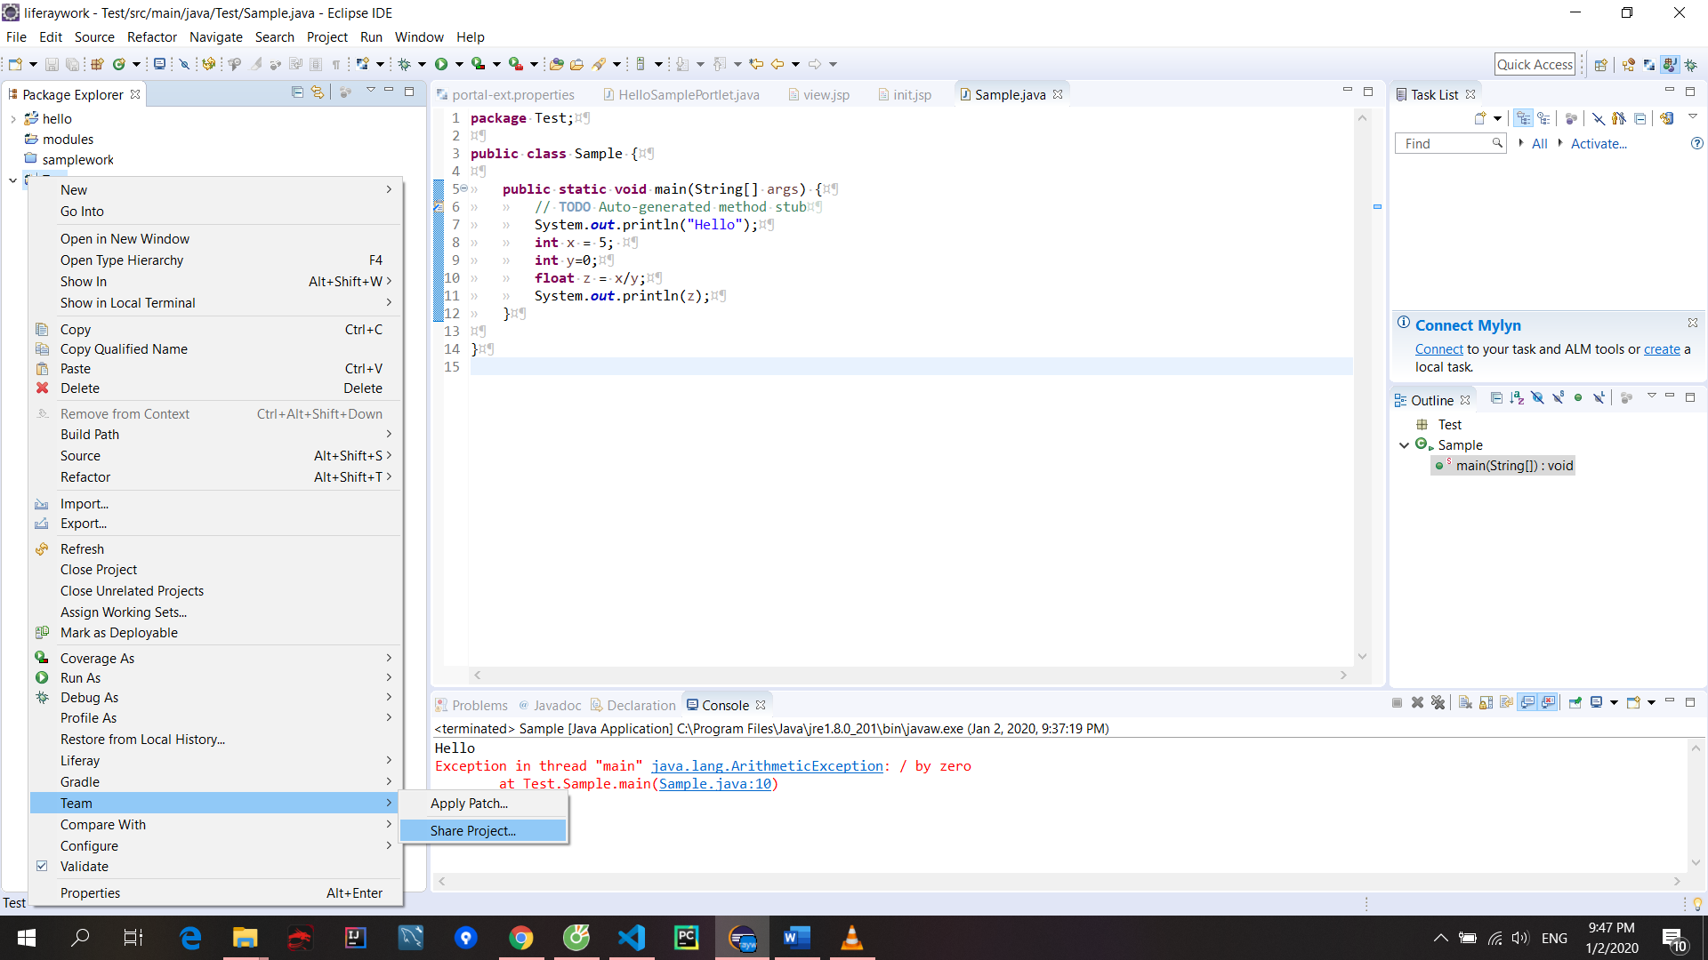

Create

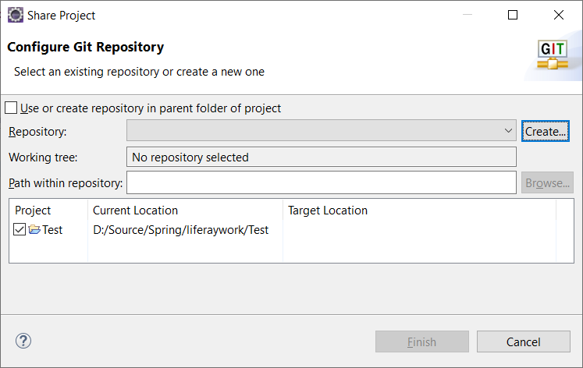

Commit:

Right click/ Team/ Commit/ hiển thị git staging (có thể xem ở show view lên)

Import

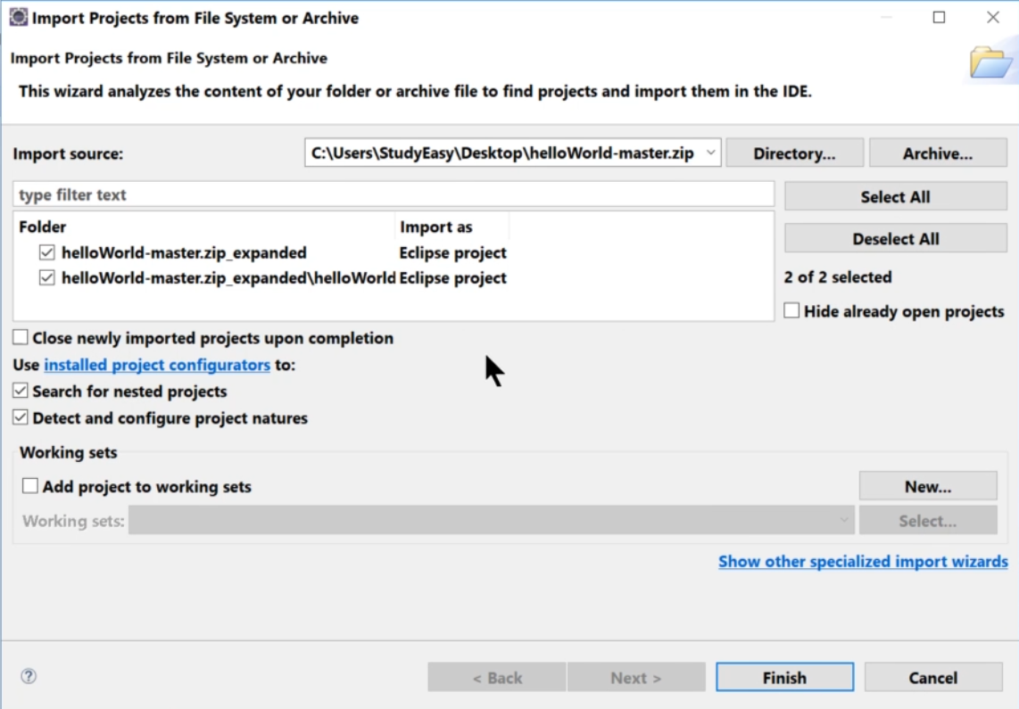

Bỏ tick dòng đầu và nhớ chọn ARCHIVE đối với file .zip

Clone GIT project directly from eclipse

Show view/ Git repository

Copy URL ở thanh địa chỉ, nếu là public thì không cần nhập username and pass

Sau đó nhập tên thư mục và ấn FINISH

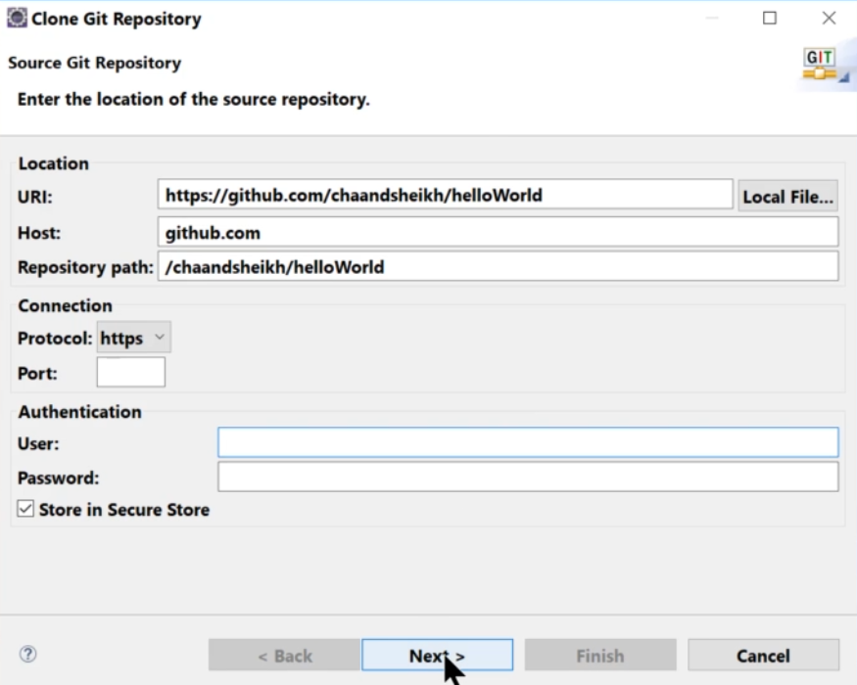

RC vào tree and import

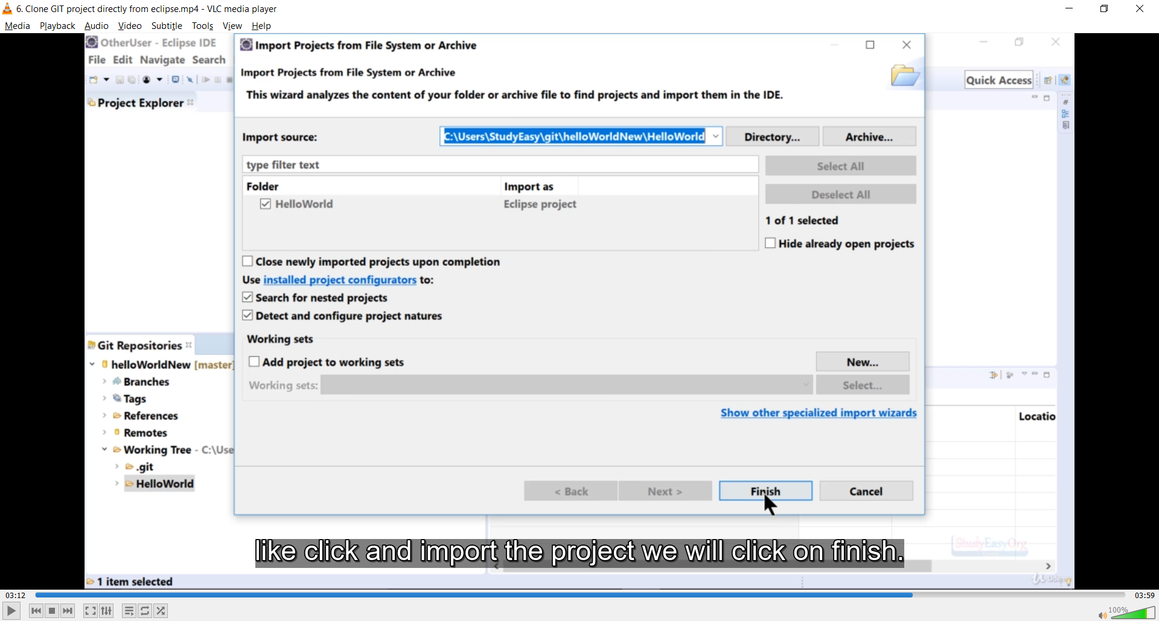

## 8. Setting Up Your Development Environment

**Install apache:** <https://tomcat.apache.org/>

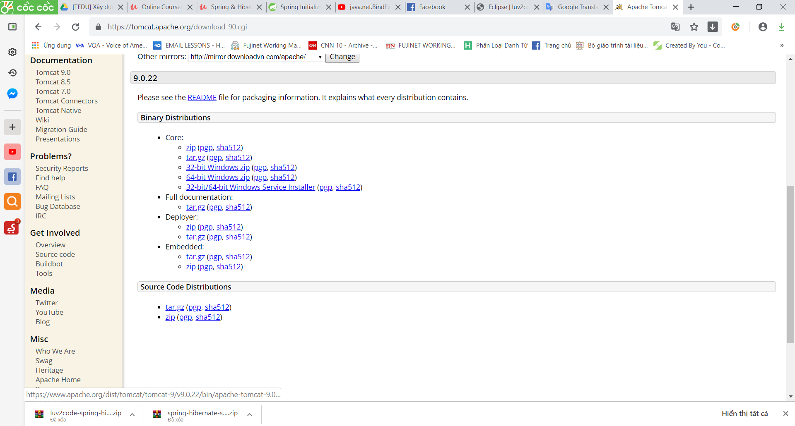

Chọn version **Tomcat9/ Chọn 32-bit/64-bit Windows Service Installer**

Sau đó cài đặt Apache :

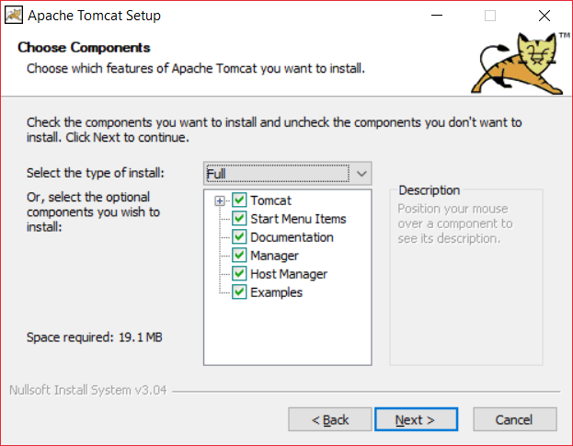

**Lưu ý :** phải chọn full, và nhập tên và pass cho admin

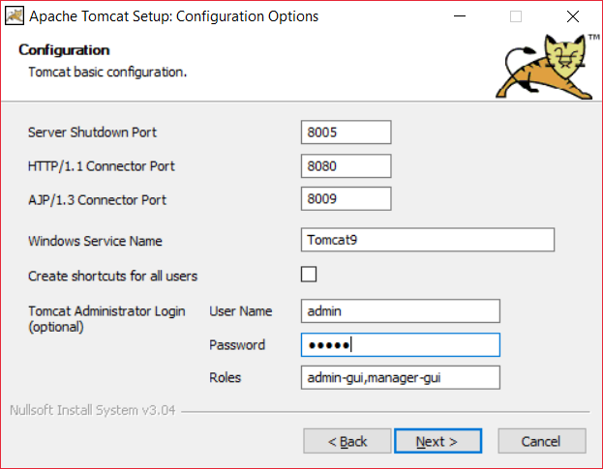

Bỏ chọn Show Readme và click Finish

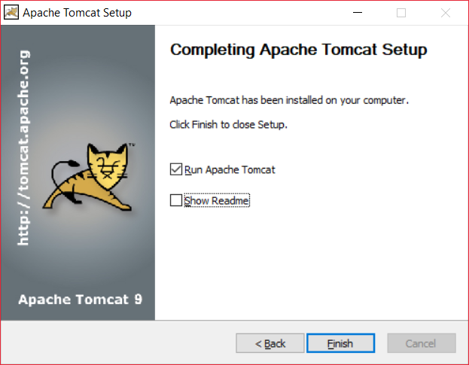

Verify install bằng cách vào link: <http://localhost:8080/>

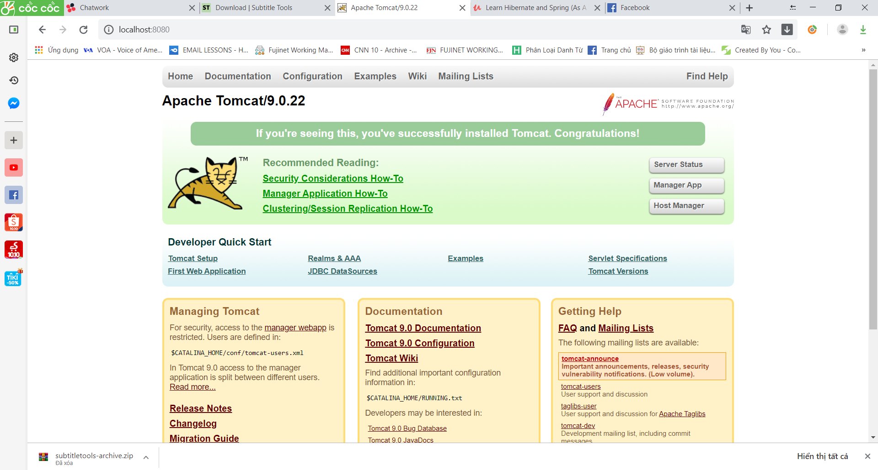

Như vậy bạn đã cài đặt thành công!

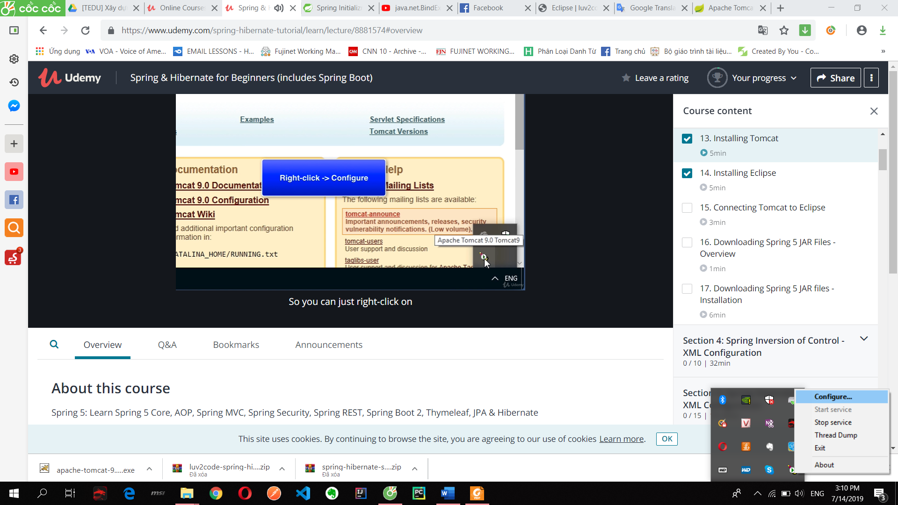

Vào windows gõ service:

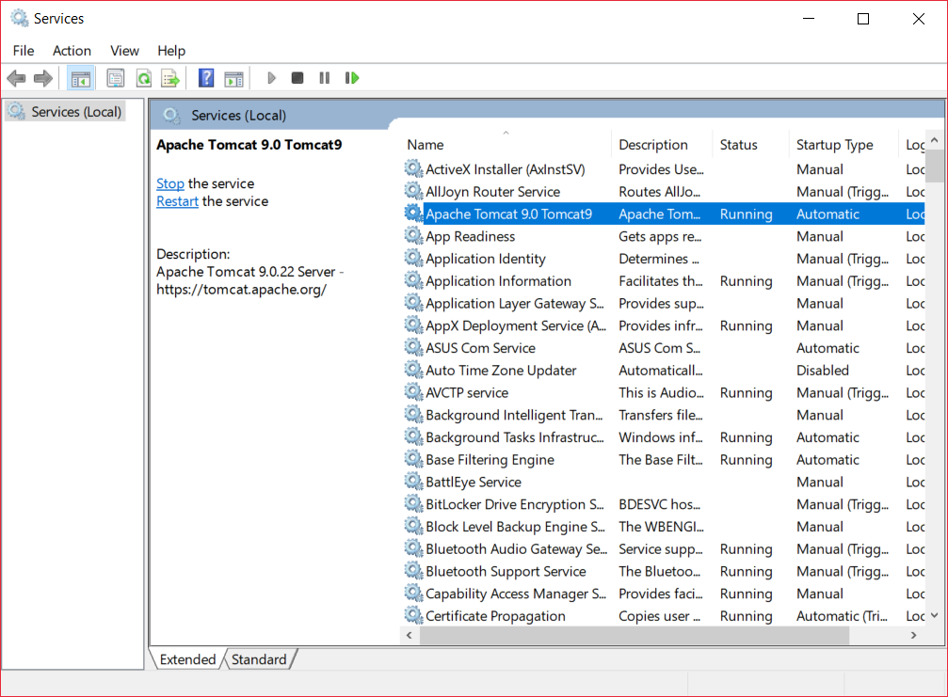

Setting port:

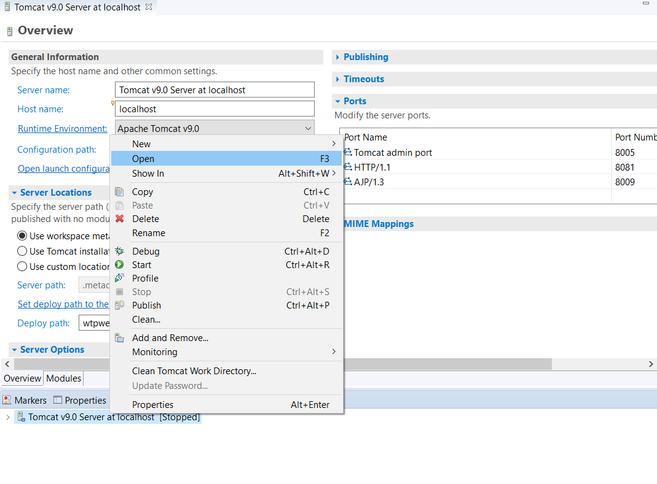

**Install eclipse:** chọn download packages => eclipse for

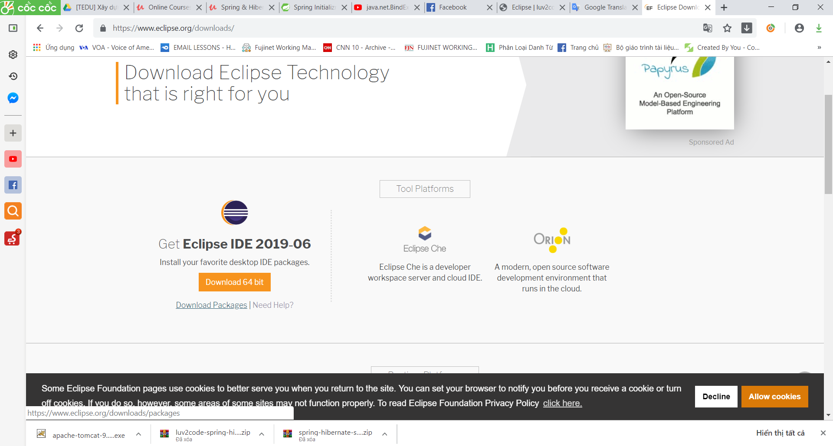

Try the Eclipse **Installer**2019‑06 R

The easiest way to install and update your Eclipse Development Environment.

Connecting Tomcat to Eclipse

**Connect apache to eclipse**

Vào tab server của eclipse/ chọn click link to add new server/ chọn Apache/ Tomcat 09/ rồi chọn đường link ở trong ổ C hoặc có thể vào Preference/ server rồi add

**C:\Program Files\Apache Software Foundation\Tomcat 9.0**

## Config servlet jsp project

Step 1: Config

File new dynamic project/ new file servlet file

<https://o7planning.org/en/10169/java-servlet-tutorial>

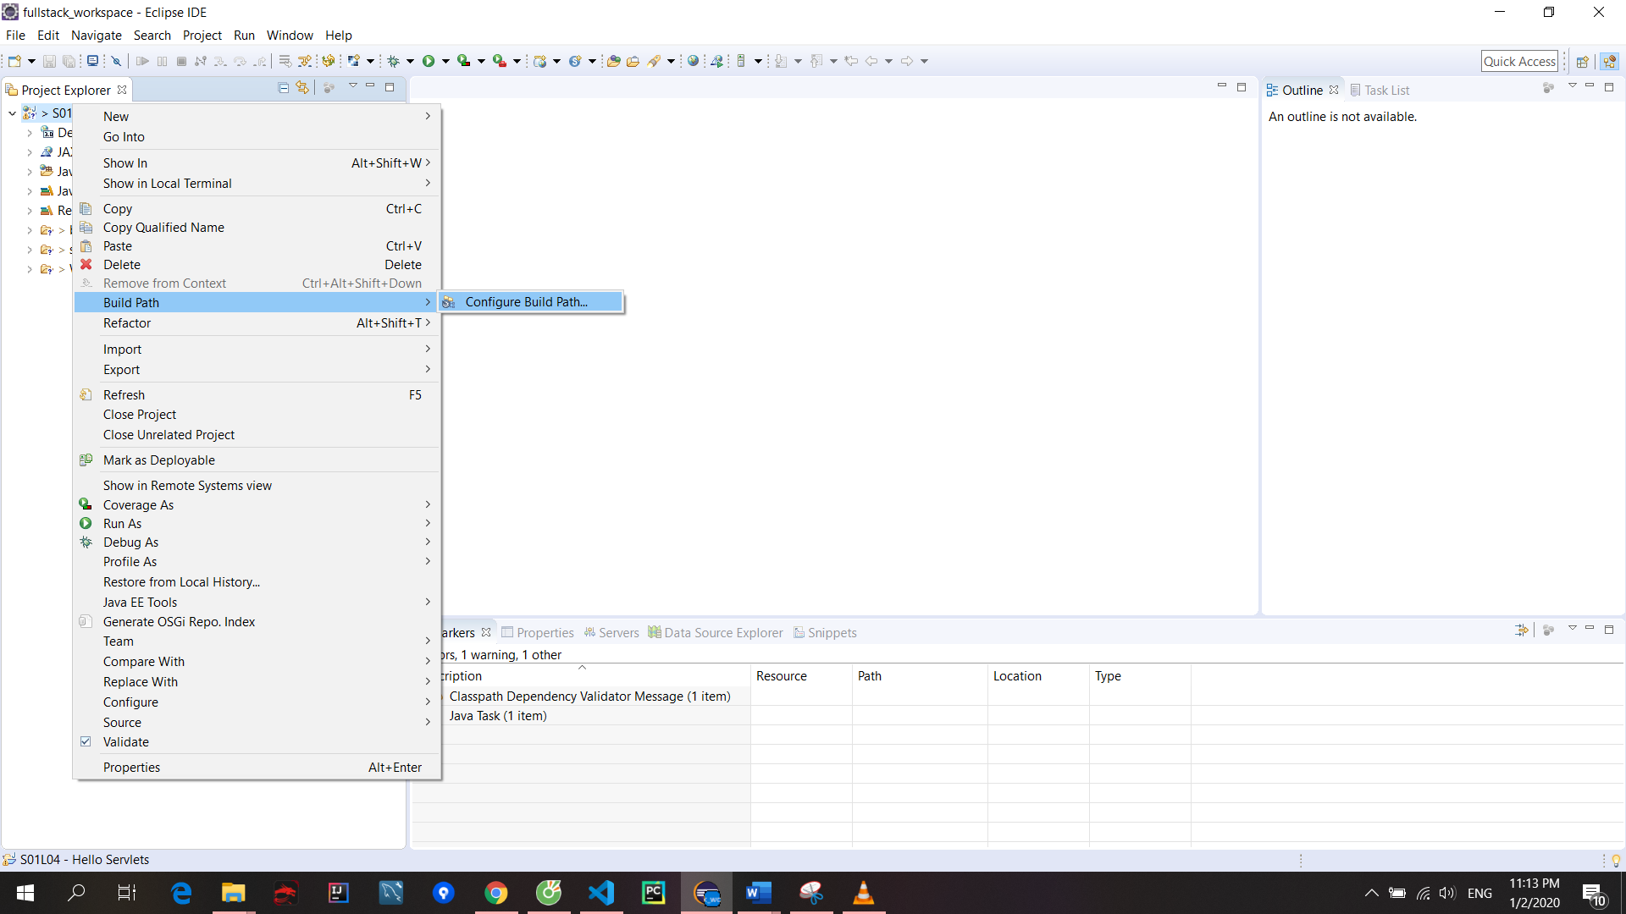

Config build path/ Add external jar/ Vào link **C:\Program Files\Apache Software Foundation\Tomcat 9.0\lib** chọn **servlet-api.jar** là project sẽ hết lỗi khi import

HelloWorld la servlet name

Hello\_Servlets la ten project

<https://www.javatpoint.com/life-cycle-of-a-servlet>

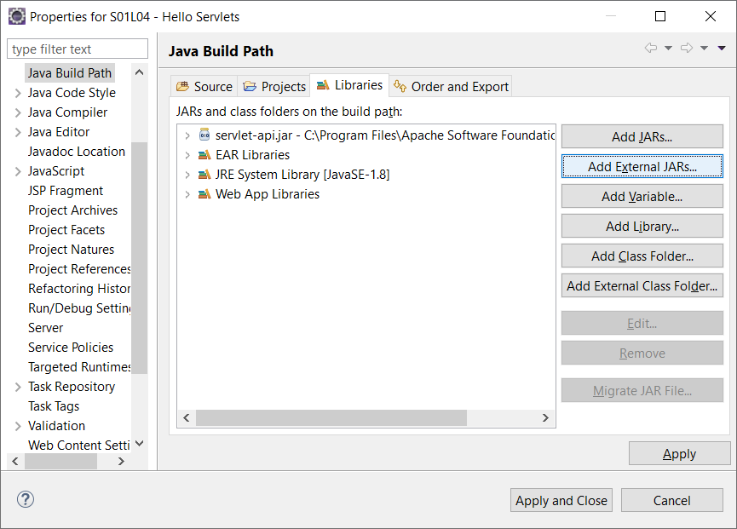

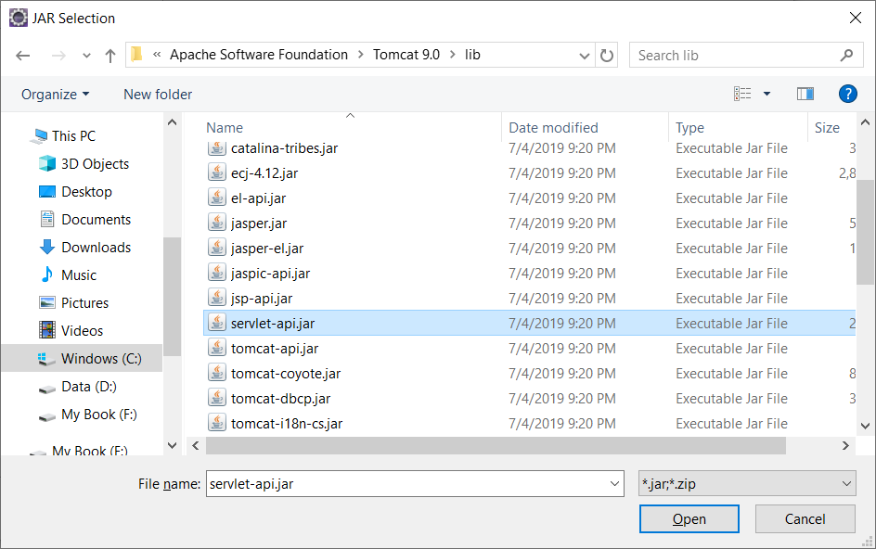

Lỗi:

t's just a simple project that show HelloWorld but for some reason I keep getting 404 error. Detail:

[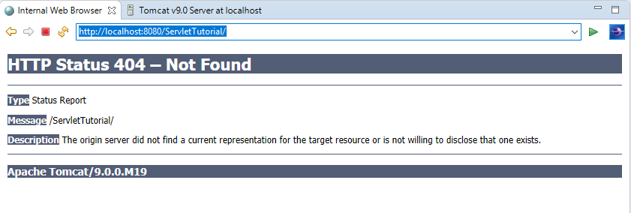](https://i.stack.imgur.com/ASMwv.png) However the Tomcat welcome page showing properly.

[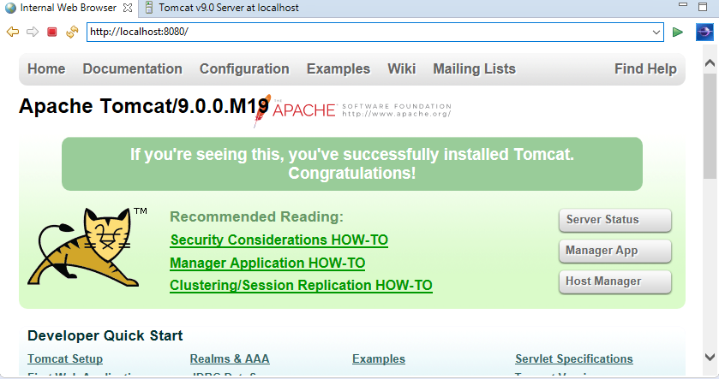](https://i.stack.imgur.com/ybGTj.png)

Here solutions that I've tried so far (and they are NOT working):

Right-click project -> properties -> Project Facets -> Runtimes -> checked "Apache Tomcat v9.0" -> Apply -> finish.

Server tab -> Right-click "Tomcat v9.0..." -> properties -> switch location -> Choose "Use tomcat installation" on "Server locations" panel.

Sau khi tạo chạy đường link <http://localhost:8080/Test/Demo> hay <http://localhost:8080/Test/index.html> để confim app chạy ok

Nếu có file web.xml

I've not added the **index.html**. Which is point out in the **web.xml**

[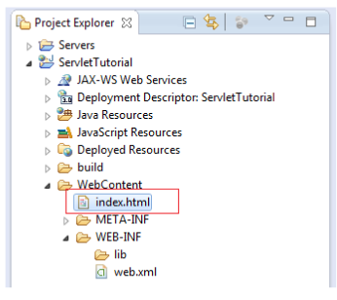](https://i.stack.imgur.com/8OoEx.png)

**Note:** a project may have more than one **web.xml** file.

if there are another **web.xml** in

src/main/webapp/WEB-INF

Then you might need to add another index (this time **index.jsp**) to

src/main/webapp/WEB-INF/pages/

Step 2: Failed to start component error

Xóa server rồi create new lại sẽ hết lỗi

Step 3: Modify url

Right click/ Properties/ Web project settings

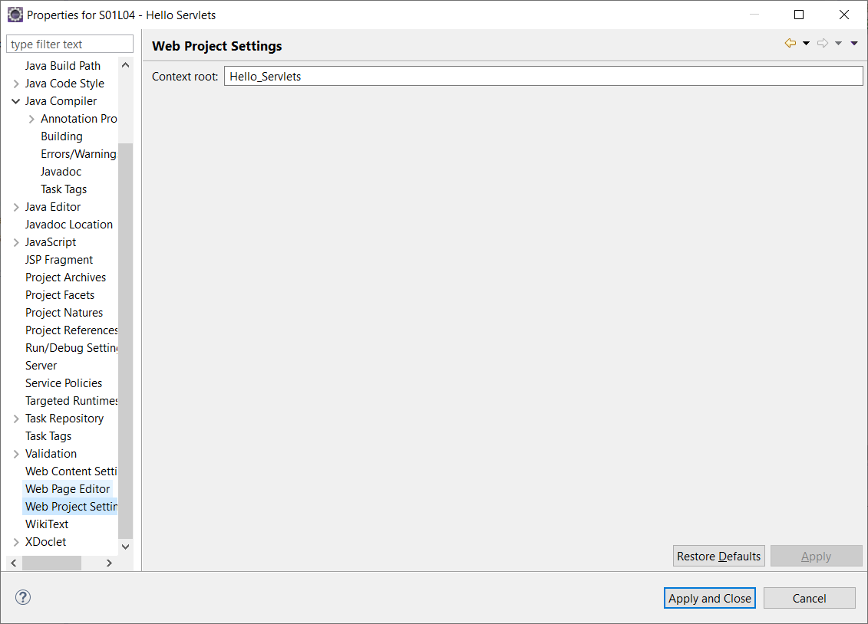

Step 4: Modify url when create project

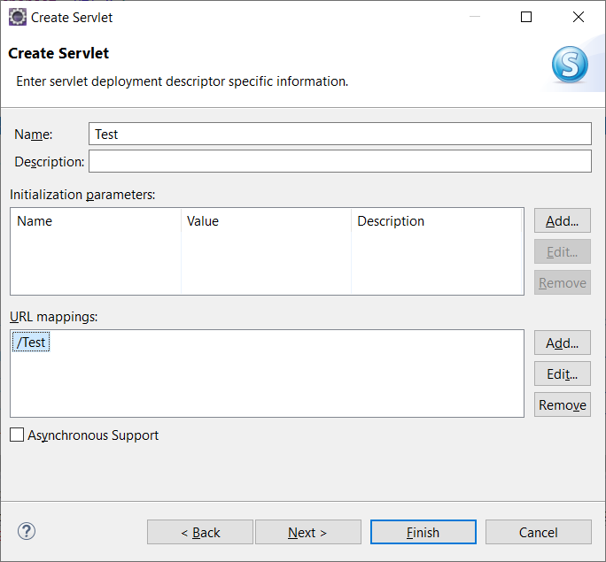

Chỉnh sửa URL khi create servlet class

add param by eclipse

Chỉnh sửa như trên

JSP expressions element

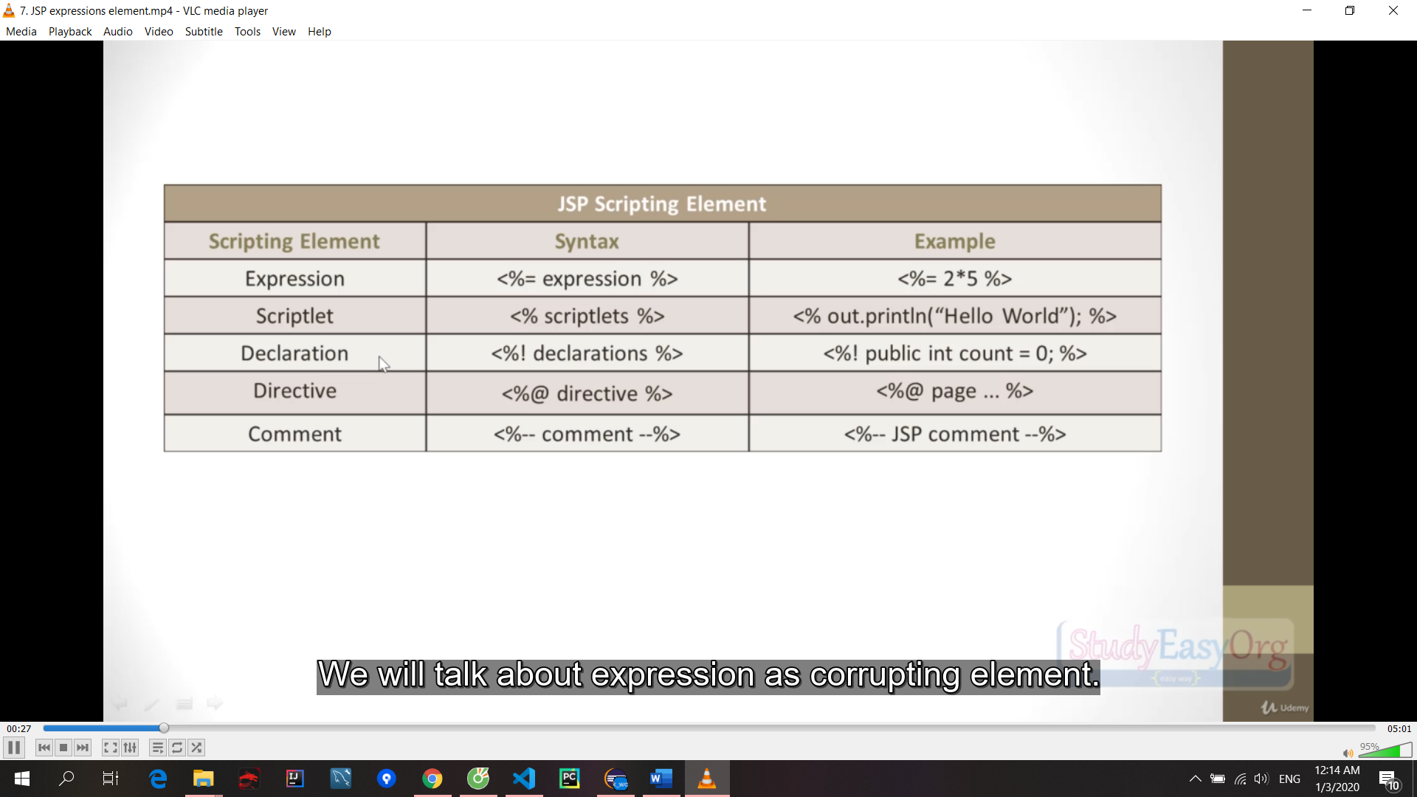

Nếu sử dụng annotation @WebServlet("/HelloWorld") thì Không cần sử dụng file web.xml

Base URL sẽ chứa cả /HelloWorld

S01L12 - Deloyment Descriptor

If you don't use annotation

<?xml version="1.0" encoding="UTF-8"?>

<web-app xmlns:xsi="http://www.w3.org/2001/XMLSchema-instance" xmlns="http://java.sun.com/xml/ns/javaee" xsi:schemaLocation="http://java.sun.com/xml/ns/javaee http://java.sun.com/xml/ns/javaee/web-app\_2\_5.xsd" id="WebApp\_ID" version="2.5">

<display-name>S01L12 - Deloyment Descriptor</display-name>

<welcome-file-list>

<welcome-file>index.html</welcome-file>

<welcome-file>index.htm</welcome-file>

<welcome-file>index.jsp</welcome-file>

<welcome-file>default.html</welcome-file>

<welcome-file>default.htm</welcome-file>

<welcome-file>default.jsp</welcome-file>

</welcome-file-list>

<servlet>

<description></description>

<display-name>Demo</display-name>

<servlet-name>Demo</servlet-name>

<servlet-class>org.studyeasy.servlet.Demo</servlet-class>

</servlet>

<servlet-mapping>

<servlet-name>Demo</servlet-name>

<url-pattern>/TESTING</url-pattern>

</servlet-mapping>

</web-app>

## Session under JSP overview

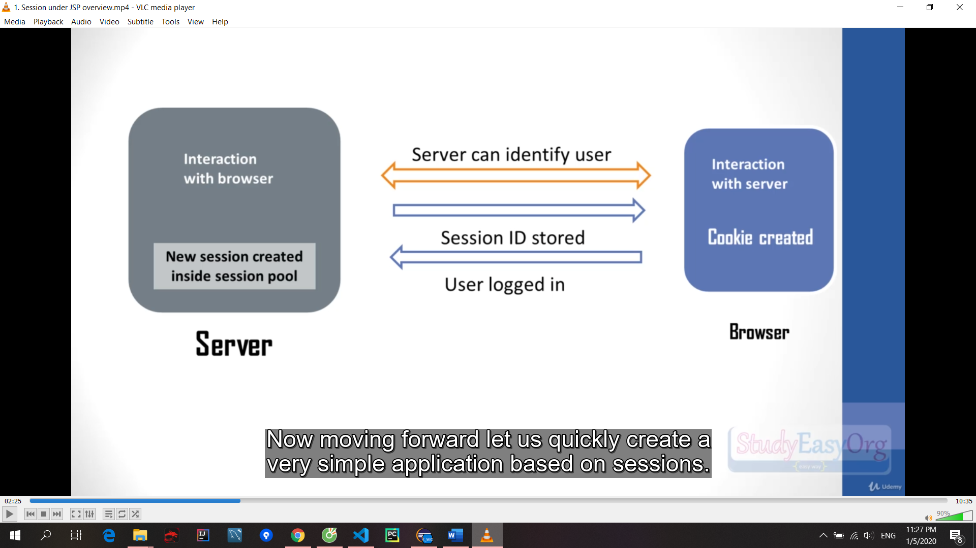

**protected** **void** doPost(HttpServletRequest request, HttpServletResponse response)

**throws** ServletException, IOException {

String username = request.getParameter("username");

String password = request.getParameter("password");

**if**(username.equals("studyeasy") && password.equals("Love")) {

//Invalidating session if any: destroy any session

request.getSession().invalidate();

HttpSession newSession = request.getSession(**true**); // create new session

newSession.setMaxInactiveInterval(300); // second

response.sendRedirect("memberArea.jsp");

}**else** {

response.sendRedirect("login.jsp");

}

}

Cookie

Maintain session and state of user in browser

Cookie is a small chunk of memory in the browser for a specific website

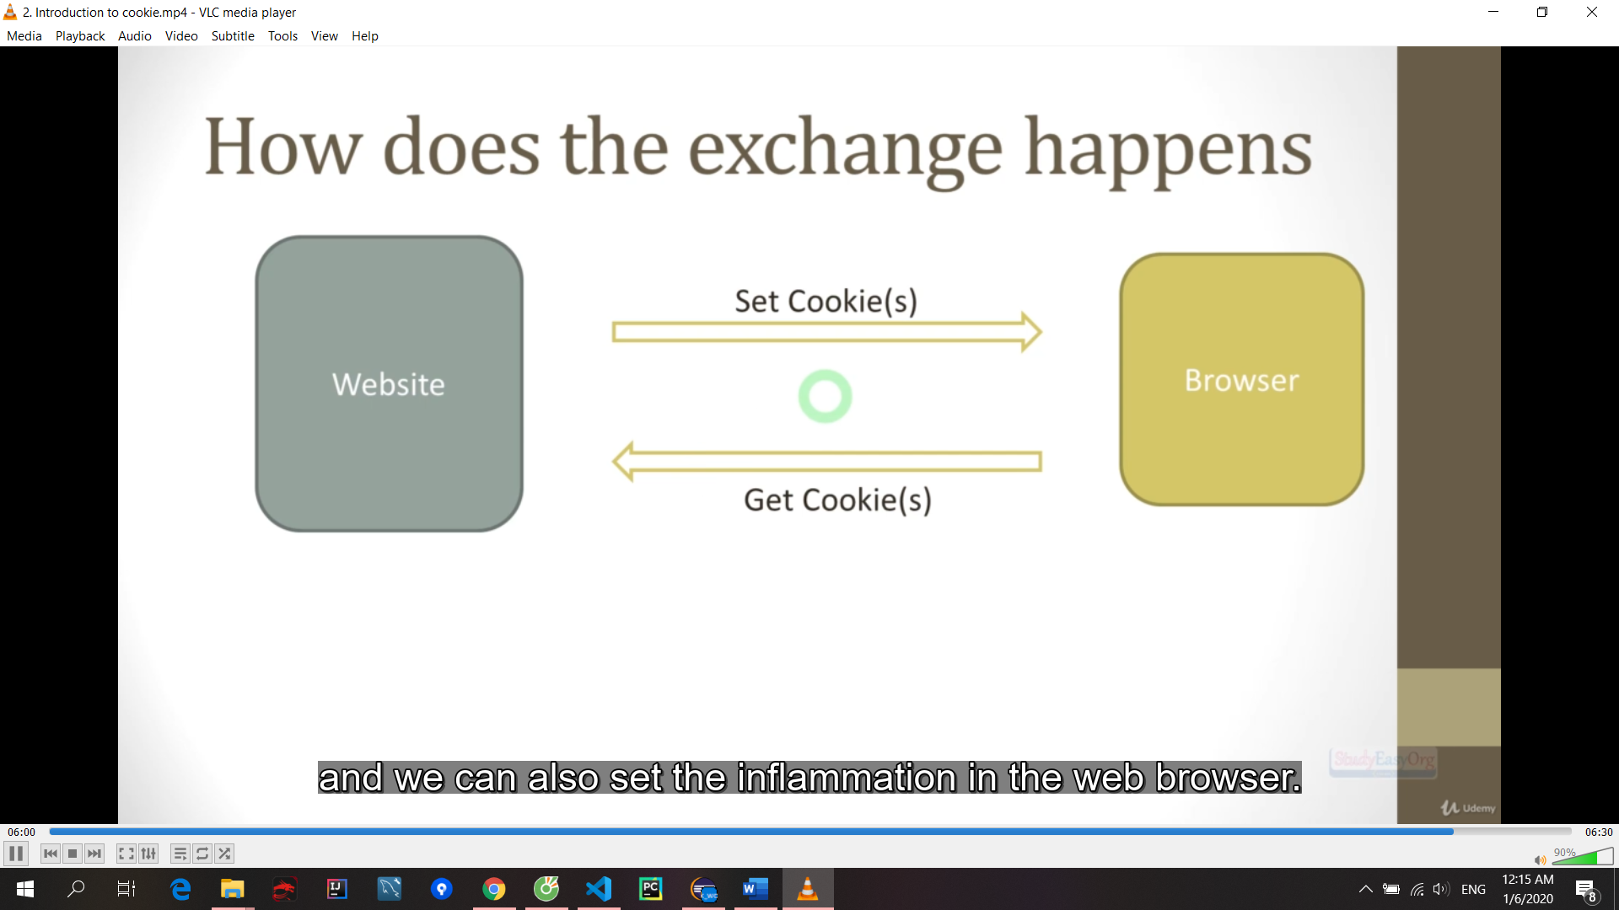

Cookie cUsername = **new** Cookie("username", username);

response.addCookie(cUsername);

jstl set up

https://docs.oracle.com/javaee/5/jstl/1.1/docs/tlddocs/

<https://studyeasy.org/general/implicit-objects/>

https://studyeasy.org/jstl/jstl-taglibs/

```ts

Core Tags

<%@ taglib prefix = "c" uri = "http://java.sun.com/jsp/jstl/core" %>

<%@ taglib prefix = "c" uri = "http://java.sun.com/jsp/jstl/core" %>

Formatting Tags

<%@ taglib prefix = "fmt" uri = "http://java.sun.com/jsp/jstl/fmt" %>

<%@ taglib prefix = "fmt" uri = "http://java.sun.com/jsp/jstl/fmt" %>

SQL Tags

<%@ taglib prefix = "sql" uri = "http://java.sun.com/jsp/jstl/sql" %>

<%@ taglib prefix = "sql" uri = "http://java.sun.com/jsp/jstl/sql" %>

XML tags

<%@ taglib prefix = "x" uri = "http://java.sun.com/jsp/jstl/xml" %>

<%@ taglib prefix = "x" uri = "http://java.sun.com/jsp/jstl/xml" %>

JSTL Functions

<%@ taglib prefix = "fn" uri = "http://java.sun.com/jsp/jstl/functions" %>

<%@ taglib prefix = "fn" uri = "http://java.sun.com/jsp/jstl/functions" %>

```

## Connect db mysql

<https://dev.mysql.com/downloads/windows/installer/8.0.html>

mysql community server/ Go to my download page/ chọn cái mấy tram MB

Download mysql connector jar

<https://dev.mysql.com/downloads/connector/j/>

Choose platform independent

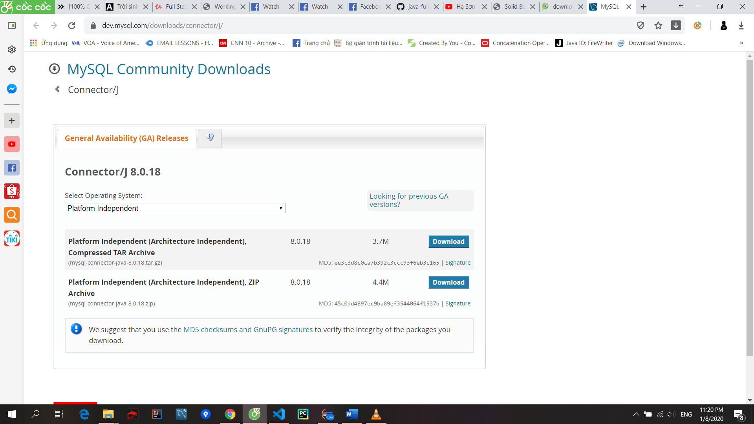

Sau khi down về copy vào thư mục lib của tomcat trong ổ C và config build path cho project và add external jar vào

<https://studyeasy.org/?s=JNDI>

Create file context.xml trong folder META-INF

<Context>

<Resource name="jdbc/project"

auth="Container" type="javax.sql.DataSource"

maxActive="25" maxIdle="5" maxWait="10000"

username="chaand" password="admin"

driverClassName="com.mysql.jdbc.Driver"

url="jdbc:mysql://127.0.0.1:3306/project?useSSL=false"/>

</Context>

* jdbc/project: Connection name
* Container: Authentication type
* javax.sql.DataSource: Connection type
* maxActive: Maximum active connection allowed
* maxIdle: Maximum inactive connection allowed in the pool
* username: Database username
* password: Database password
* driverClassName: Class name of the MySQL driver
* url: URL of the database

copy

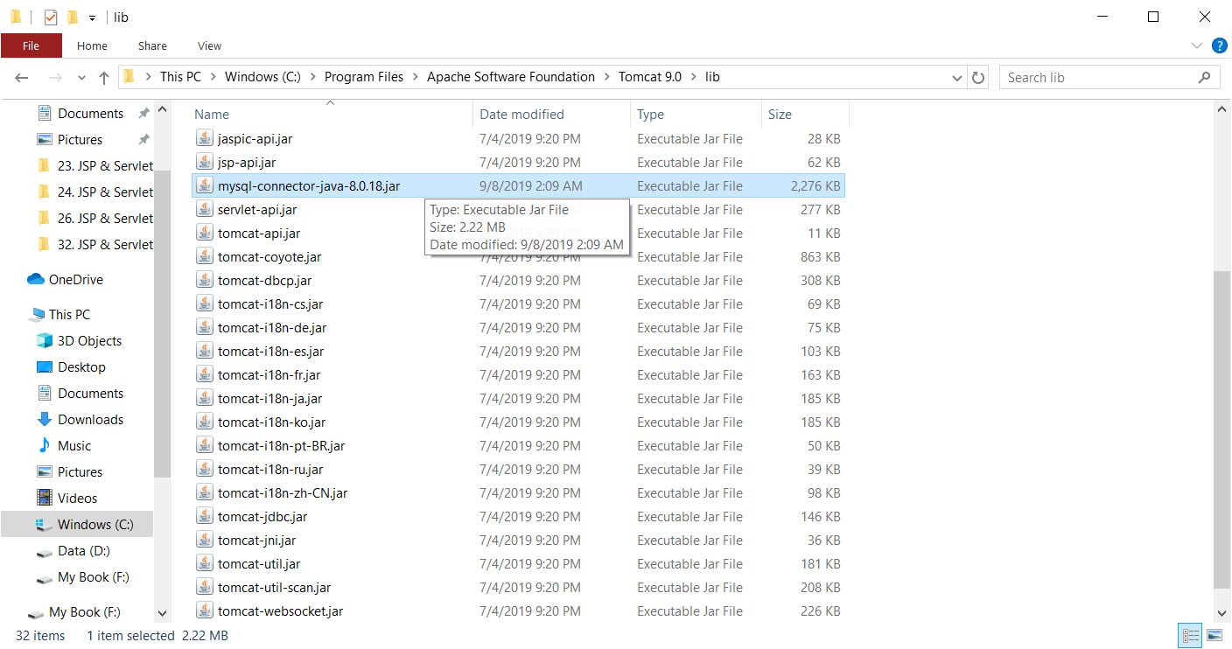

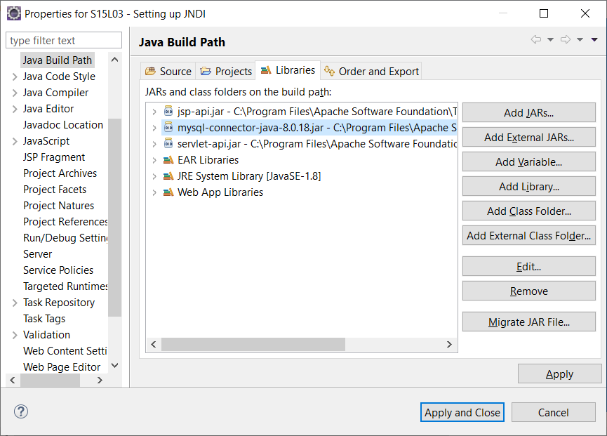

Copy name: com.mysql.cj.jdbc.Driver.class thay vào

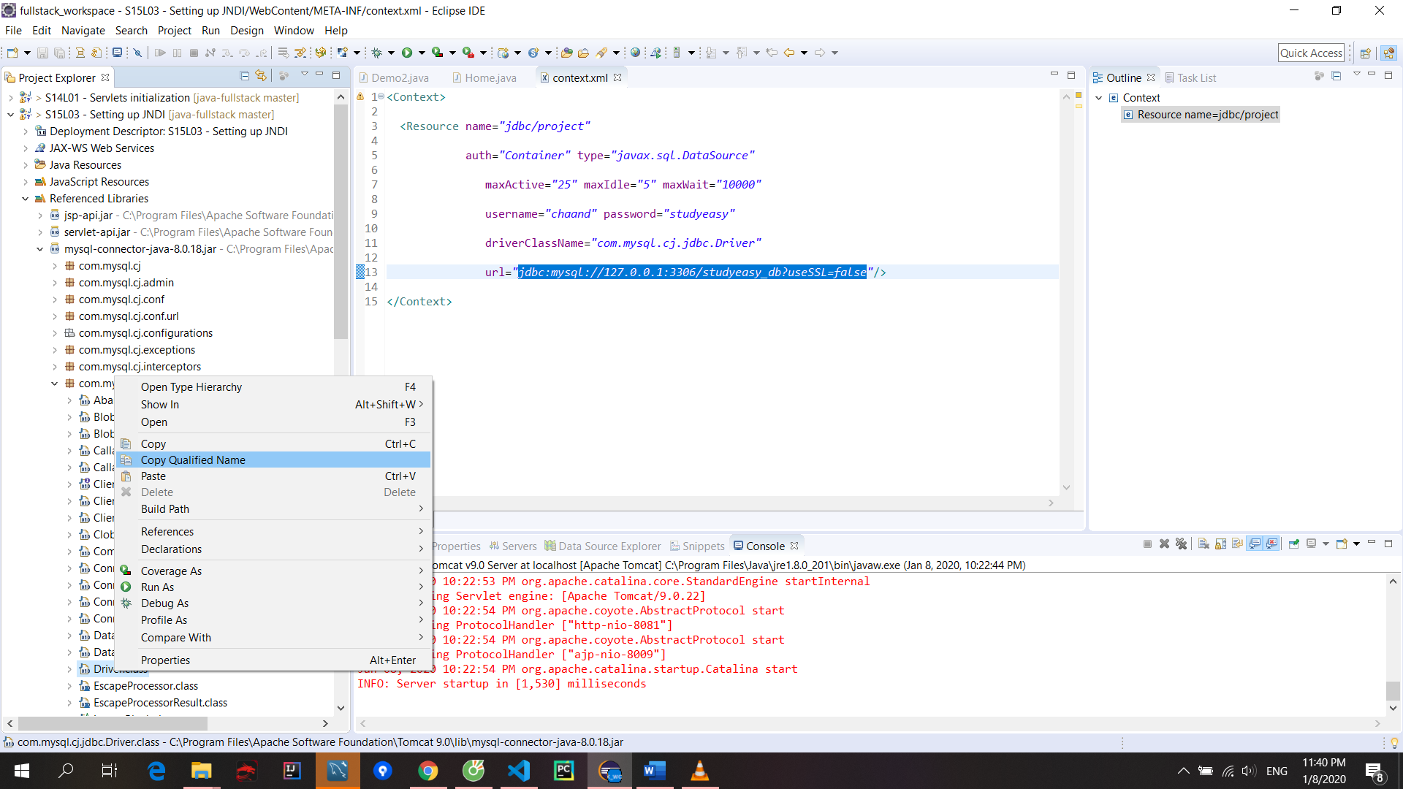

## hibernate

ORM

Hibernate ORM is an object-relational-mapping tool for java

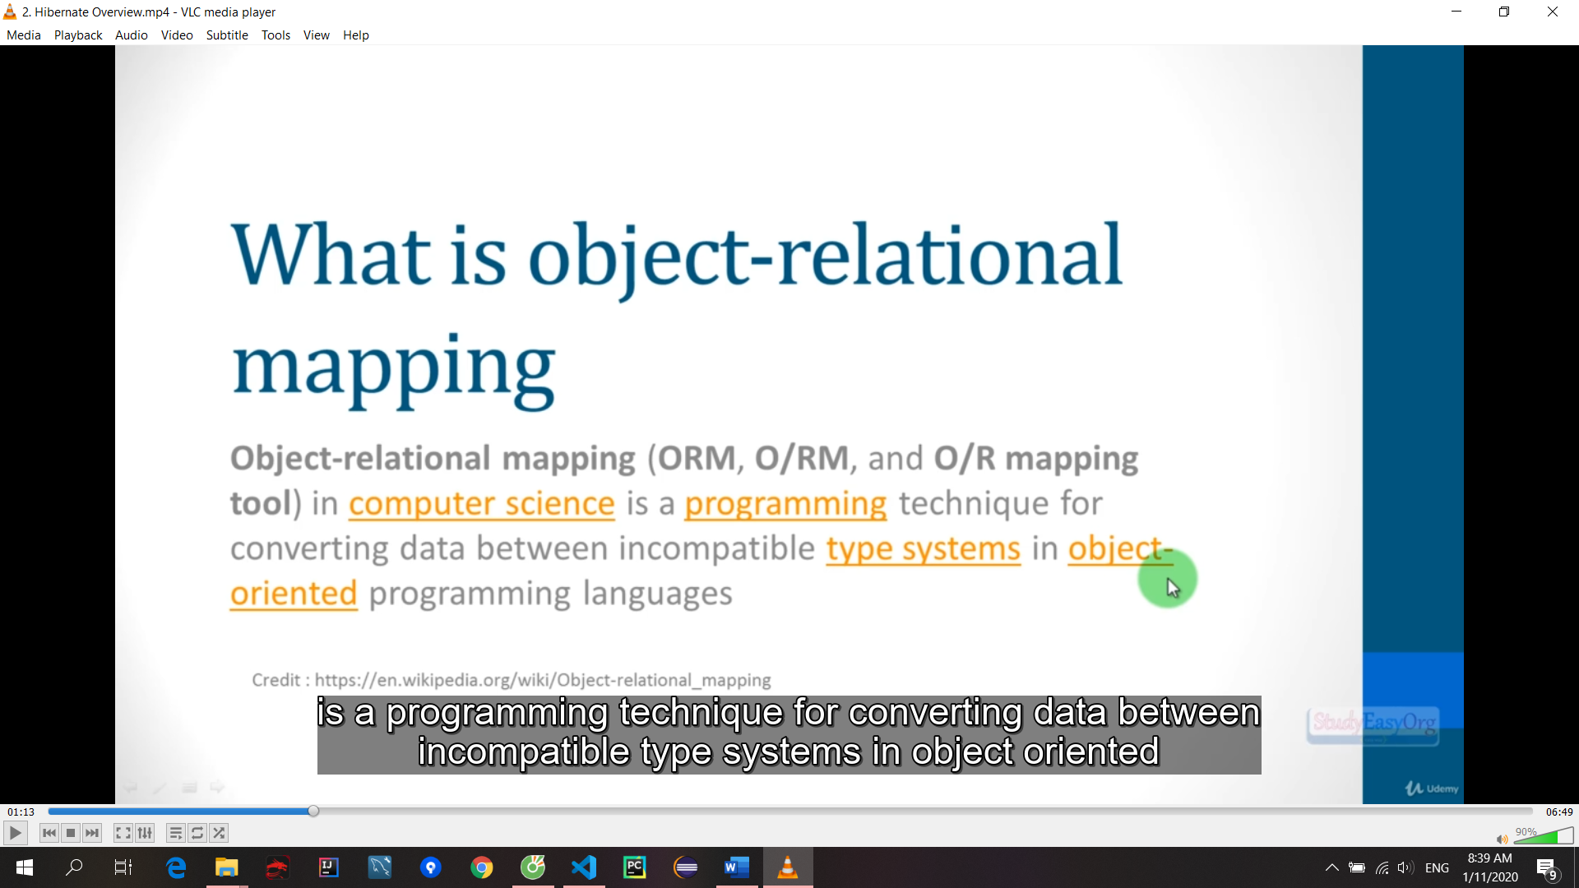

Bebefit

Hibernate is database independent

Handle level SQL for you

Minimize jdbc related code in your app

Setting

Download hibernate ORM: <http://hibernate.org/orm/>

Download mysql connector jar

<https://dev.mysql.com/downloads/connector/j/>

Copy tất cả lib paste vào thư mục lib của project mới tạo ra:

hibernate-release-5.4.6.Final\lib\required

Copy connector jdbc vào lib và sau đó vào build path/ Add jar

<https://studyeasy.org/spring/>

Session factory and session

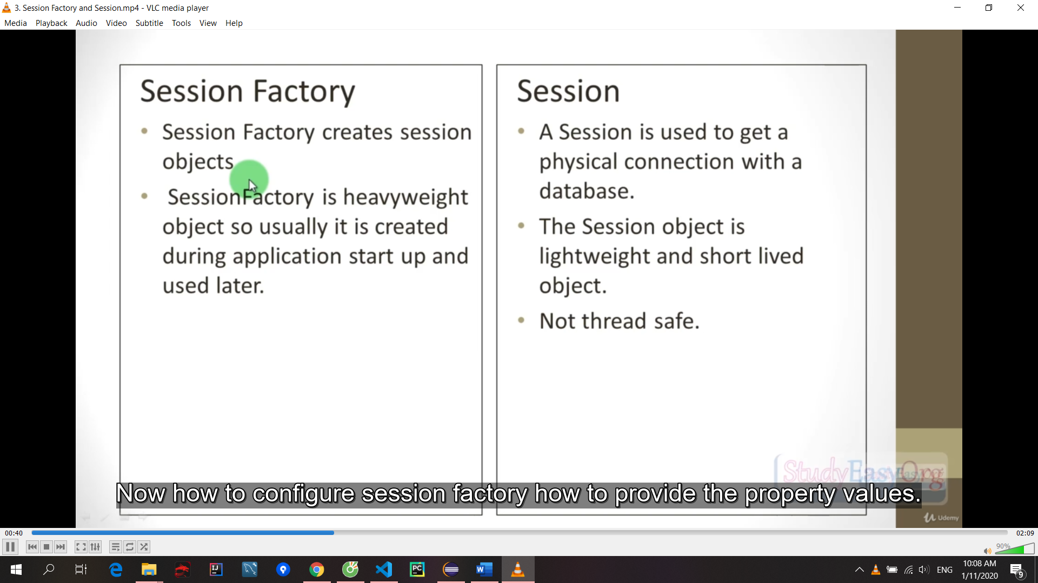

Chưa commit 43

## Spring

Step 1: config IDE

Tải tomcat

<http://studyeasy.org/tomcat8> - <https://archive.apache.org/dist/tomcat/tomcat-8/>

Step 2: Install spring ide

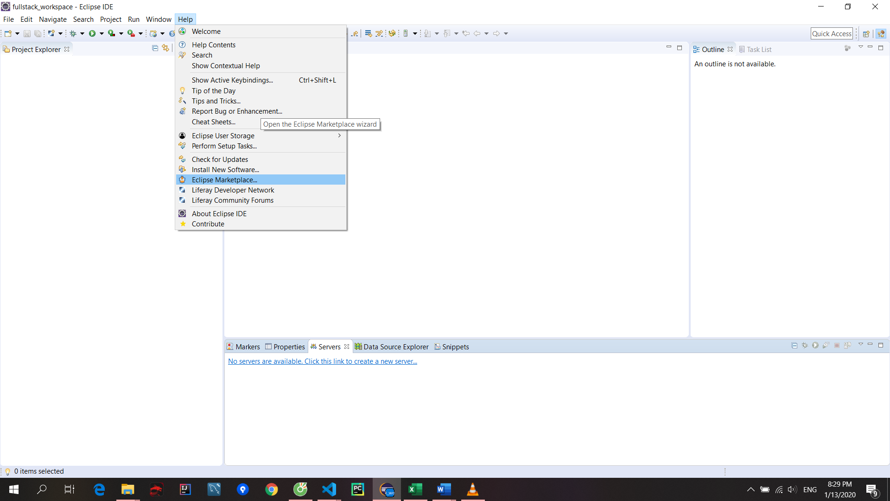

Step 3: Download Spring

File new Dynamic web project

Click generate web.xml file

Search: repo spring

<https://repo.spring.io/release/org/springframework/spring/>

**Thêm thủ công vào** <http://www.luv2code.com/downloadspring> =>

<http://repo.spring.io/release/org/springframework/spring/>

chọn version release ở dưới cùng rồi chọn **spring-framework-5.1.8.RELEASE-dist.zip** để tải

Tạo project java bình thường, sau đó **tạo thư mục lib** rồi copy tất các các thư viện trong lib đã tải paste vào

**Right click/ properties/ Java build path/ libraries/ classpath/** ấn add jar rồi chon đến thư mục lib trong project mà ta vừa tạo chọn hết tất cả các file

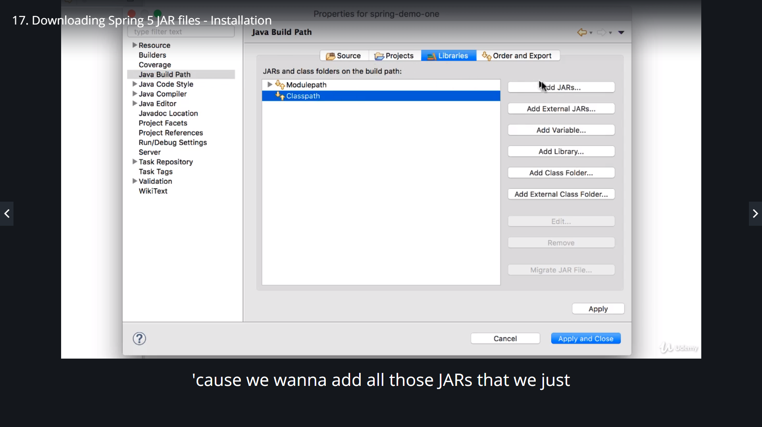

Nếu đúng sẽ xuất hiện **Referenced libraries**:

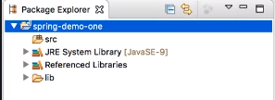

Mở **perspective**(ta project..): vào **windows/ perspective**

Search: apache commons logging

<https://commons.apache.org/proper/commons-logging/>

commons-logging-1.2-bin.zip

Sau đó copy thư mục lib vào project hiện tại(2 file jar của logging)

Vào build path add jar

Step 4: JSTL

In the following videos for Spring MVC, I provide a collection of starter files.

Download these files from the link below.

<http://www.luv2code.com/downloads/udemy-spring-hibernate/solution-code-spring-mvc-config-files.zip>

Step 5: Add logging

HEADS UP - Add Logging Messages in Spring 5.1

The Problem

In Spring 5.1, the Spring Development team changed the logging levels internally. As a result, by default you will no longer see the red logging messages at the INFO level. This is different than in the videos.

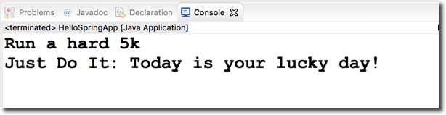

The Solution

If you would like to configure your app to show similar logging messages as in the video, you can make the following updates listed below. Note, you will not see the EXACT same messages, since the Spring team periodically changes the text of the internal logging messages. However, this should give you some additional logging data.

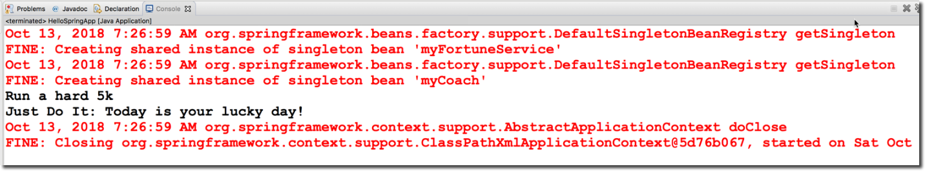

Overview of the steps

1. Create a bean to configure the parent logger and console handler

2. Configure the bean in the Spring XML config file

Detailed Steps

1. Create a bean to configure the parent logger and console handler

This class will set the parent logger level for the application context. It will also set the logging level for console handler. It sets the logger level to FINE. For more detailed logging info, you can set the logging level to level to FINEST.  You can read more about the logging levels at <http://www.vogella.com/tutorials/Logging/article.html>

This class also has an init method to handle the actual configuration. The init method is executed after the bean has been created and dependencies injected.

File: MyLoggerConfig.java

* package com.luv2code.springdemo;
* import java.util.logging.ConsoleHandler;
* import java.util.logging.Level;
* import java.util.logging.Logger;
* import java.util.logging.SimpleFormatter;
* import org.springframework.context.annotation.AnnotationConfigApplicationContext;
* public class MyLoggerConfig {
* private String rootLoggerLevel;
* private String printedLoggerLevel;
* public void setRootLoggerLevel(String rootLoggerLevel) {
* this.rootLoggerLevel = rootLoggerLevel;
* }
* public void setPrintedLoggerLevel(String printedLoggerLevel) {
* this.printedLoggerLevel = printedLoggerLevel;
* }
* public void initLogger() {
* // parse levels
* Level rootLevel = Level.parse(rootLoggerLevel);
* Level printedLevel = Level.parse(printedLoggerLevel);
* // get logger for app context
* Logger applicationContextLogger = Logger.getLogger(AnnotationConfigApplicationContext.class.getName());
* // get parent logger
* Logger loggerParent = applicationContextLogger.getParent();
* // set root logging level
* loggerParent.setLevel(rootLevel);
* // set up console handler
* ConsoleHandler consoleHandler = new ConsoleHandler();
* consoleHandler.setLevel(printedLevel);
* consoleHandler.setFormatter(new SimpleFormatter());
* // add handler to the logger
* loggerParent.addHandler(consoleHandler);
* }
* }

---

2. Configure the bean in the Spring XML config file

In your XML config file, add the following bean entry. Make sure to list this as the first bean so that it is initialized first. Since the bean is initialized first, then you will get all of the logging traffic. If you move it later in the config file after the other beans, then you will miss out on some of the initial logging messages.

File: applicationContext.xml (snippet)

* <!--
* Add a logger config to see logging messages.
* - For more detailed logs, set values to "FINEST"
* - For info on logging levels, see: http://www.vogella.com/tutorials/Logging/article.html
* -->
* <bean id="myLoggerConfig" class="com.luv2code.springdemo.MyLoggerConfig" init-method="initLogger">
* <property name="rootLoggerLevel" value="FINE" />
* <property name="printedLoggerLevel" value="FINE"/>
* </bean>

---

[Source code is available here](https://gist.github.com/darbyluv2code/cfb16c2fd1825a947d8faca3724b47a9). : <https://gist.github.com/darbyluv2code/cfb16c2fd1825a947d8faca3724b47a9>

Step 6: Validation

Bean validation

Tải file zip từ trang chủ hibernate

<https://beanvalidation.org/>

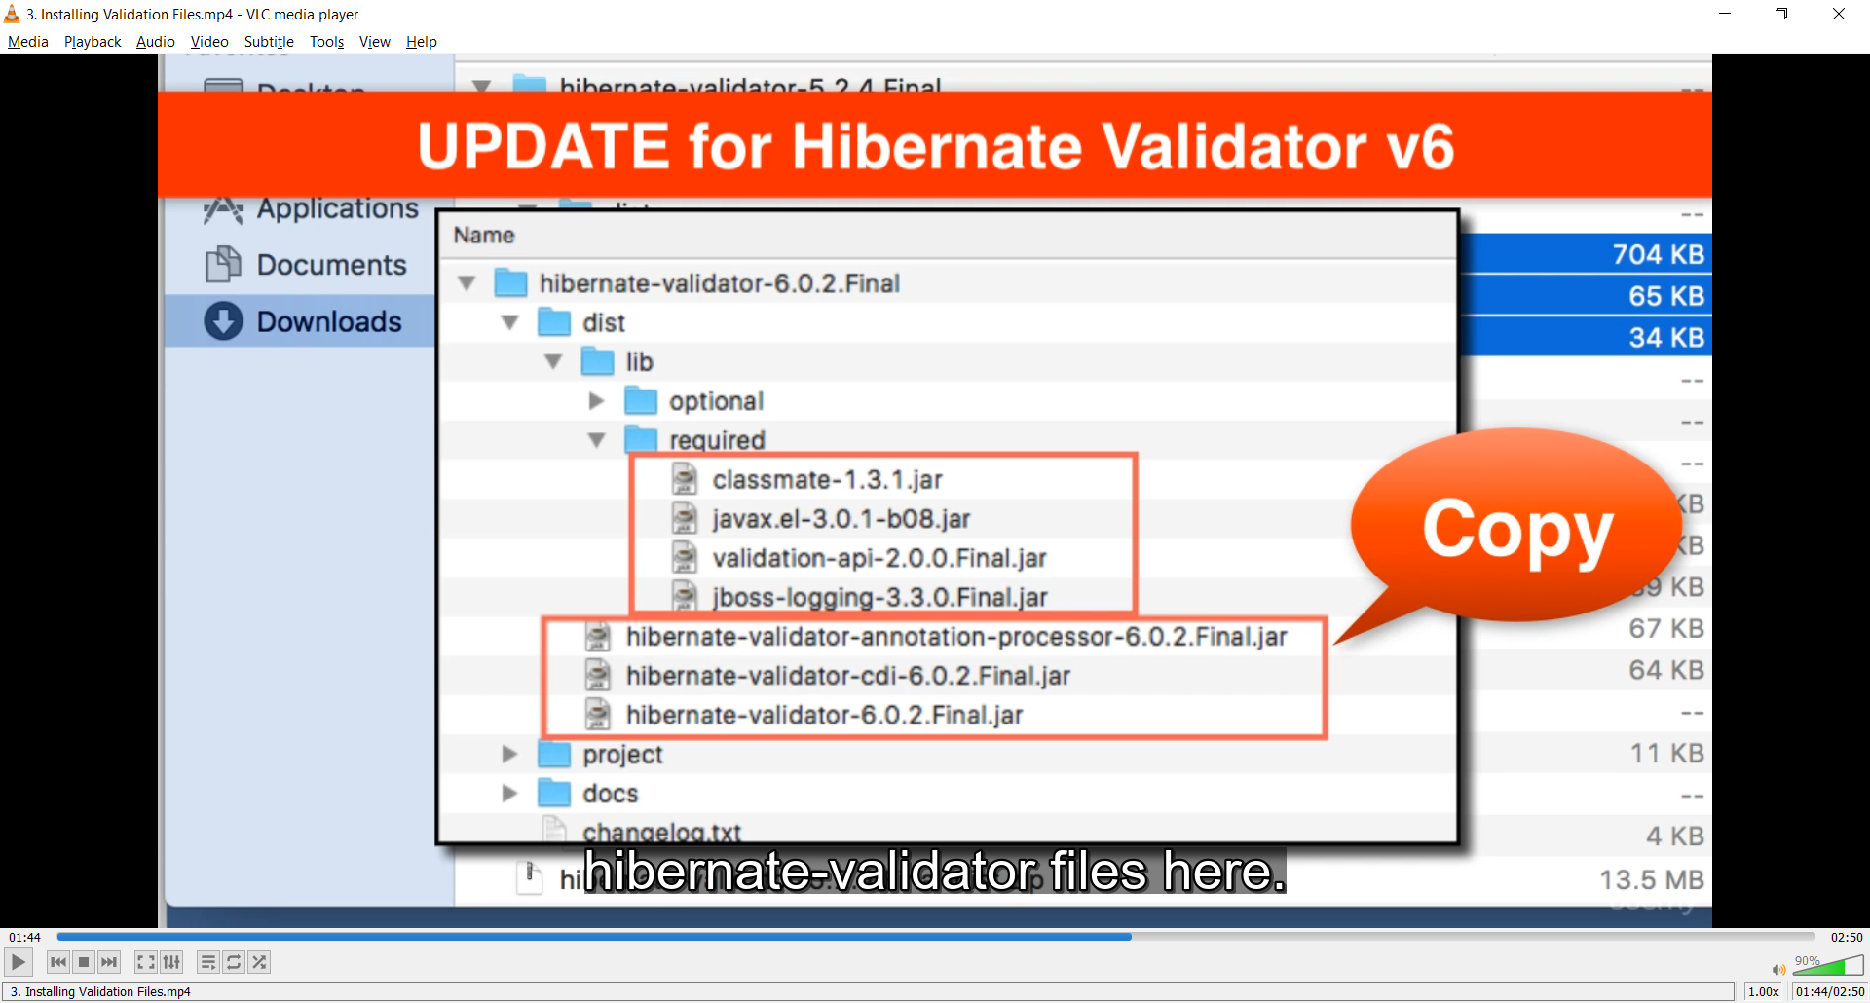

<http://hibernate.org/validator/>

Special Note about BindingResult Parameter Order.html

When performing Spring MVC validation, the location of the BindingResult parameter is very important. In the method signature, **the BindingResult parameter must appear immediately after the model attribute**.

If you place it in any other location, Spring MVC validation will not work as desired. In fact, your validation rules will be ignored.

@RequestMapping("/processForm")

public String processForm(

@Valid @ModelAttribute("customer") Customer theCustomer,

BindingResult theBindingResult) {

...

}

Here is the relevant section from the Spring Reference Manual

---

**Defining @RequestMapping methods**

@RequestMapping handler methods have a flexible signature and can choose from a range of supported controller method arguments and return values....

The Errors or BindingResult parameters have to follow the model object that is beingbound immediately ...

Source: <https://docs.spring.io/spring/docs/current/spring-framework-reference/web.html#mvc-ann-methods>

Kiểu dữ liệu khi validate phải là object và có đầy đủ get set

How to Handle String input for Integer Fields - Configure Resource Bundle

Thêm:

<bean id="messageSource"   
 class="org.springframework.context.support.ResourceBundleMessageSource">  
 <property name="basenames" value="resources/messages" />  
</bean>

Tạo file messages.properties trong src/resources

pdf

**FAQ: How to Make Integer field required and handle Strings: freePasses?**

***Question:***

I am getting the following error when i submit the form with an empty value for customer "freePasses". I am  using @NotNull on the field "freePasses". It is not throwing "is required" after validation after submit.

How to fix this? Please help.

Also, how do I handle validation if the user enters String input for the integer field?

-----

***Answer:***

Great question!

The root cause is the freePasses field is using a primitive type: int. In order to check for null we must use the appropriate wrapper class: **Integer**.

To resolve this, In Customer.java, replace "int" with "Integer"

@NotNull(message="is required")       
@Min(value=0, message="must be greater than or equal to zero")       
@Max(value=10, message="must be less than or equal to 10")       
private **Integer** freePasses;

Then update your getter/setter methods to use "Integer"

    public **Integer** getFreePasses() {  
        return freePasses;  
    }

    public void setFreePasses(**Integer** freePasses) {  
        this.freePasses = freePasses;  
    }

Save everything and retest.

=====

Here is the full source code.

package com.luv2code.springdemo.mvc;

import javax.validation.constraints.Max;

import javax.validation.constraints.Min;

import javax.validation.constraints.NotNull;

import javax.validation.constraints.Pattern;

import javax.validation.constraints.Size;

public class Customer {

private String firstName;

@NotNull(message="is required")

@Size(min=1, message="is required")

private String lastName;

@NotNull(message="is required")

@Min(value=0, message="must be greater than or equal to zero")

@Max(value=10, message="must be less than or equal to 10")

private Integer freePasses;

@Pattern(regexp="^[a-zA-Z0-9]{5}", message="only 5 chars/digits")

private String postalCode;

public String getPostalCode() {

return postalCode;

}

public void setPostalCode(String postalCode) {

this.postalCode = postalCode;

}

public String getFirstName() {

return firstName;

}

public void setFirstName(String firstName) {

this.firstName = firstName;

}

public String getLastName() {

return lastName;

}

public void setLastName(String lastName) {

this.lastName = lastName;

}

public Integer getFreePasses() {

return freePasses;

}

public void setFreePasses(Integer freePasses) {

this.freePasses = freePasses;

}

}

====

**Handle String Input for Integer Fields**

If the user enters String input such as "abcde" for the Free Passes integer field, we'd like to give a descriptive error message.

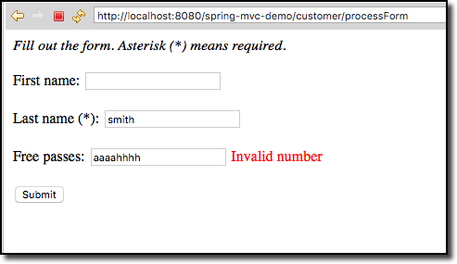

We basically need to override the default Spring MVC validation messages.

Follow these steps.

1. In your Eclipse project, expand the node: **Java Resources**

2. Right-click the **src** directory and create a new sub-directory: **resources**

3. Right-click the **resources** sub-directory and create a new file named: **messages.properties**

Your directory structure should look like this:

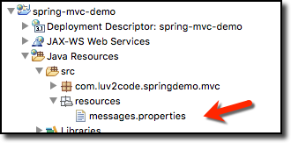

4. Add the following entry to the **messages.properties** file

typeMismatch.customer.freePasses=Invalid number

5. Save file

---

This file contains key/value pairs for the error message type

For a basic example:

  typeMismatch.customer.freePasses=Invalid number

The format of the error key is:   code + "." + object name + "." + field

To find out the given error code, in your Spring controller, you can log the details of the binding result

 System.out.println("Binding result: " + theBindingResult);

For details, see the docs here

- <http://docs.spring.io/spring/docs/current/javadoc-api/org/springframework/validation/DefaultMessageCodesResolver.html>

---

6. Edit your config file: **WEB-INF/spring-mvc-demo-servlet.xml**

Add the following:

<bean id="messageSource"

class="org.springframework.context.support.ResourceBundleMessageSource">

<property name="basenames" value="resources/messages" />

</bean>

7. Save the file. Restart the Tomcat server

8. Run your app and add bad data for the "Free Passes" field. You will see the error message from our properties file.



Custom Form Validation

pdf

Create custom validation rule  
a. Create @CourseCode annotation  
b. Create CourseCodeConstraintValidator

@Constraint(validatedBy = CourseCodeConstraintValidator.class)

@Target( { ElementType.METHOD, ElementType.FIELD } )

@Retention(RetentionPolicy.RUNTIME)

public @interface CourseCode {

// define default course code

public String value() default "LUV";

// define default error message

public String message() default "must start with LUV";

// define default groups

public Class<?>[] groups() default {};

// define default payloads

public Class<? extends Payload>[] payload() default {};

}

---

public class CourseCodeConstraintValidator

implements ConstraintValidator<CourseCode, String> { // String is type of data validate against

private String coursePrefix;

@Override

public void initialize(CourseCode theCourseCode) {

coursePrefix = theCourseCode.value();

}

@Override

public boolean isValid(String theCode,

ConstraintValidatorContext theConstraintValidatorContext) {

boolean result;

if (theCode != null) {

result = theCode.startsWith(coursePrefix);

}

else {

result = true;

}

return result;

}

}

// can add additional error msg in theConstraintValidatorContext

**Spring MVC Custom Validation - FAQ: Is it possible to integrate multiple validation string in one annotation?**

**Question:**

Is it possible to integrate multiple validation string in one annotation? For example, validate against both LUV and TOPS.

**Answer:**

Yes, you can do this. In your validation, you will make use of an array of strings.

Here's an overview of the steps.

1. Update CourseCode.java to use an array of strings

2. Update CourseCodeConstraintValidator.java to validate against array of strings

3. Update Customer.java to validate using array of strings

---

**Detailed Steps**

**1. Update CourseCode.java to use an array of strings**

Change the value entry to an array of Strings:

// define default course code

public String[] value() default {"LUV"};

Note the use of square brackets for the array of Strings. Also, the initialized value uses curley-braces for array data.

**2. Update CourseCodeConstraintValidator.java to validate against array of strings**

Change the field for coursePrefixes to an array

private String[] coursePrefixes;

Update the isValid(...) method to loop through the course prefixes. In the loop, check to see if the code matches any of the course prefixes.

@Override

public boolean isValid(String theCode,

ConstraintValidatorContext theConstraintValidatorContext) {

boolean result = false;

if (theCode != null) {

//

// loop thru course prefixes

//

// check to see if code matches any of the course prefixes

//

for (String tempPrefix : coursePrefixes) {

result = theCode.startsWith(tempPrefix);

// if we found a match then break out of the loop

if (result) {

break;

}

}

}

else {

result = true;

}

return result;

}

**3. Update Customer.java to validate using array of strings**

@CourseCode(value={"TOPS", "LUV"}, message="must start with TOPS or LUV")

private String courseCode;

Note the use of curley braces.

---

Complete Source Code:

<https://gist.github.com/darbyluv2code/0275ddb6e70e085a10fd464e36a42739>

---

That's it. This provides a solution to integrate multiple validation string in one annotation. In this example, the code validates against both LUV and TOPS.

Spring bean

Spring beans are just object instances that are

managed by the Spring IoC (Inversion of Control).

Beans are created and wired by the framework and

put into a "bag of objects" (the container) from where

you can get them later.

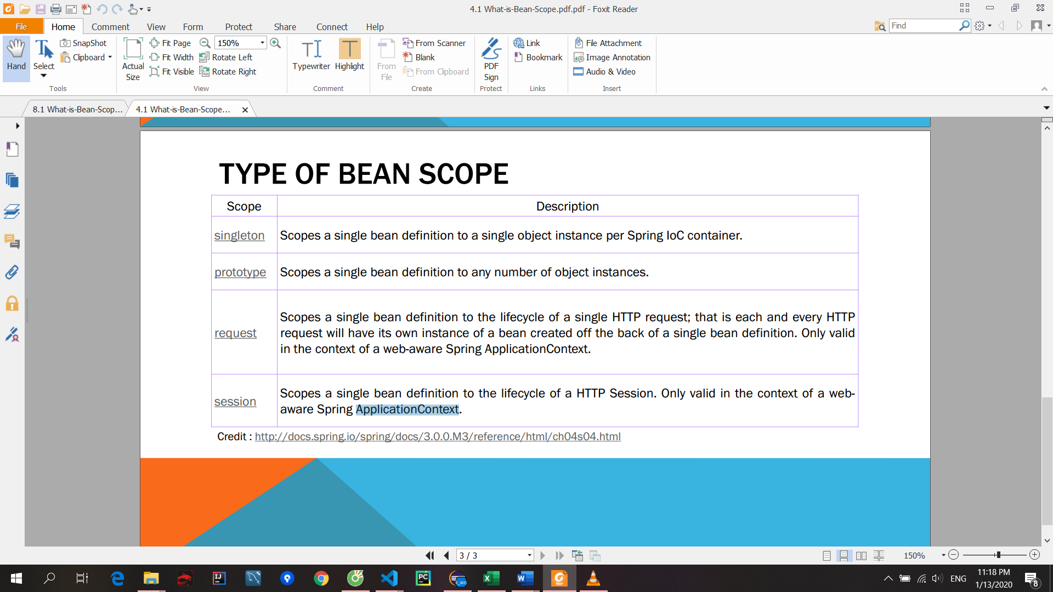

How do I use CSS, JavaScript and Images in a Spring MVC Web App?

Answer

Here are the steps on how to access static resources in a Spring MVC. For example, you can use this to access images, css, JavaScript files etc.

Any static resource is processed as a URL Mapping in Spring MVC. You can configure references to static resources in the spring-mvc-demo-servlet.xml.

In my example, I'm going to have the following directory structure:

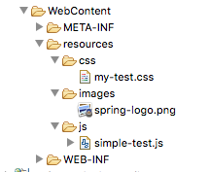

I chose to put everything in the "resources" directory. But you can use any name for "resources", such as "assets", "foobar" etc. Also, you can give any name that you want for the subdirectories under "resources".

---

Step 1: Add the following entry to your Spring MVC configuration file: spring-mvc-demo-servlet.xml

You can place this entry anywhere in your Spring MVC config file.

<mvc:resources mapping="/resources/\*\*" location="/resources/"></mvc:resources>

Step 2: Now in your view pages, you can access the static files using this syntax:

<img src="${pageContext.request.contextPath}/resources/images/spring-logo.png">

You need to use the JSP expression ${pageContext.request.contextPath} to access the correct root directory for your web application.

Apply the same technique for reading CSS and JavaScript.

---

Here's a full example that reads CSS, JavaScript and images.

<!DOCTYPE html> <html>

<head>

    <link rel="stylesheet" type="text/css"

            href="${pageContext.request.contextPath}/resources/css/my-test.css">

    <script src="${pageContext.request.contextPath}/resources/js/simple-test.js"></script>

</head>

<body>

<h2>Spring MVC Demo - Home Page</h2>

<a href="showForm">Plain Hello World</a>

<br><br>

<img src="${pageContext.request.contextPath}/resources/images/spring-logo.png" />

<br><br>

<input type="button" onclick="doSomeWork()" value="Click Me"/>

</body>

</html>

---

Source code for this example are available here:

- <https://gist.github.com/darbyluv2code/9a09543a226baeedc04b9a5037ca52ec>

Xem them pdf add css in real app

Create resource folder in WEBCONTENT

<!-- Add support for reading web resources: css, images, js, etc ... -->

<mvc:resources location="/resources/" mapping="/resources/\*\*"></mvc:resources>

reference our style sheet in JSP page

<!-- reference our style sheet -->

<link type="text/css"

rel="stylesheet"

href="${pageContext.request.contextPath}/resources/css/style

Bonus: Deploying your App to Tomcat as a Web Application Archive (WAR) file

When you deploy your Java web apps, you can make use of a Web Application Archive (WAR) file.

The Web Application Archive (WAR) file is a compressed version of your web application. It uses the zip file format but the file has the .war extension.

If you are using Eclipse, then the best way to visualize it is think of your "WebContent" directory being compressed as a zip file with the .war extension.

This includes all of your web pages, images, css etc. It also includes the WEB-INF directory which includes your classes in WEB-INF/classes and supporting JAR files in WEB-INF/lib.

The WAR file format is part of the Java EE / Servlet specification. As a result, all Java EE servers support this format (ie jboss, weblogic, websphere, glassfish and tomcat).

Below, I provide steps on how to create a WAR file in Eclipse. I also show how to deploy the WAR file on Tomcat.

---

1. In Eclipse, stop Tomcat

2. Right-click your project and select Export > WAR File

3. In the Destination field, enter: <any-directory>/mycoolapp.war

4. Outside of Eclipse, start Tomcat  
- If you are using MS Windows, then you should find it on the Start menu

5. Make sure Tomcat is up and running by visiting: http://localhost:8080

6. Deploy your new WAR file by copying it to <tomcat-install-directory>\webapps

Give it about 10-15 seconds to make the deployment. You'll know the deployment is over because you'll see a new folder created in webapps ... with your WAR file name.

7. Visit your new app. If your war file was: mycoolapp.war then you can access it with:  http://localhost:8080/mycoolapp/

## Link source

Link drive spring jsp servlet

The Project Files on Google Drive : <https://drive.google.com/drive/folders/0B8TGufNXX6YwRG9GZHdLVEhiRjQ?usp=sharing>

## Validate

Create a custom validation

64. 8.1 Chapter-3.pdf.pdf

12/8/2016 Chapter 3. Creating custom constraints  
<https://docs.jboss.org/hibernate/validator/4.1/reference/en-US/html/validator-customconstraints.html#validator-customconstraints-compound>  
Chapter 3. Creating custom constraints  
3.1. Creating a simple constraint  
3.1.1. The constraint annotation  
3.1.2. The constraint validator  
3.1.3. The error message  
3.1.4. Using the constraint  
3.2. Constraint composition  
Though the Bean Validation API defines a whole set of standard constraint annotations one can easily think of  
situations in which these standard annotations won't suffice. For these cases you are able to create custom  
constraints tailored to your specific validation requirements in a simple manner.  
3.1. Creating a simple constraint  
To create a custom constraint, the following three steps are required:  
Create a constraint annotation  
Implement a validator  
Define a default error message  
3.1.1. The constraint annotation  
Let's write a constraint annotation, that can be used to express that a given string shall either be upper case  
or lower case. We'll apply it later on to the licensePlate field of the Car class from Chapter 1, *Getting started* to  
ensure, that the field is always an upper­case string.  
First we need a way to express the two case modes. We might use String constants, but a better way to go is  
to use a Java 5 enum for that purpose:  
Example 3.1. Enum CaseMode to express upper vs. lower case  
package com.mycompany;  
public enum CaseMode {  
UPPER,  
LOWER;  
}  
Now we can define the actual constraint annotation. If you've never designed an annotation before, this may  
look a bit scary, but actually it's not that hard:  
Prev Next  
12/8/2016 Chapter 3. Creating custom constraints  
https://docs.jboss.org/hibernate/validator/4.1/reference/en­US/html/validator­customconstraints.html#validator­customconstraints­compound 2/8  
Example 3.2. Defining CheckCase constraint annotation  
package com.mycompany;  
import static java.lang.annotation.ElementType.\*;  
import static java.lang.annotation.RetentionPolicy.\*;  
import java.lang.annotation.Documented;  
import java.lang.annotation.Retention;  
import java.lang.annotation.Target;  
import javax.validation.Constraint;  
import javax.validation.Payload;  
@Target( { METHOD, FIELD, ANNOTATION\_TYPE })  
@Retention(RUNTIME)  
@Constraint(validatedBy = CheckCaseValidator.class)  
@Documented  
public @interface CheckCase {  
String message() default "{com.mycompany.constraints.checkcase}";  
Class<?>[] groups() default {};  
Class<? extends Payload>[] payload() default {};  
CaseMode value();  
}  
An annotation type is defined using the @interface keyword. All attributes of an annotation type are declared in  
a method­like manner. The specification of the Bean Validation API demands, that any constraint annotation  
defines  
an attribute message that returns the default key for creating error messages in case the constraint is  
violated  
an attribute groups that allows the specification of validation groups, to which this constraint belongs (see  
Section 2.3, “Validating groups”). This must default to an empty array of type Class<?>.  
an attribute payload that can be used by clients of the Bean Validation API to assign custom payload  
objects to a constraint. This attribute is not used by the API itself.  
Tip  
An example for a custom payload could be the definition of a severity.  
public class Severity {  
public static class Info extends Payload {};  
public static class Error extends Payload {};  
} p  
ublic class ContactDetails {  
@NotNull(message="Name is mandatory", payload=Severity.Error.class)  
private String name;  
@NotNull(message="Phone number not specified, but not mandatory", payload=Severity.Info.class)  
private String phoneNumber;  
// ...  
}  
Now a client can after the validation of a ContactDetails instance access the severity of a  
constraint using ConstraintViolation.getConstraintDescriptor().getPayload() and adjust its  
behaviour depending on the severity.  
12/8/2016 Chapter 3. Creating custom constraints  
https://docs.jboss.org/hibernate/validator/4.1/reference/en­US/html/validator­customconstraints.html#validator­customconstraints­compound 3/8  
Besides those three mandatory attributes (message, groups and payload) we add another one allowing for the  
required case mode to be specified. The name value is a special one, which can be omitted upon using the  
annotation, if it is the only attribute specified, as e.g. in @CheckCase(CaseMode.UPPER).  
In addition we annotate the annotation type with a couple of so­called meta annotations:  
@Target({ METHOD, FIELD, ANNOTATION\_TYPE }): Says, that methods, fields and annotation declarations  
may be annotated with @CheckCase (but not type declarations e.g.)  
@Retention(RUNTIME): Specifies, that annotations of this type will be available at runtime by the means of  
reflection  
@Constraint(validatedBy = CheckCaseValidator.class): Specifies the validator to be used to validate elements  
annotated with @CheckCase  
@Documented: Says, that the use of @CheckCase will be contained in the JavaDoc of elements annotated  
with it  
3.1.2. The constraint validator  
Next, we need to implement a constraint validator, that's able to validate elements with a @CheckCase  
annotation. To do so, we implement the interface ConstraintValidator as shown below:  
Example 3.3. Implementing a constraint validator for the constraint CheckCase  
package com.mycompany;  
import javax.validation.ConstraintValidator;  
import javax.validation.ConstraintValidatorContext;  
public class CheckCaseValidator implements ConstraintValidator<CheckCase, String> {  
private CaseMode caseMode;  
public void initialize(CheckCase constraintAnnotation) {  
this.caseMode = constraintAnnotation.value();  
} p  
ublic boolean isValid(String object, ConstraintValidatorContext constraintContext) {  
if (object == null)  
return true;  
if (caseMode == CaseMode.UPPER)  
return object.equals(object.toUpperCase());  
else  
return object.equals(object.toLowerCase());  
}  
}  
The ConstraintValidator interface defines two type parameters, which we set in our implementation. The first  
one specifies the annotation type to be validated (in our example CheckCase), the second one the type of  
elements, which the validator can handle (here String).  
In case a constraint annotation is allowed at elements of different types, a ConstraintValidator for each allowed  
type has to be implemented and registered at the constraint annotation as shown above.  
The implementation of the validator is straightforward. The initialize() method gives us access to the attribute  
values of the annotation to be validated. In the example we store the CaseMode in a field of the validator for  
further usage.  
12/8/2016 Chapter 3. Creating custom constraints  
https://docs.jboss.org/hibernate/validator/4.1/reference/en­US/html/validator­customconstraints.html#validator­customconstraints­compound 4/8  
In the isValid() method we implement the logic, that determines, whether a String is valid according to a given  
@CheckCase annotation or not. This decision depends on the case mode retrieved in initialize(). As the Bean  
Validation specification recommends, we consider null values as being valid. If null is not a valid value for an  
element, it should be annotated with @NotNull explicitly.  
3.1.2.1. The ConstraintValidatorContext  
Example 3.3, “Implementing a constraint validator for the constraint CheckCase” relies on the default error  
message generation by just returning true or false from the isValid call. Using the passed  
ConstraintValidatorContext object it is possible to either add additional error messages or completely disable the  
default error message generation and solely define custom error messages. The ConstraintValidatorContext API  
is modeled as fluent interface and is best demonstrated with an example:  
Example 3.4. Use of ConstraintValidatorContext to define custom error messages  
package com.mycompany;  
import javax.validation.ConstraintValidator;  
import javax.validation.ConstraintValidatorContext;  
public class CheckCaseValidator implements ConstraintValidator<CheckCase, String> {  
private CaseMode caseMode;  
public void initialize(CheckCase constraintAnnotation) {  
this.caseMode = constraintAnnotation.value();  
} p  
ublic boolean isValid(String object, ConstraintValidatorContext constraintContext) {  
if (object == null)  
return true;  
boolean isValid;  
if (caseMode == CaseMode.UPPER) {  
isValid = object.equals(object.toUpperCase());  
}e  
lse {  
isValid = object.equals(object.toLowerCase());  
} i  
f(!isValid) {  
constraintContext.disableDefaultConstraintViolation();  
constraintContext.buildConstraintViolationWithTemplate( "{com.mycompany.constraints.CheckCase.message}"  
}r  
eturn result;  
}  
}  
Example 3.4, “Use of ConstraintValidatorContext to define custom error messages” shows how you can  
disable the default error message generation and add a custom error message using a specified message  
template. In this example the use of the ConstraintValidatorContext results in the same error message as the  
default error message generation.  
Tip  
It is important to end each new constraint violation with addConstraintViolation. Only after that  
the new constraint violation will be created.  
12/8/2016 Chapter 3. Creating custom constraints  
https://docs.jboss.org/hibernate/validator/4.1/reference/en­US/html/validator­customconstraints.html#validator­customconstraints­compound 5/8  
In case you are implementing a ConstraintValidator a class level constraint it is also possible to adjust set the  
property path for the created constraint violations. This is important for the case where you validate multiple  
properties of the class or even traverse the object graph. A custom property path creation could look like  
Example 3.5, “Adding new ConstraintViolation with custom property path”.  
Example 3.5. Adding new ConstraintViolation with custom property path  
public boolean isValid(Group group, ConstraintValidatorContext constraintValidatorContext) {  
boolean isValid = false;  
...  
if(!isValid) {  
constraintValidatorContext  
.buildConstraintViolationWithTemplate( "{my.custom.template}" )  
.addNode( "myProperty" ).addConstraintViolation();  
}r  
eturn isValid;  
}  
3.1.3. The error message  
Finally we need to specify the error message, that shall be used, in case a @CheckCase constraint is violated.  
To do so, we add the following to our custom ValidationMessages.properties (see also Section 2.2.4, “Message  
interpolation”)  
Example 3.6. Defining a custom error message for the CheckCase constraint  
com.mycompany.constraints.CheckCase.message=Case mode must be {value}.  
If a validation error occurs, the validation runtime will use the default value, that we specified for the message  
attribute of the @CheckCase annotation to look up the error message in this file.  
3.1.4. Using the constraint  
Now that our first custom constraint is completed, we can use it in the Car class from the Chapter 1, *Getting  
started* chapter to specify that the licensePlate field shall only contain upper­case strings:  
Example 3.7. Applying the CheckCase constraint  
package com.mycompany;  
import javax.validation.constraints.Min;  
import javax.validation.constraints.NotNull;  
import javax.validation.constraints.Size;  
public class Car {  
@NotNull  
private String manufacturer;  
@NotNull  
@Size(min = 2, max = 14)  
@CheckCase(CaseMode.UPPER)  
private String licensePlate;  
@Min(2)  
private int seatCount;  
12/8/2016 Chapter 3. Creating custom constraints  
https://docs.jboss.org/hibernate/validator/4.1/reference/en­US/html/validator­customconstraints.html#validator­customconstraints­compound 6/8  
public Car(String manufacturer, String licencePlate, int seatCount) {  
this.manufacturer = manufacturer;  
this.licensePlate = licencePlate;  
this.seatCount = seatCount;  
} /  
/getters and setters ...  
}  
Finally let's demonstrate in a little test that the @CheckCase constraint is properly validated:  
Example 3.8. Testcase demonstrating the CheckCase validation  
package com.mycompany;  
import static org.junit.Assert.\*;  
import java.util.Set;  
import javax.validation.ConstraintViolation;  
import javax.validation.Validation;  
import javax.validation.Validator;  
import javax.validation.ValidatorFactory;  
import org.junit.BeforeClass;  
import org.junit.Test;  
public class CarTest {  
private static Validator validator;  
@BeforeClass  
public static void setUp() {  
ValidatorFactory factory = Validation.buildDefaultValidatorFactory();  
validator = factory.getValidator();  
} @  
Test  
public void testLicensePlateNotUpperCase() {  
Car car = new Car("Morris", "dd‐ab‐123", 4);  
Set<ConstraintViolation<Car>> constraintViolations =  
validator.validate(car);  
assertEquals(1, constraintViolations.size());  
assertEquals(  
"Case mode must be UPPER.",  
constraintViolations.iterator().next().getMessage());  
} @  
Test  
public void carIsValid() {  
Car car = new Car("Morris", "DD‐AB‐123", 4);  
Set<ConstraintViolation<Car>> constraintViolations =  
validator.validate(car);  
assertEquals(0, constraintViolations.size());  
}  
}  
3.2. Constraint composition  
12/8/2016 Chapter 3. Creating custom constraints  
https://docs.jboss.org/hibernate/validator/4.1/reference/en­US/html/validator­customconstraints.html#validator­customconstraints­compound 7/8  
Looking at the licensePlate field of the Car class in Example 3.7, “Applying the CheckCase constraint”, we see  
three constraint annotations already. In complexer scenarios, where even more constraints could be applied to  
one element, this might become a bit confusing easily. Furthermore, if we had a licensePlate field in another  
class, we would have to copy all constraint declarations to the other class as well, violating the DRY principle.  
This problem can be tackled using compound constraints. In the following we create a new constraint  
annotation @ValidLicensePlate, that comprises the constraints @NotNull, @Size and @CheckCase:  
Example 3.9. Creating a composing constraint ValidLicensePlate  
package com.mycompany;  
import static java.lang.annotation.ElementType.\*;  
import static java.lang.annotation.RetentionPolicy.\*;  
import java.lang.annotation.Documented;  
import java.lang.annotation.Retention;  
import java.lang.annotation.Target;  
import javax.validation.Constraint;  
import javax.validation.Payload;  
import javax.validation.constraints.NotNull;  
import javax.validation.constraints.Size;  
@NotNull  
@Size(min = 2, max = 14)  
@CheckCase(CaseMode.UPPER)  
@Target( { METHOD, FIELD, ANNOTATION\_TYPE })  
@Retention(RUNTIME)  
@Constraint(validatedBy = {})  
@Documented  
public @interface ValidLicensePlate {  
String message() default "{com.mycompany.constraints.validlicenseplate}";  
Class<?>[] groups() default {};  
Class<? extends Payload>[] payload() default {};  
}  
To do so, we just have to annotate the constraint declaration with its comprising constraints (btw. that's  
exactly why we allowed annotation types as target for the @CheckCase annotation). As no additional validation  
is required for the @ValidLicensePlate annotation itself, we don't declare a validator within the @Constraint meta  
annotation.  
Using the new compound constraint at the licensePlate field now is fully equivalent to the previous version,  
where we declared the three constraints directly at the field itself:  
Example 3.10. Application of composing constraint ValidLicensePlate  
package com.mycompany;  
public class Car {  
@ValidLicensePlate  
private String licensePlate;  
//...  
}  
12/8/2016 Chapter 3. Creating custom constraints  
https://docs.jboss.org/hibernate/validator/4.1/reference/en­US/html/validator­customconstraints.html#validator­customconstraints­compound 8/8  
The set of ConstraintViolations retrieved when validating a Car instance will contain an entry for each violated  
composing constraint of the @ValidLicensePlate constraint. If you rather prefer a single ConstraintViolation in  
case any of the composing constraints is violated, the @ReportAsSingleViolation meta constraint can be used as  
follows:  
Example 3.11. Usage of @ReportAsSingleViolation  
//...  
@ReportAsSingleViolation  
public @interface ValidLicensePlate {  
String message() default "{com.mycompany.constraints.validlicenseplate}";  
Class<?>[] groups() default {};  
Class<? extends Payload>[] payload() default {};  
}  
Copyright © 2009, 2010 Red Hat, Inc. & Gunnar Morling  
Top of page Front page  
Prev  
Chapter 2. Validation step by step  
Next  
Chapter 4. XML configuration  
This content refers to an earlier version of Hibernate Validator.  
Go to latest stable: version 5.3 .

## Authentication

“Authentication” is the process of establishing a principal is who they claim to  
be (a “principal” generally means a user, device or some other system which can perform an action in your application).  
• “Authorization” refers to the process of deciding whether a principal is allowed to perform an action within your application

## Install Open JDK in eclipse

Đầu tiên, gỡ cài đặt JDK 11 trước tiên, vào Control Panel -> Programs -> Uninstall rồi tìm Java 11 để uninstall Java 11.

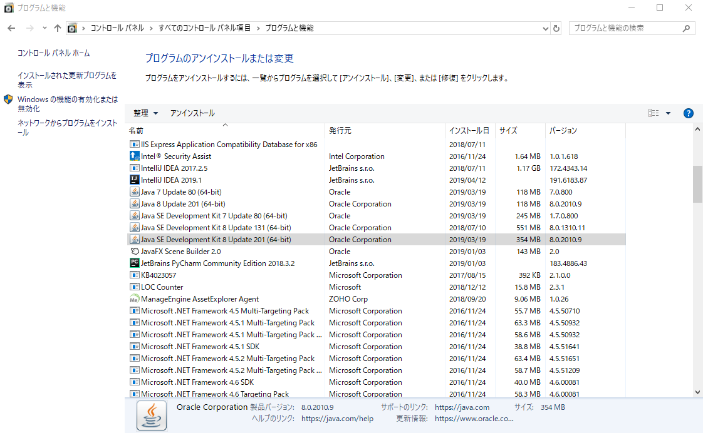

Tiếp theo, cài OpenJDK 11: sau khi lấy file: **openjdk-11\_windows-x64\_bin.zip** giải nén và copy vào thư mục: **C:\Program Files\Java**

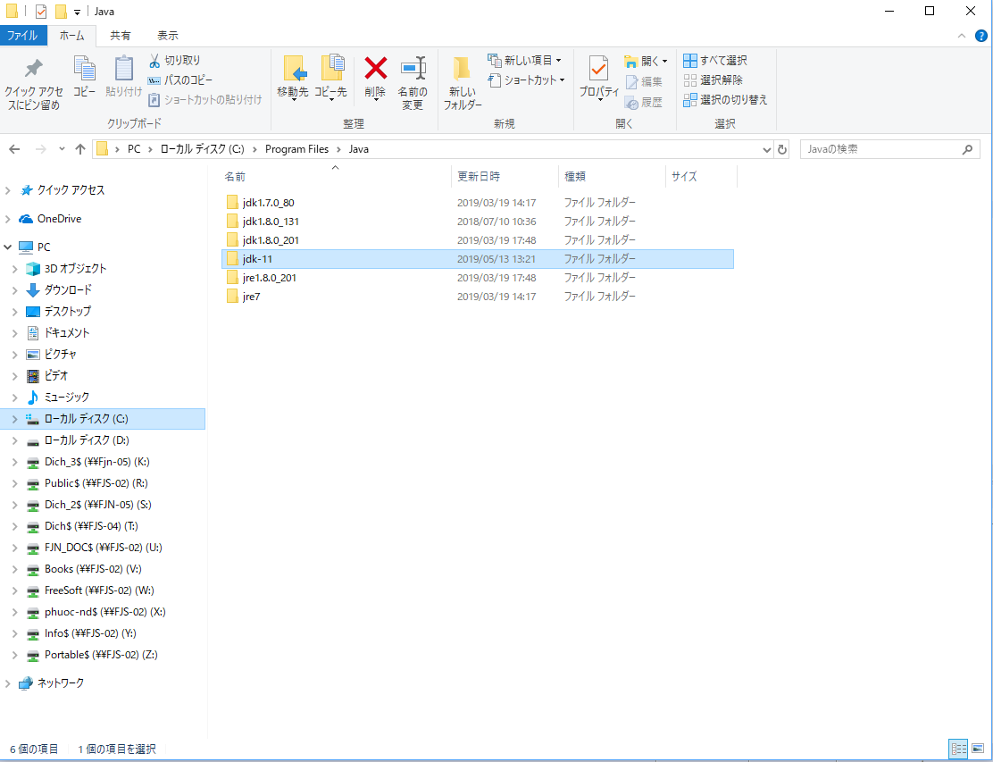

Tiếp theo, cài lại JAVA\_HOME và Path cho Java: **Advanced system settings => Advanced => Enviroment Variable** tại **System variables**

* Ở **Path**: add thêm **C:\Program Files\Java\jdk-11\bin**

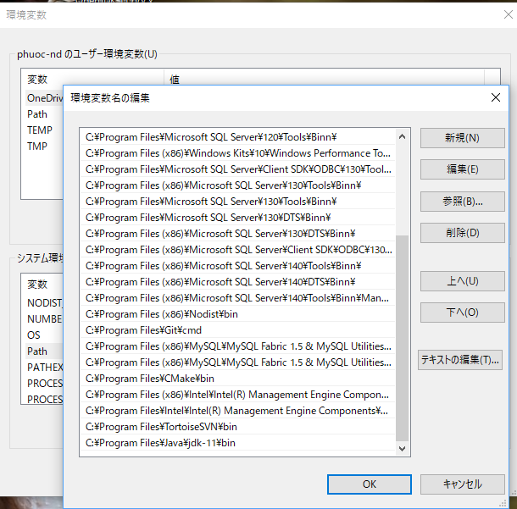

* Add them **JAVA\_HOME**: **C:\Program Files\Java\jdk-11**

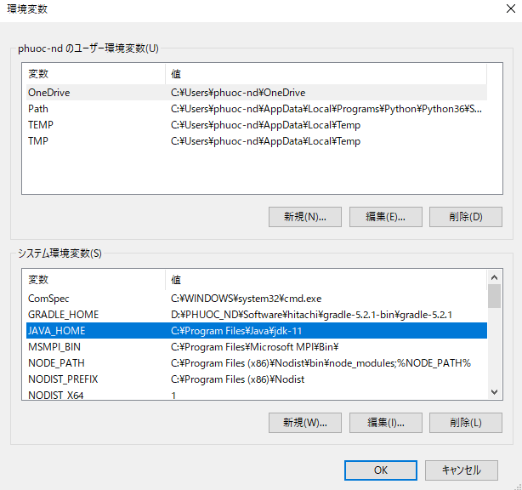

Tiếp theo là cài vào Eclipse:

Mở Eclipse chọn **Window => Java => Installed JREs => Search =>** chọn thư mục **jdk-11.**

Tick vào nhấn **Apply.**

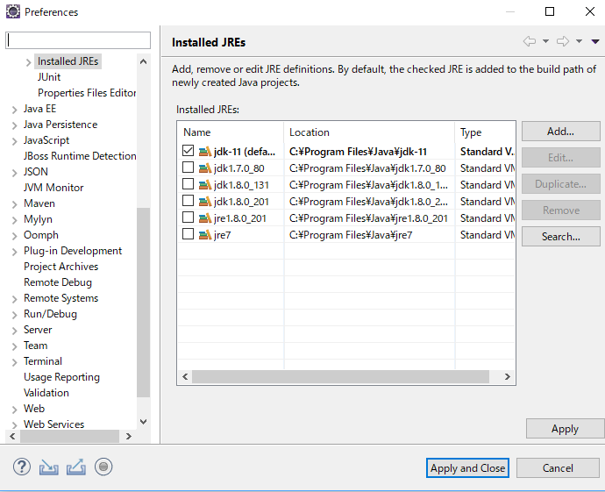

Tiếp theo, click chuột phải vào project **DMM\_Controller =>** chọn **Properties => Java Build Path =>** Xóa Java cũ và add them Java mới vào.

Chọn **Modulepath => Add Library => JRE System Library =>** chọn **jdk-11** ở mục **Alternate JRE => finish**

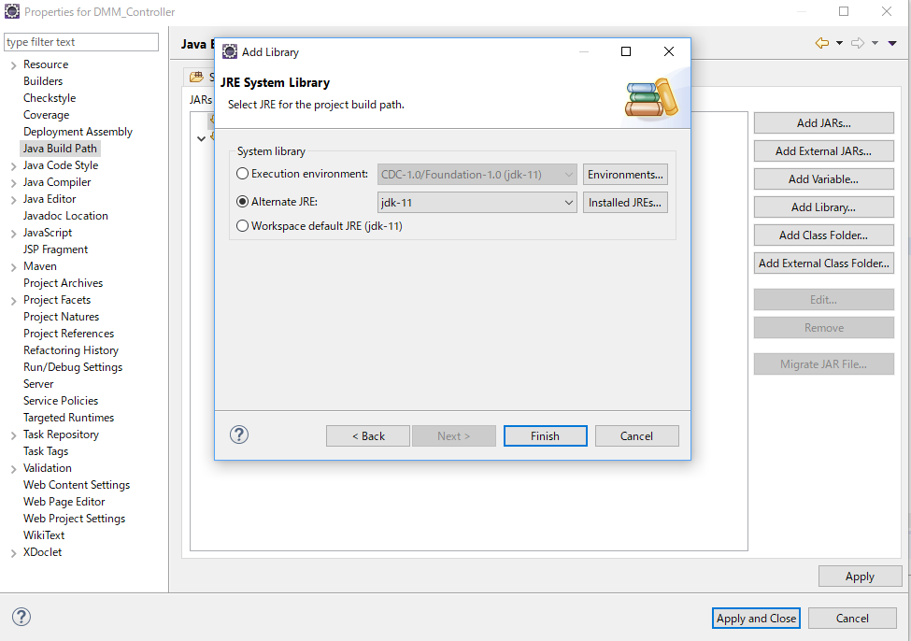

**Apply and Close.**

Các trường hợp bị lỗi:

* Lỗi thiếu Module khi build: Add them **--add-modules java.se (như hình). 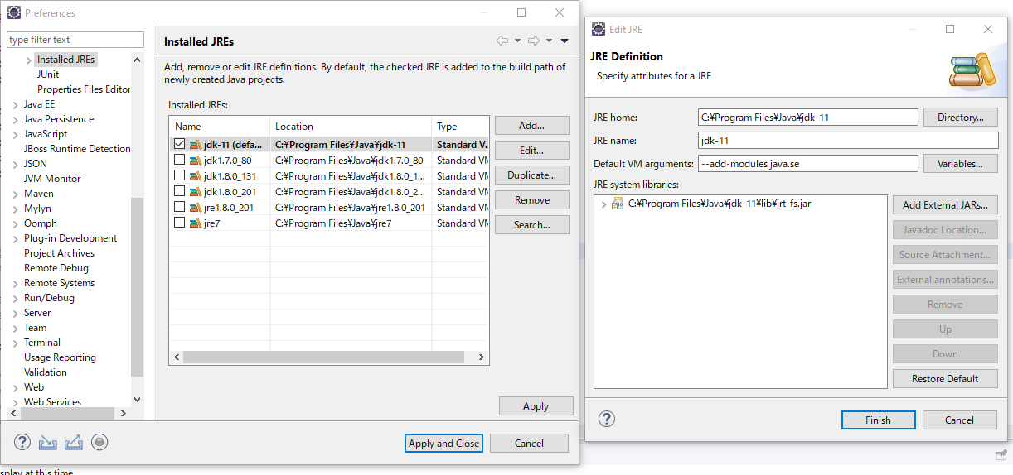**
* Lỗi **Dynamic Web Module** đang là 4.0:

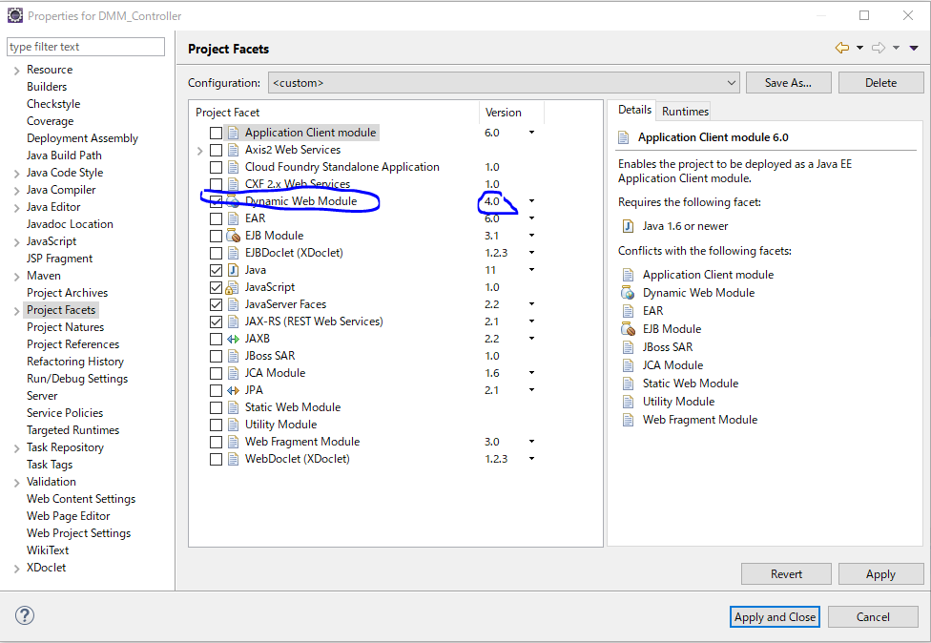

* Chuột phải vào project -> **Show in** -> **System Explorer** -> chọn **DMM\_Controller** -> .**settings** -> **org.eclipse.wst.common.project.facet.core ->** sửa dòng có **facet="jst.web"** với **version =4.0** thành **version = 2.5.**

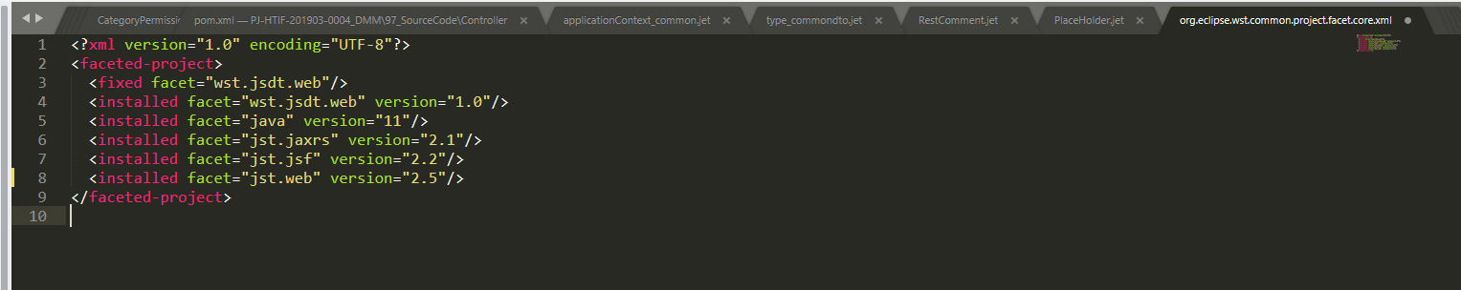

## Install Lombok in eclipse

<https://www.journaldev.com/18124/java-project-lombok>

**Project Lombok Maven**

Adding Lombok in your project is simple. Just add the below dependency in your maven project pom.xml file.

<dependency>

<groupId>org.projectlombok</groupId>

<artifactId>lombok</artifactId>

<version>1.16.20</version>

</dependency>

**Adding the Lombok Plugin in IDE (Eclipse)**

Here are the installation steps for Windows:

1. Downloaded jar from <https://projectlombok.org/download> or use the jar which is downloaded from your maven build.
2. Execute command in terminal: java -jar lombok.jar
3. This command will open window as show in the picture below, install and quit the installer and restart eclipse.

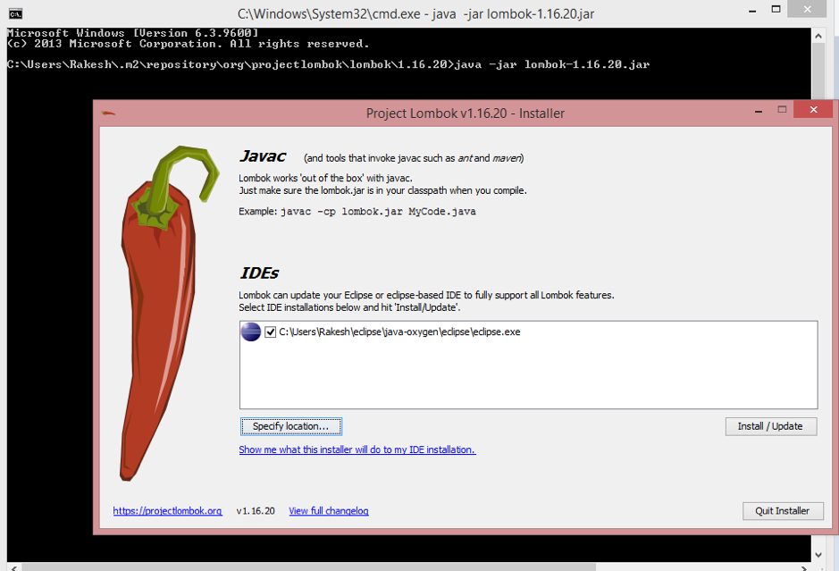

If you are on MacOS, then following are the steps to use Lombok in your project.

1. Copy lombok.jar into Eclipse.app/Contents/MacOS directory.
2. Add -javaagent:lombok.jar to the end of Eclipse.app/Contents/Eclipse/eclipse.ini file.
3. Restart Eclipse and enable “Annotation Processing” in project properties as shown in below image.  
   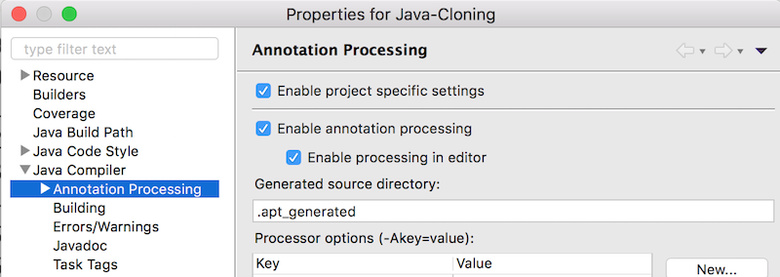

The offical lombok website can be found here: https://projectlombok.org/

<https://www.vogella.com/tutorials/Lombok/article.html>

## Junit 4

Thêm(thay thế) dependency của junit vào file pom.xml:

<dependency>

<groupId>junit</groupId>

<artifactId>junit</artifactId>

<version>4.12</version>

</dependency>

Sau đó tiến hành build lại project

Các bạn chạy thử Junit bằng tải và chép file testJunit ở …

Nội dung file:

**package** com.hitachi.sample.rest.category;

**import** **static** io.restassured.RestAssured.*get*;

**import** org.junit.BeforeClass;

**import** org.junit.Test;

**import** **static** org.junit.Assert.*assertEquals*;

**import** io.restassured.RestAssured;

**import** io.restassured.path.json.JsonPath;

**import** io.restassured.response.Response;

**public** **class** testJunit {

@BeforeClass

**public** **static** **void** init() {

RestAssured.*baseURI* = "http://localhost/";

RestAssured.*port* = 8080;

}

@Test

**public** **void** testGetInfoSuccess() {

String category="123";

Response response=*get*("category/categoryRankingInfo/{CategoryId}?Locale=1&Version=2",category);

String dataString=response.getBody().asString();

JsonPath jsonPath = **new** JsonPath(dataString);

**int** code=response.getStatusCode();

String responseCode=jsonPath.getString("categoryRankingInfo");

System.***out***.println(responseCode);

*assertEquals*(200, code);

}

}

Cách bạn có thể chạy thử hàm test như cách bên dưới

Lưu ý: Nhớ bật app trước khi chạy thử file test

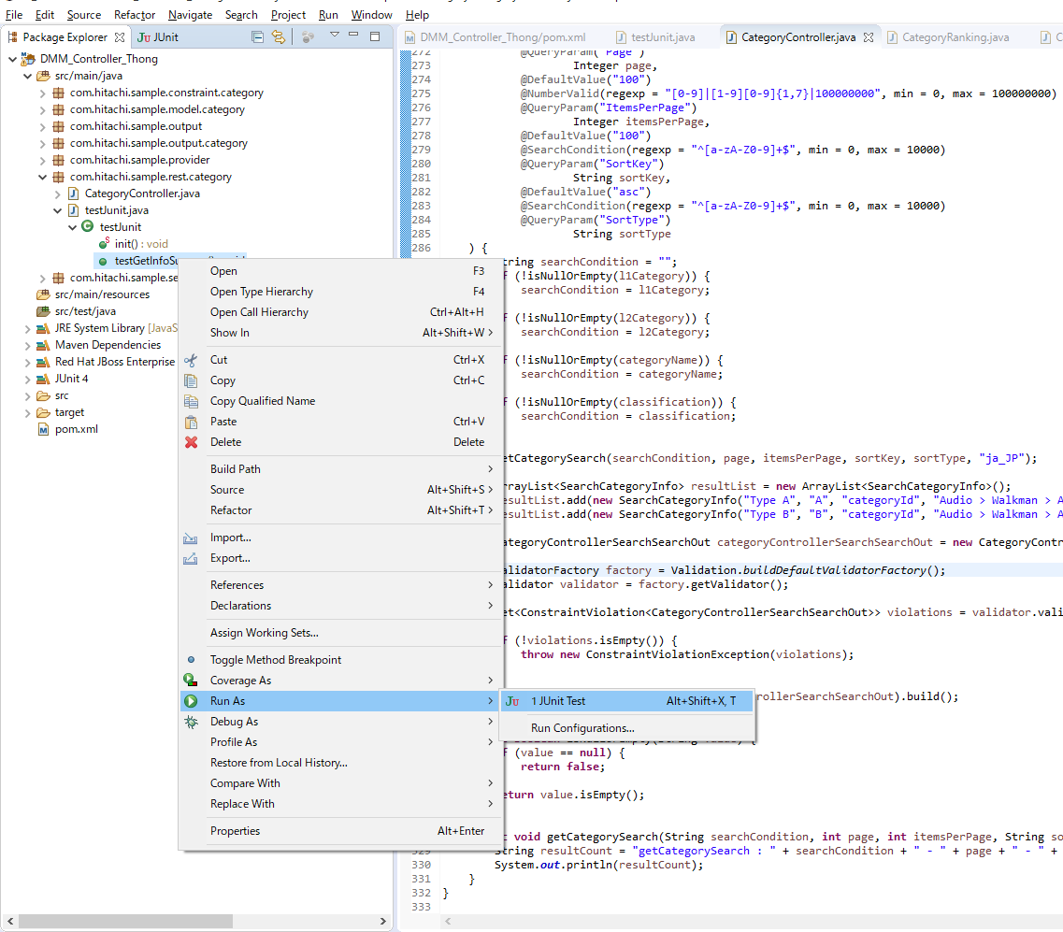

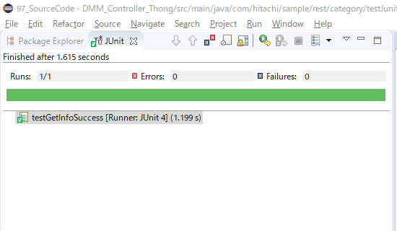

Kết quả nếu test thành công,trong trường hợp này,tất cả tham số truyền vào đầy đủ và hợp lệ nên kết quả test ok.Còn trường hợp nếu như truyền thiếu dữ liệu hoặc dữ liệu không hợp lệ.thì kết quả chạy Junit test sẽ thất bại

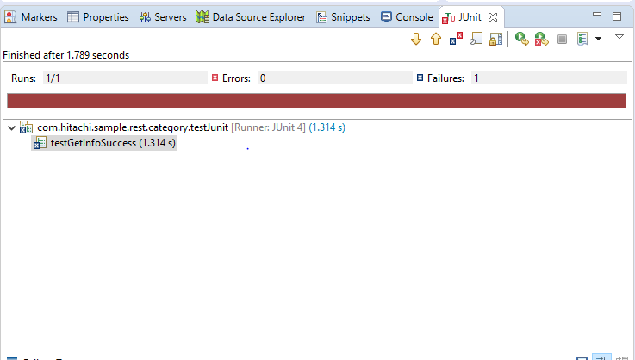

Một hàm test khác cho phương thức post:

@Test

**public** **void** testRegInfo() {

String request = "{\r\n" +

" \"common\": {\r\n" +

" \"displayName\": \"null\",\r\n" +

" \"lastUpdateDate\": \"1111-11-11\",\r\n" +

" \"lastUpdateBy\": \"Tan\",\r\n" +

" \"permission\": {\r\n" +

" \"editStatus\": true,\r\n" +

" \"authorizationInfo\": [{ \r\n" +

" \"classification\": \"null\",\r\n" +

" \"name\": \"null\",\r\n" +

" \"userGroupId\": \"12\",\r\n" +

" \"userId\": \"142\"\r\n" +

" }]\r\n" +

" }\r\n" +

" },\r\n" +

" \r\n" +

" \"master\": {\r\n" +

" \"systemInternalInfo\":{\r\n" +

" \"concurrencyMessage\": null\r\n" +

" },\r\n" +

" \"localeName\": null,\r\n" +

" \"localeId\": \"1\",\r\n" +

" \"highlightedAttributes\": null,\r\n" +

" \"readOnlyAttributes\": null,\r\n" +

" \"categoryId\":\"2\",\r\n" +

" \"masterCategoryName\": null,\r\n" +

" \"masterCategoryId\": null,\r\n" +

" \"level3CategoryName\": null,\r\n" +

" \"level2CategoryId\": null,\r\n" +

" \"level2CategoryName\": null,\r\n" +

" \"level1CategoryId\": null,\r\n" +

" \"level1CategoryName\": null,\r\n" +

" \"categoryGroupName\":null,\r\n" +

" \"categorySlug\": null,\r\n" +

" \"categoryExternalLinkUrl\":null,\r\n" +

" \"categoryRank\": null,\r\n" +

" \"categoryLogo\": [{\r\n" +

" \"assetId\":\"1\",\r\n" +

" \"assetName\":\"1\",\r\n" +

" \"assetType\":\"1\",\r\n" +

" \"imagePath\":null,\r\n" +

" \"altText\":null,\r\n" +

" \"linkTitle\":null,\r\n" +

" \"rank\":null,\r\n" +

" \"fileType\":null,\r\n" +

" \"fileSize\":null\r\n" +

" }],\r\n" +

" \"categoryReversedLogo\": [{\r\n" +

" \"assetId\":\"1\",\r\n" +

" \"assetName\":\"1\",\r\n" +

" \"assetType\":\"1\",\r\n" +

" \"imagePath\":null,\r\n" +

" \"altText\":null,\r\n" +

" \"linkTitle\":null,\r\n" +

" \"rank\":null,\r\n" +

" \"fileType\":null,\r\n" +

" \"fileSize\":null\r\n" +

" }],\r\n" +

" \"categoryImage\": null,\r\n" +

" \"categoryImageAltText\": null,\r\n" +

" \"categoryImageCaption\": null,\r\n" +

" \"categoryNavigationImage\": null,\r\n" +

" \"categoryNavigationImageAltText\": null,\r\n" +

" \"categoryNavigationImageCaption\": null,\r\n" +

" \"categoryNote\": null,\r\n" +

" \"categoryTranslationTargetLocales\": [{\r\n" +

" \"name\": \"1\",\r\n" +

" \"id\": \"1\",\r\n" +

" \"type\": \"1\",\r\n" +

" \"locale\":null,\r\n" +

" \"regionCode\": null,\r\n" +

" \"countryName\": null\r\n" +

" }],\r\n" +

" \"categoryTranslationTargetLocalesforSpec\":[{\r\n" +

" \"name\": \"1\",\r\n" +

" \"id\": \"1\",\r\n" +

" \"type\": \"1\",\r\n" +

" \"locale\":null,\r\n" +

" \"regionCode\": null,\r\n" +

" \"countryName\": null\r\n" +

" }],\r\n" +

" \"categoryFloatingFootnoteCopy\": null,\r\n" +

" \"categoryFloatingFootnoteRank\": null,\r\n" +

" \"supportLinks\": [{\r\n" +

" \"supportId\": null,\r\n" +

" \"supportLinkIcon\": null,\r\n" +

" \"supportLinkLabel\": null,\r\n" +

" \"supportLinkExternalUrl\": null,\r\n" +

" \"supportLinkInternalKeyword\": null,\r\n" +

" \"supportLinkRank\": null,\r\n" +

" \"supportLinkOpenInNewWindowFlag\": null\r\n" +

" }],\r\n" +

" \"brochureDataSource\":[{\r\n" +

" \"assetId\":\"1\",\r\n" +

" \"assetName\":\"1\",\r\n" +

" \"assetType\":\"1\",\r\n" +

" \"imagePath\":null,\r\n" +

" \"altText\":null,\r\n" +

" \"linkTitle\":null,\r\n" +

" \"rank\":null,\r\n" +

" \"fileType\":null,\r\n" +

" \"fileSize\":null\r\n" +

" }],\r\n" +

" \"brochureRank\": null,\r\n" +

" \"groupedCategory\": [{\r\n" +

" \"categoryId\":null,\r\n" +

" \"categoryName\":null\r\n" +

" }]\r\n" +

" },\r\n" +

" \"translation\": null,\r\n" +

" \"localization\": null\r\n" +

"}";

Response response= *given*()

.contentType(ContentType.***JSON***)

.body(request)

.post("category/TestPost/2?Version=3")

.then()

.extract()

.response();

System.***out***.println(response.getStatusCode());

System.***out***.println(response.getBody().asString());

Hàm trên dùng để test thử một một đường dẫn mà mình tự viết bên dưới:

/\*\*

\* Dùng cho test cho Junit

\*

\* **@param** CategoryId

\* **@return** Version

\*/

@POST

@Path("/TestPost/{CategoryId}")

@Produces(MediaType.***APPLICATION\_JSON***)

**public** Response TestPost(

@NotNull

@Pattern(regexp = "^[a-zA-Z0-9 -/:-@\\[-\\`\\{-\\~]+$")

@Size(min = 1, max = 256)

@PathParam("CategoryId")

String categoryId,

@NotNull

@Version(regexp = "[1-9]|[1-9][0-9]{1,7}|100000000", min = 1, max = 100000000)

@QueryParam("Version")

Integer version,

@NotNull

@Valid

CategoryInfo categoryInfo) {

**return** Response

.*ok*()

.build();

}

Kết quả test nếu thành công

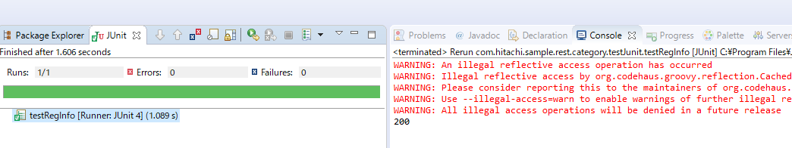

Nếu trường hợp các giá trị của request body không hợp lệ:

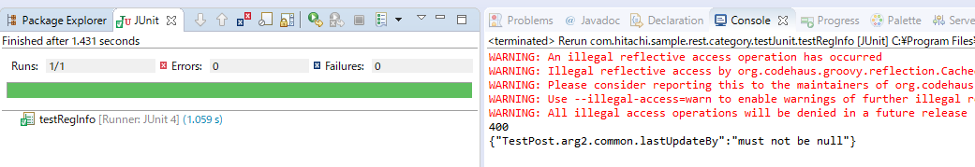

## Error in spring mvc with eclipse

4. FAQ HELP! My Spring MVC Controller is not working. What to do.html

JUST A HEADS UP ...

IN THE VIDEOS YOUR SPRING MVC CONTROLLER CODE MAY NOT WORK

THIS IS AN ECLIPSE CACHING BUG

IF YOUR CONTROLLER DOESN'T WORK THEN TRY THE STEPS BELOW

----  
**Question:**HELP! My Spring MVC Controller is not working. What to do?

**Answer:**

***Debug Tip #0: Make sure you are accessing the correct URL***

You need to access the correct URL, localhost:8080/spring-mvc-demo/

Note: Do not attempt to run the JSP files directly. This will not work due to MVC.

---

***Debug Tip #1: Make Sure your Package Names is consistent***

The Spring configuration file used in the videos expects for your controller to be in the package:

***package com.luv2code.springdemo.mvc;***

*Make sure your controller is this package.*

***----***

***Debug Tip #2:  Reimport Project into Eclipse***

Sometimes the Eclipse project settings can become corrupted. One possible solution is to remove the Eclipse project  and reimport into Eclipse.

Here are the steps.

1. Remove the project from Eclipse.

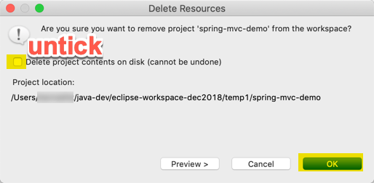

2. Open the project in file system and remove the files/ folders except src and WebContent.

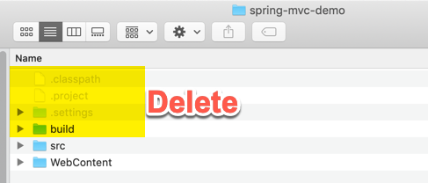

3. Open the project in Eclipse again using **File > Import ... > General > Existing Projects into Workspace**

4.  Check the project properties(Right click on the project and click on Properties),

5. Check the Java Build Path, Java Compiler and Project Facets and make sure that the Java version is same in all the windows.

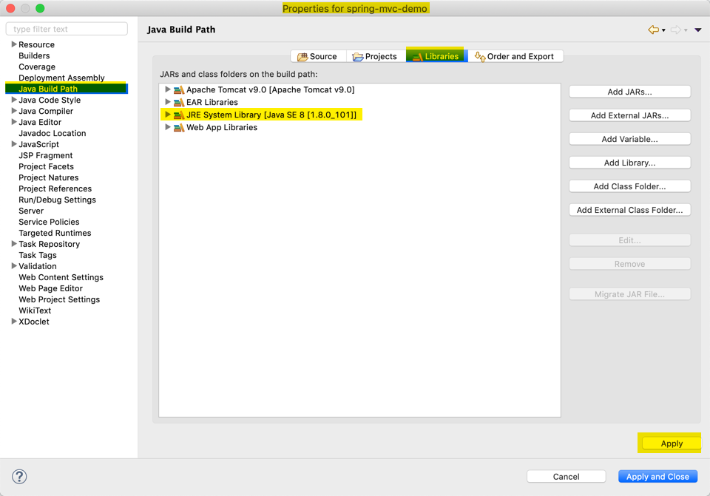

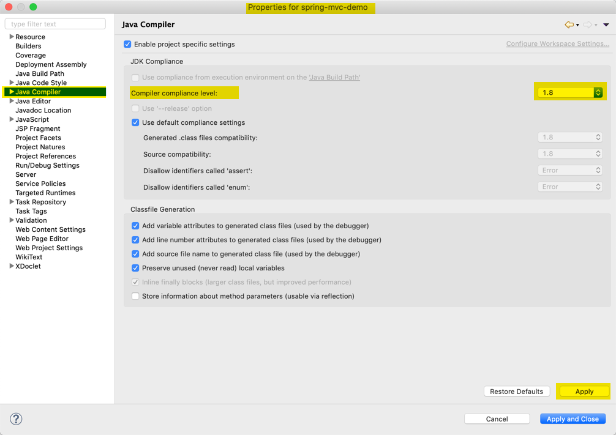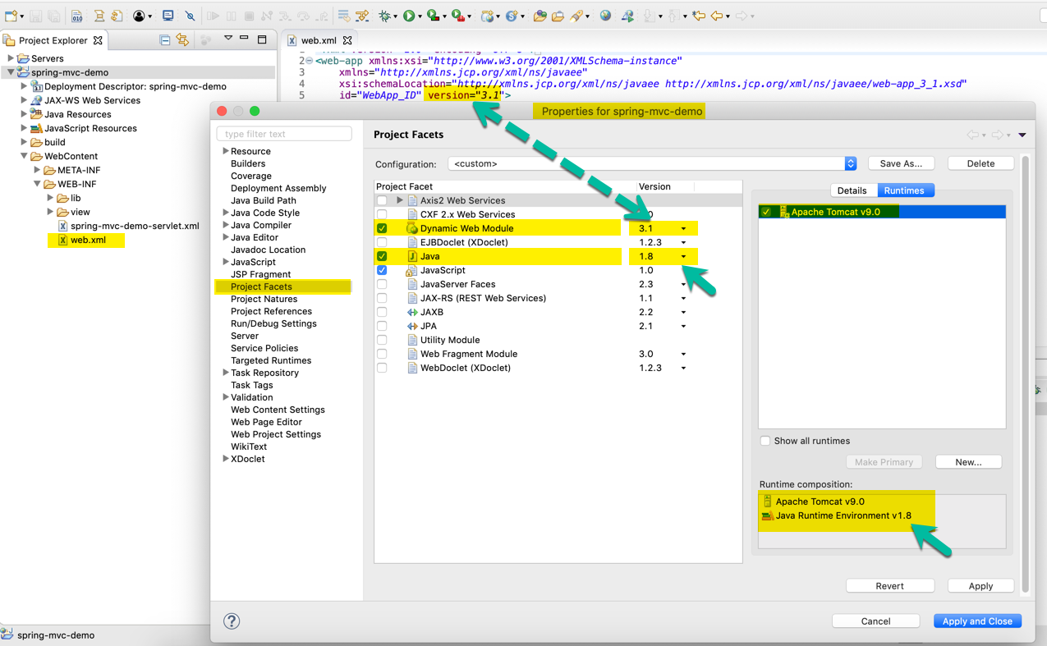

5. Build the project and try again.

***----***

***Debug Tip #3: Clear Tomcat Cache***This is normally a caching issue with the cache.

Here are some steps to clear the Eclipse cache and Tomcat cache.

1. In the Server's tab in Eclipse, Stop the Tomcat server

2. Right-click the server and select "Clean..."

3. Right-click the server again and select "Clean Tomcat Work Directory..."

---

4. In the Eclipse, select the top-level menu option, Project > Clean ...

5. Be sure your project is selected and click Ok

6. Restart Eclipse

Retest your application. If you continue to have problems try Debug Tip #2

---

***Debug Tip #4: Import the Project in  a new workspace***

1. Copy your project to a new directory on your computer like, c:\foobar

2. In Eclipse, open a new workspace: Create a new workspace in Eclipse: File > Switch Workspace > Other ... > give any name

3. In Eclipse, import the project

3a. Use File > Import > General > Existing Projects into Workspace

3b. Browse to directory: c:\foobar

4. In your new workspace, add a reference to the Tomcat server

5. Test your app in the new workspace

---

If you still have problems, then post your code to the classroom discussion forum.

Be sure to include the following files:  
- spring-mvc-demo-servlet.xml  
- your controller .java  
- your view page .jsp

5. FAQ HELP! - Can't Start Tomcat - Ports are in Use!.html

Can't Start Tomcat - Ports are in Use

You may have a problem starting Tomcat. You may see this ugly error message about ports in use.

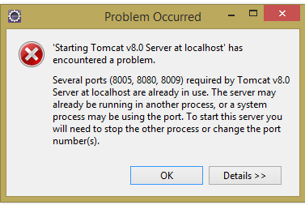

**Solution**

You can use the troubleshooting tips below.

***Troubleshooting Tip #1***

1. Exit Eclipse

2. Open a web web browser and visit, http://localhost:8080

3. If you see a "Tomcat" web page then that means Tomcat is running as a Windows service. To stop Tomcat running as a Windows services, open your Windows Control Panel. Find the service "Apache Tomcat" and stop it.

4. If you don't see a "Tomcat" web page, then stop the appropriate process displayed.

--  
***Troubleshooting Tip #2 - GUI Option***

Steps to free port which is already used to run Tomcat server in Eclipse

1. On MS Windows, select *Start > All Programs  > Accessories > System Tools >Resource Monitor*

2. Expand the **Network Tab**

3. Move to the section for **Listening Ports**

4. Look in the Port column and scroll to find entry for port 8080

5. Select the given process and delete/kill the process

6. Return back to Eclipse and start the Tomcat Server, it should start up now.

---

***Troubleshooting Tip #3 - Command-Line Option***

Steps to free port which is already used to run Tomcat server in Eclipse

For example , suppose 8080 port is used , we need to make free 8080 to run tomcat

Step 1: (open the CMD command)

C:\Users\username>netstat -o -n -a | findstr 0.0:8080

TCP    0.0.0.0:3000      0.0.0.0:0              LISTENING       3116

Now , we can see that LISTENING port is 3116 for 8080 ,

We need to kill 3116 now

Step 2:

C:\Users\username>taskkill /F /PID 3116

Step 3:  Return back to Eclipse and start the Tomcat Server, it should start up now.

====

**Mac/Linux SOLUTION**

Step 0: Exit Eclipse

Step 1: Open a terminal window

Step 2: Enter the following command to find the process id

lsof -i :8080

This will give output of the application that is running on port 8080

Step 3: Enter the following command to kill the process

kill $(lsof -t -i :8080)

Step 4:  Return back to Eclipse and start the Tomcat Server, it should start up now.

6. FAQ How Does Component Scan Work - Your Package Names are Different!.html

How Does Component Scan Work - Your Package Names are Different!

**Question**

How does component scan work in this example? You have different package names.

You listed the component scan package as: com.luv2code.springdemo

But the our MVC controllers are defined in com.luv2code.springdemo.mvc

**Answer**  
For the Spring attribute:  base-package="com.luv2code.springdemo"

Spring will recursively scan for components starting at the base package: "com.luv2code.springdemo"

When I say "recursive", it means that Spring will start at the base package and scan all sub packages.

The package com.luv2code.springdemo.mvc is a sub package because of naming structure, just like folders on a file system.

As a result, it will be included in the scan.

14. FAQ How to use CSS, JavaScript and Images in Spring MVC Web App.html

**Question**

How do I use CSS, JavaScript and Images in a Spring MVC Web App?

**Answer**

Here are the steps on how to access static resources in a Spring MVC. For example, you can use this to access images, css, JavaScript files etc.

Any static resource is processed as a URL Mapping in Spring MVC. You can configure references to static resources in the spring-mvc-demo-servlet.xml.

In my example, I'm going to have the following directory structure:



I chose to put everything in the "resources" directory. But you can use any name for "resources", such as "assets", "foobar" etc. Also, you can give any name that you want for the subdirectories under "resources".

---

**Step 1:** Add the following entry to your Spring MVC configuration file: **spring-mvc-demo-servlet.xml**

You can place this entry anywhere in your Spring MVC config file.

<mvc:resources mapping="/resources/\*\*" location="/resources/"></mvc:resources>

**Step 2:** Now in your view pages, you can access the static files using this syntax:

<img src="${pageContext.request.contextPath}/resources/images/spring-logo.png">

You need to use the JSP expression **${pageContext.request.contextPath}** to access the correct root directory for your web application.

Apply the same technique for reading CSS and JavaScript.

---

Here's a full example that reads CSS, JavaScript and images.

<!DOCTYPE html> <html>

<head>

**<link rel="stylesheet" type="text/css"**

**href="${pageContext.request.contextPath}/resources/css/my-test.css">**

**<script src="${pageContext.request.contextPath}/resources/js/simple-test.js"></script>**

</head>

<body>

<h2>Spring MVC Demo - Home Page</h2>

<a href="showForm">Plain Hello World</a>

<br><br>

**<img src="${pageContext.request.contextPath}/resources/images/spring-logo.png" />**

<br><br>

<input type="button" onclick="doSomeWork()" value="Click Me"/>

</body>

</html>

---

Source code for this example are available here:

- <https://gist.github.com/darbyluv2code/9a09543a226baeedc04b9a5037ca52ec>

15. Bonus Deploying To Tomcat using WAR files.html

**Bonus: Deploying your App to Tomcat as a Web Application Archive (WAR) file**

When you deploy your Java web apps, you can make use of a Web Application Archive (WAR) file.

The Web Application Archive (WAR) file is a compressed version of your web application. It uses the zip file format but the file has the .war extension.

If you are using Eclipse, then the best way to visualize it is think of your "WebContent" directory being compressed as a zip file with the .war extension.

This includes all of your web pages, images, css etc. It also includes the WEB-INF directory which includes your classes in WEB-INF/classes and supporting JAR files in WEB-INF/lib.

The WAR file format is part of the Java EE / Servlet specification. As a result, all Java EE servers support this format (ie jboss, weblogic, websphere, glassfish and tomcat).

Below, I provide steps on how to create a WAR file in Eclipse. I also show how to deploy the WAR file on Tomcat.

---

1. In Eclipse, stop Tomcat

2. Right-click your project and select Export > WAR File

3. In the Destination field, enter: <any-directory>/mycoolapp.war

4. Outside of Eclipse, start Tomcat  
- If you are using MS Windows, then you should find it on the Start menu

5. Make sure Tomcat is up and running by visiting: http://localhost:8080

6. Deploy your new WAR file by copying it to <tomcat-install-directory>\webapps

Give it about 10-15 seconds to make the deployment. You'll know the deployment is over because you'll see a new folder created in webapps ... with your WAR file name.

7. Visit your new app. If your war file was: mycoolapp.war then you can access it with:  http://localhost:8080/mycoolapp/

## Hibernate

This course uses Hibernate 5.2.

Hibernate 5.2 requires Java 8.

In order to run the examples in this course, you will need have Java 8 installed.

Installing MySQL on MS Windows

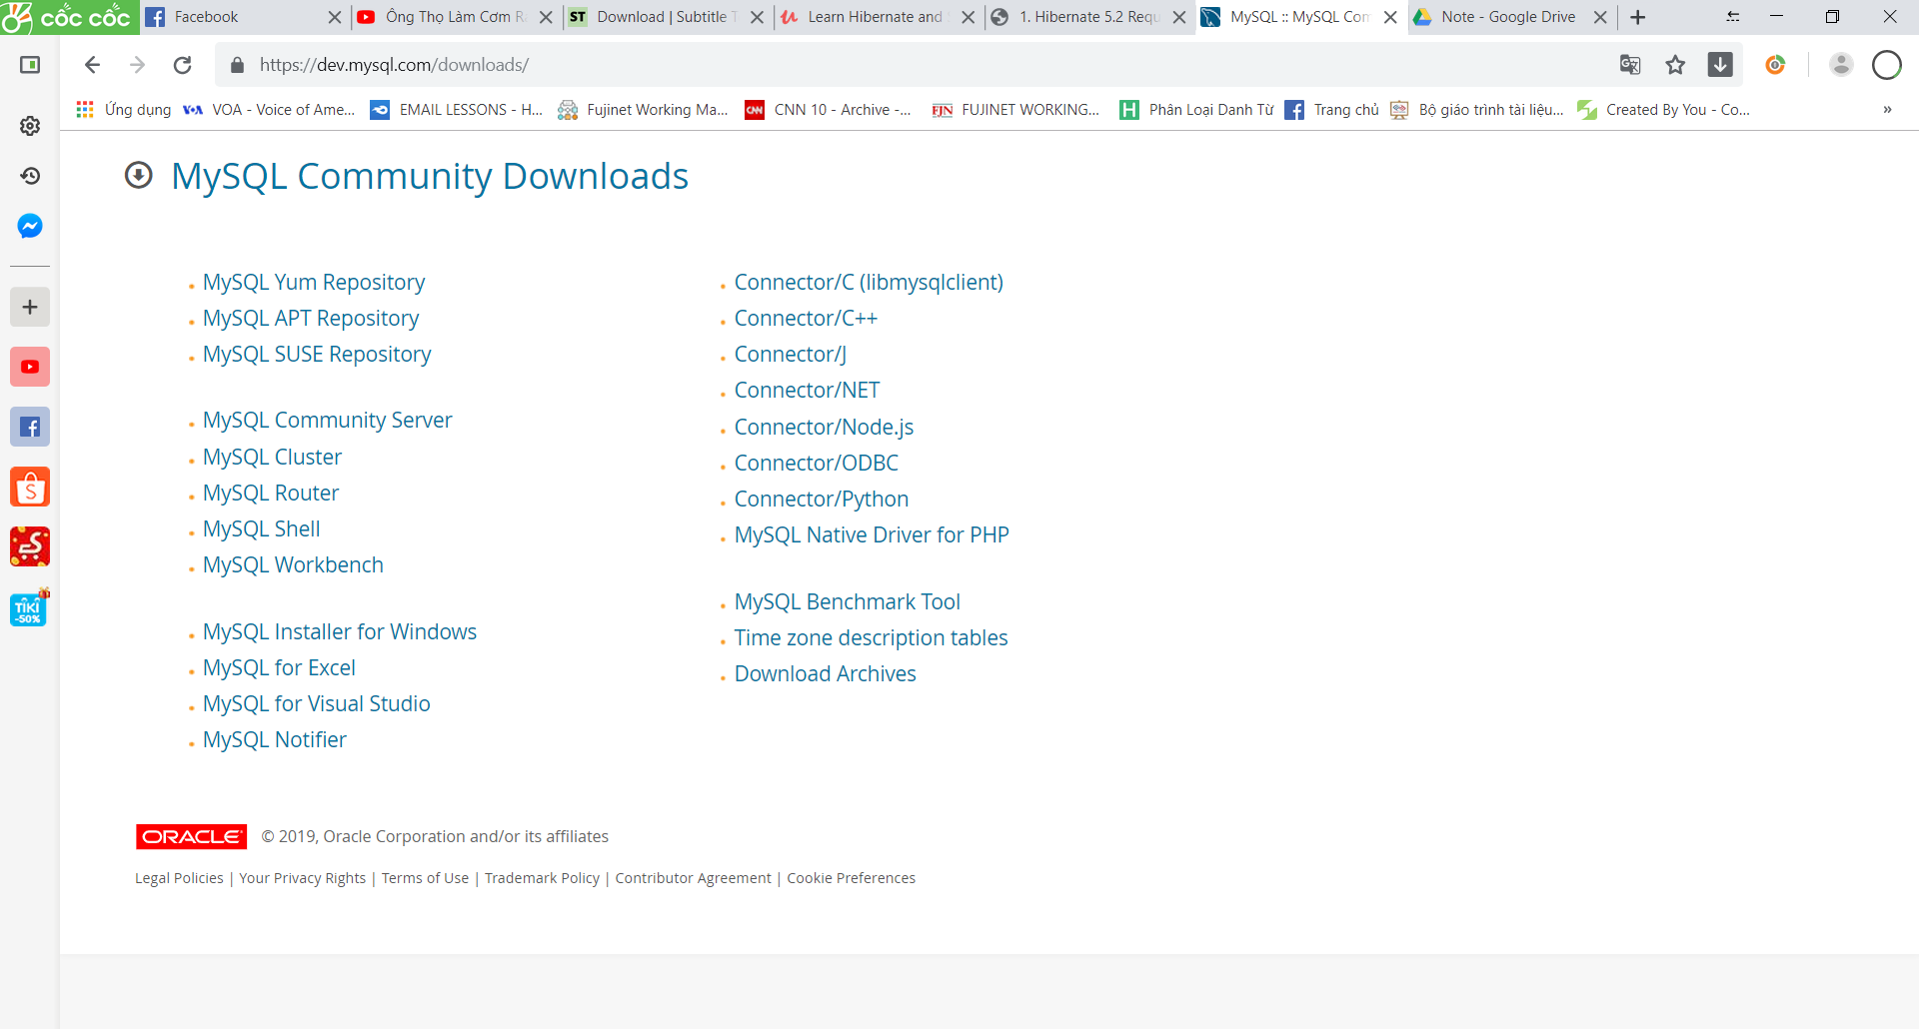

mysql-installer-community-8.0.16.0

pass: 1234

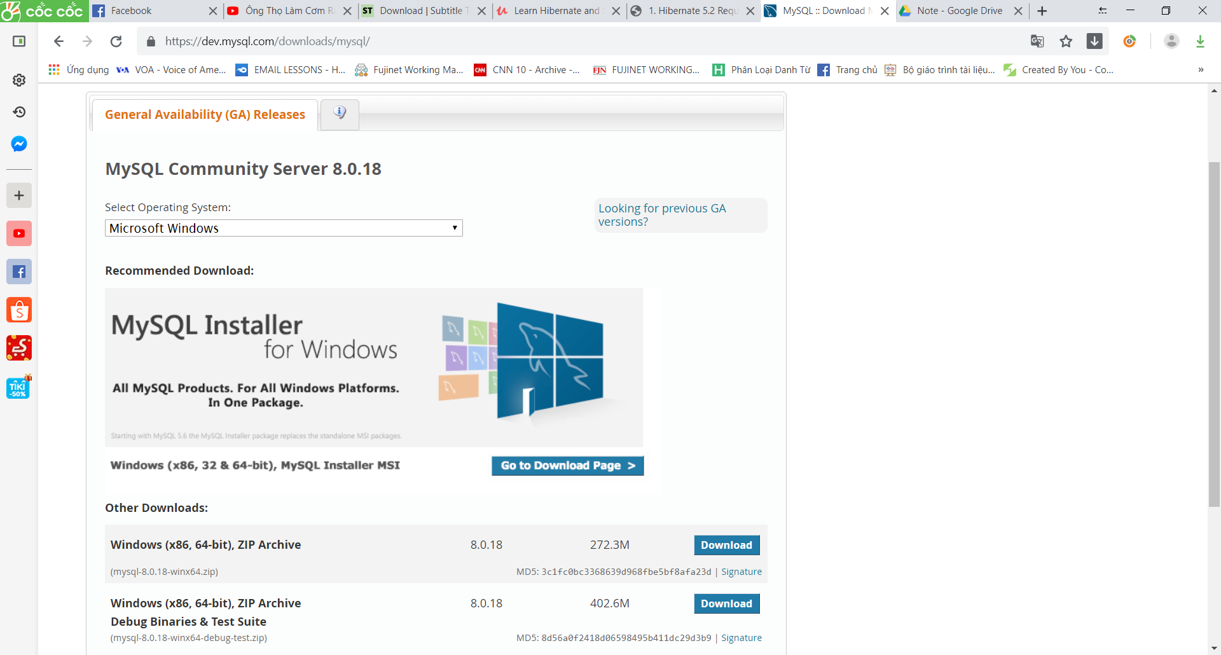

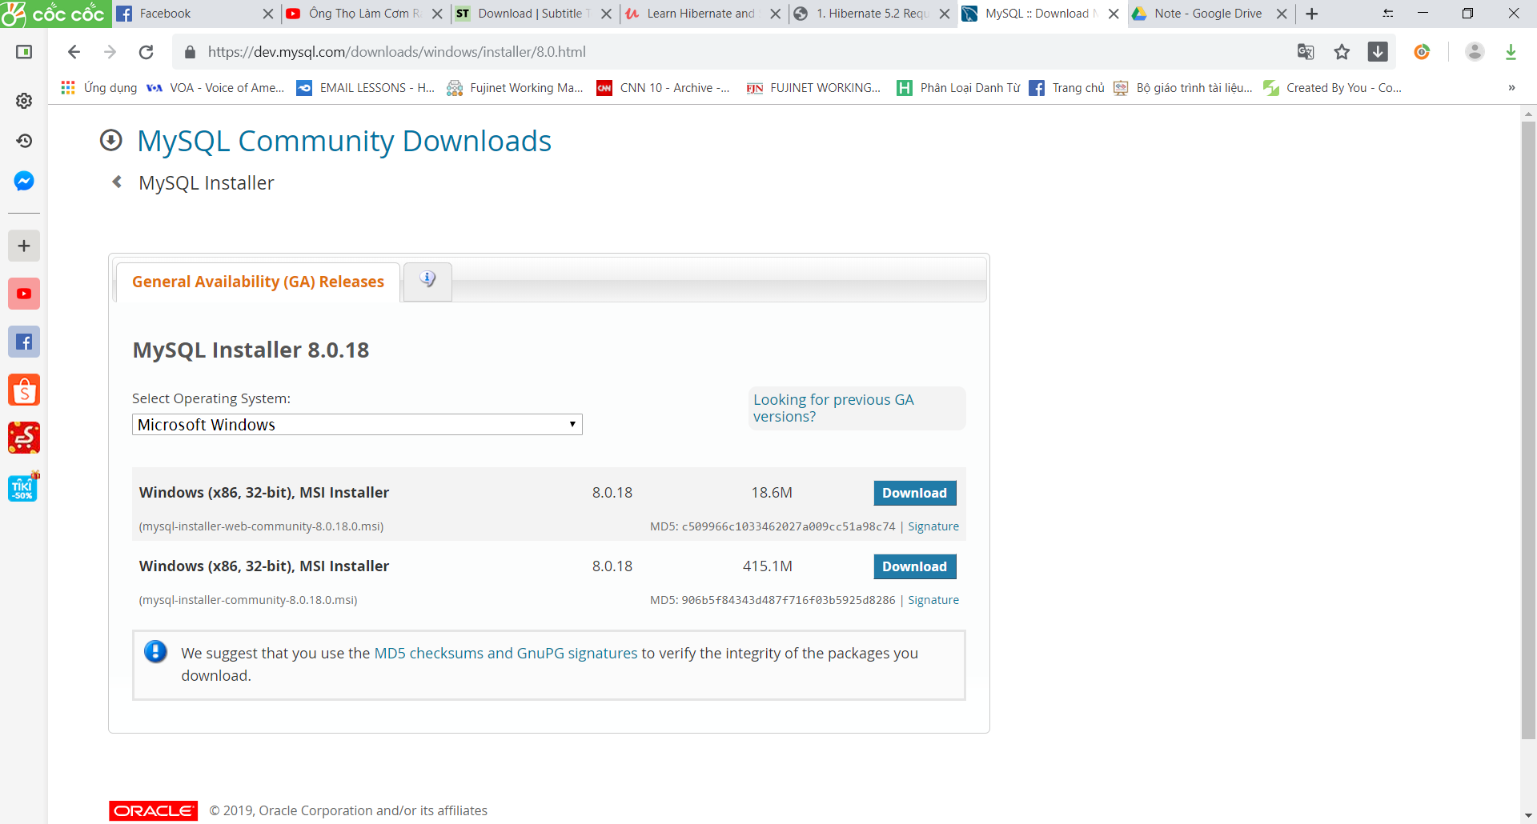

Chọn [No thanks, just start my download.](https://dev.mysql.com/get/Downloads/MySQLInstaller/mysql-installer-web-community-8.0.18.0.msi)

Chọn Mysql workbench rồi ấn Execute

Install MySQL on MAC

**Official MySQL Installation instructions**

<http://dev.mysql.com/doc/refman/5.7/en/osx-installation.html>

Setting Up Database Table

1. Folder: sql-scripts

01-create-user.sql

02-student-tracker.sql

1. Create a new MySQL user for our application  
user id: **hbstudent**password: **hbstudent**

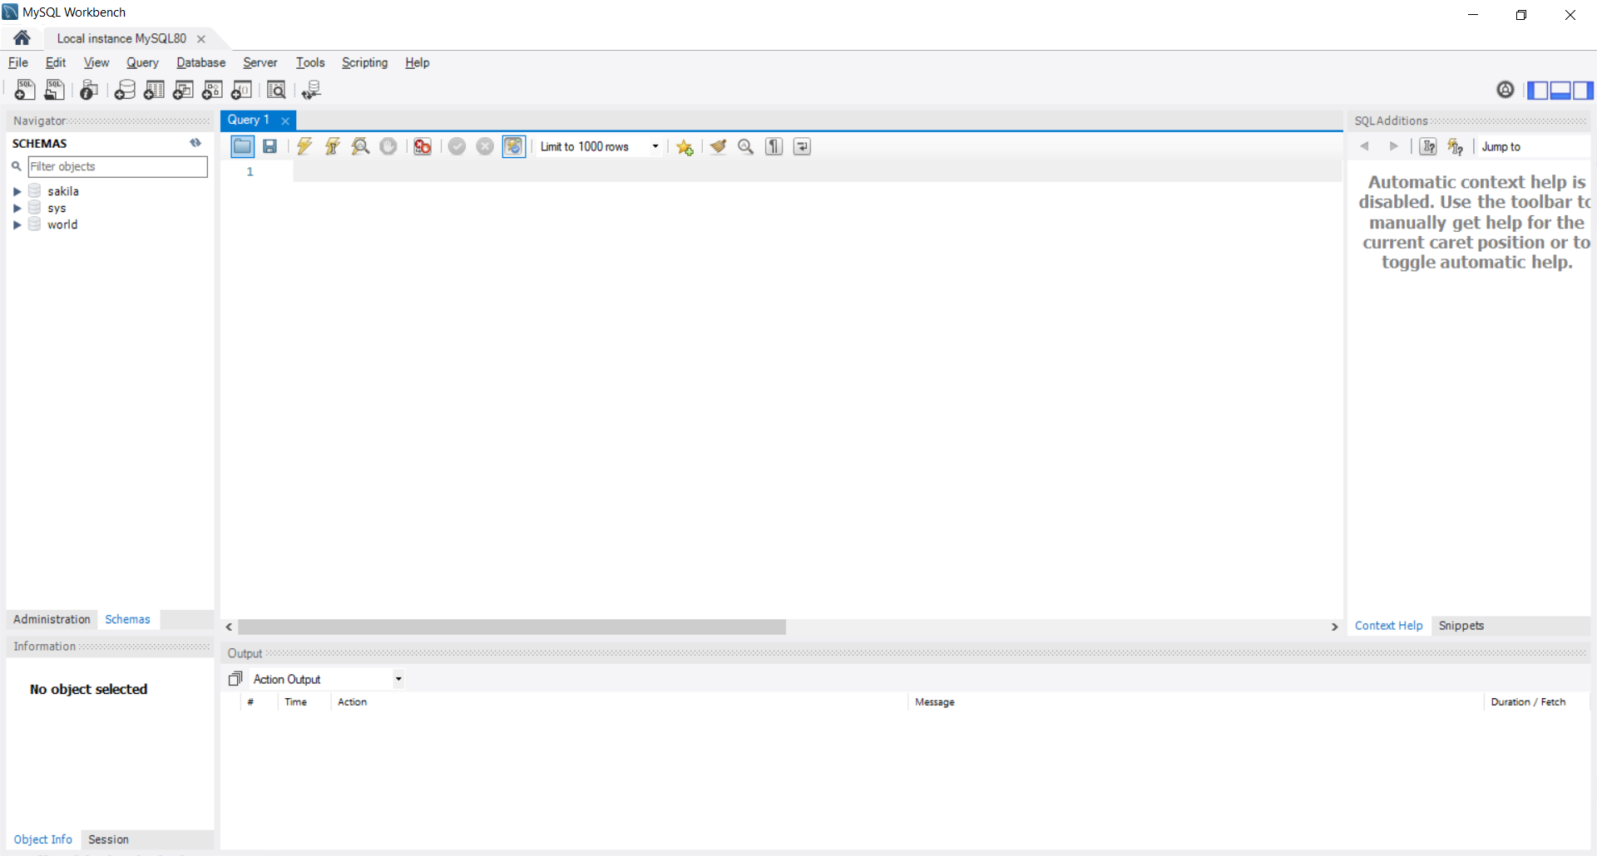

Chọn vào icon folder

Import file 01-create-user.sql để tạo user mới

CREATE USER 'hbstudent'@'localhost' IDENTIFIED BY 'hbstudent';  
  
GRANT ALL PRIVILEGES ON \* . \* TO 'hbstudent'@'localhost';  
  
#  
# Starting with MySQL 8.0.4, the MySQL team changed the   
# default authentication plugin for MySQL server   
# from mysql\_native\_password to caching\_sha2\_password.  
#  
# The command below will make the appropriate updates for your user account.  
#  
# See the MySQL Reference Manual for details:   
# https://dev.mysql.com/doc/refman/8.0/en/caching-sha2-pluggable-authentication.html  
#  
ALTER USER 'hbstudent'@'localhost' IDENTIFIED WITH mysql\_native\_password BY 'hbstudent';

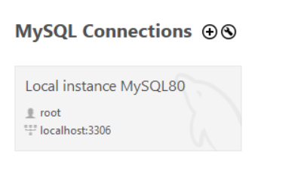

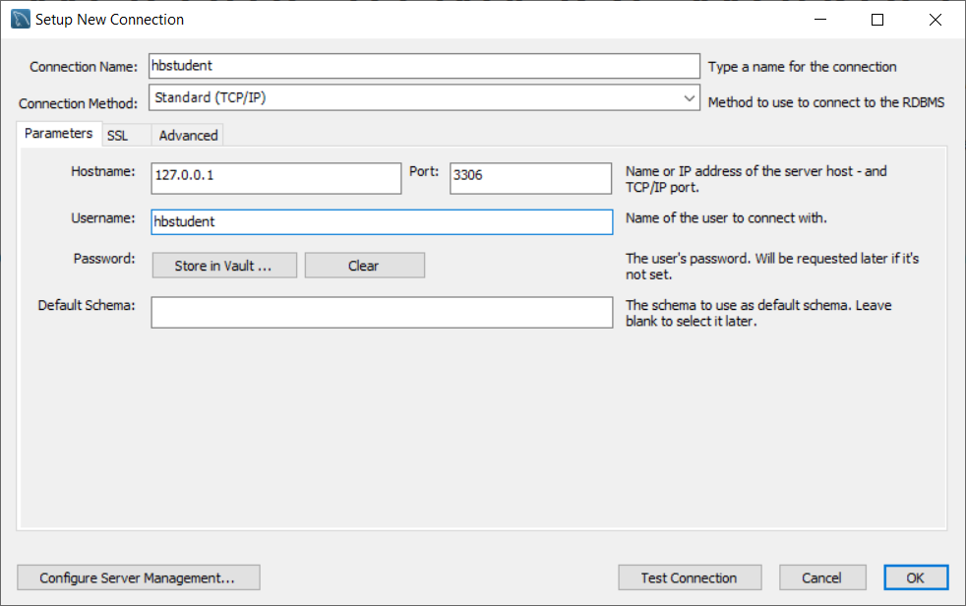

Pass: hbstudent

App

CREATE USER 'spstudent'@'localhost' IDENTIFIED BY 'spstudent';

GRANT ALL PRIVILEGES ON \* . \* TO 'spstudent'@'localhost';

To see which user you are, and whose permissions you have:

select user(), current\_user();

To delete the pesky anonymous user:

drop user ''@'localhost';

This is something to do with user permissions. Giving proper grants will solve this issue.

Step [1]: Open terminal and run this command

$ mysql -uroot -p

Output [1]: This should give you mysql prompt shown below

[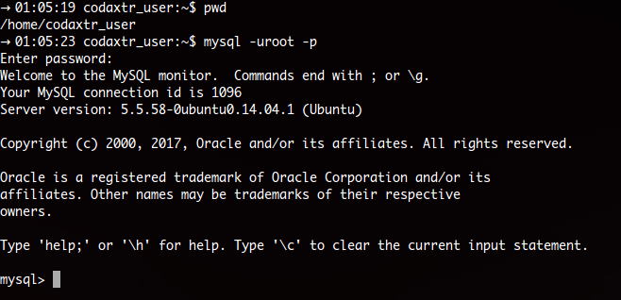](https://i.stack.imgur.com/MFbiL.png)

Step [2]:

mysql> CREATE USER 'parsa'@'localhost' IDENTIFIED BY 'your\_password';

mysql> grant all privileges on \*.\* to 'parsa'@'localhost';

Syntax:

mysql> grant all privileges on `database\_name`.`table\_name` to 'user\_name'@'hostname';

Note:

* hostname can be IP address, localhost, 127.0.0.1
* In database\_name/table\_name, \* means all databases
* In hostname, to specify all hosts use '%'

Step [3]: Get out of current mysql prompt by either entering quit / exit command or press Ctrl+D.

Step [4]: Login to your new user

$ mysql -uparsa -pyour\_password

Step [5]: Create the database

mysql> create database `database\_name`;

Setting up Hibernate in Eclipse

File new java project/ Create folder lib/ in src

<https://hibernate.org/orm/>

Tải version 5.4

Copy tất cả file trong \hibernate-release-5.4.6.Final\lib\required

Tải jdbc connector:

<https://dev.mysql.com/downloads/connector/j/5.1.html>

Rồi copy 1 file jar đó vào eclipse

Testing Your JDBC Connection

Tạo file TestJdbc

useSLL: get rid of Mysql SSL warning

import java.sql.Connection;  
import java.sql.DriverManager;

public static void main(String[] args) {  
  
 String jdbcUrl = "jdbc:mysql://localhost:3306/hb\_student\_tracker?useSSL=false&serverTimezone=UTC";  
 String user = "hbstudent";  
 String pass = "hbstudent";  
   
 try {  
 System.out.println("Connecting to database: " + jdbcUrl);  
   
 Connection myConn =  
 DriverManager.getConnection(jdbcUrl, user, pass);  
   
 System.out.println("Connection successful!!!");  
   
 }  
 catch (Exception exc) {  
 exc.printStackTrace();  
 }  
   
}

<http://luv2code.com/hibernate-tutorial>

Add Hibernate Configuration file

**hibernate.cfg.xml**

|  |
| --- |
| <!DOCTYPE hibernate-configuration PUBLIC |
|  | "-//Hibernate/Hibernate Configuration DTD 3.0//EN" |
|  | "http://www.hibernate.org/dtd/hibernate-configuration-3.0.dtd"> |
|  |  |
|  | <hibernate-configuration> |
|  | <session-factory> |
|  |  |
|  | <!-- Connection settings --> |
|  | <property name="connection.driver\_class">com.mysql.jdbc.Driver</property> |
|  | <property name="dialect">org.hibernate.dialect.MySQLDialect</property> |
|  | <!-- Sample MySQL URL provided --> |
|  | <property name="connection.url">jdbc:mysql://localhost:3306/project</property> |
|  | <property name="connection.username">root</property> |
|  | <property name="connection.password">root</property> |
|  |  |
|  | <!-- Show SQL on console --> |
|  | <property name="show\_sql">true</property> |
|  |  |
|  | <!--Setting Session context model --> |
|  | <property name="current\_session\_context\_class">thread</property> |
|  |  |
|  | </session-factory> |
|  | </hibernate-configuration> |

Nằm trong thư mục src

Tại class entity them getter và setter, hàm tạo có tham số trừ id

Thêm

@Entity

@Table(name = "users")

Class App

|  |
| --- |
|  |
| package org.studyeasy.hibernate; |
|  |  |
|  | import org.hibernate.Session; |
|  | import org.hibernate.SessionFactory; |
|  | import org.hibernate.cfg.Configuration; |
|  | import org.studyeasy.hibernate.entity.Users; |
|  |  |
|  | public class App { |
|  |  |
|  | public static void main(String[] args) { |
|  |  |
|  | SessionFactory factory = new Configuration() |
|  | .configure("hibernate.cfg.xml") |
|  | .addAnnotatedClass(Users.class) |
|  | .buildSessionFactory(); |
|  |  |
|  | Session session = factory.getCurrentSession(); |
|  |  |
|  | try { |
|  | // Create object of entity class type |
|  | Users user = new Users("username", "password", "firstName", "lastName"); |
|  | // Start transaction |
|  | session.beginTransaction(); |
|  | // Perform operation |
|  | session.save(user); |
|  | // Commit the transaction |
|  | session.getTransaction().commit(); |
|  | System.out.println("Row added!"); |
|  |  |
|  |  |
|  | } finally { |
|  | session.close(); |
|  | factory.close(); |
|  | } |
|  |  |
|  | } |
|  | } |
|  |  |
|  |  |
|  |  |

<https://studyeasy.org/hibernate/hibernate-configuration-xml/>

Annotate Java Class

@Entity, @Id, @Column

HEADS UP - FOR JAVA 9 USERS.html

**JUST A HEADS UP - FOR JAVA 9, 10 and 11 USERS**

**If you are using Java 9, 10 or 11, then you will encounter an error when you run your Hibernate program.**

**These are the steps to resolve it. Come back to the lecture if you hit the error.**

----

**Error: Exception in thread "main" java.lang.NoClassDefFoundError: javax/xml/bind/JAXBException**

This happens because of Java 9 and higher.

Java 9 and higher has removed java.xml.bind from its default classpath. That's why we get the class not found exception.  We have to explicitly add JAR files to the build path.

---

***Solution***

For Java 9 and higher, you need to additional JAR files.

You need to download the following JAR files:

javax.activation-1.2.0.jar  
jaxb-api-2.3.0.jar  
jaxb-core-2.3.0.jar  
jaxb-impl-2.3.0.jar

---

1. Download the files using links below:

[javax.activation-1.2.0.jar](http://search.maven.org/remotecontent?filepath=com/sun/activation/javax.activation/1.2.0/javax.activation-1.2.0.jar)

[jaxb-api-2.3.0.jar](http://search.maven.org/remotecontent?filepath=javax/xml/bind/jaxb-api/2.3.0/jaxb-api-2.3.0.jar)

[jaxb-core-2.3.0.jar](http://search.maven.org/remotecontent?filepath=com/sun/xml/bind/jaxb-core/2.3.0/jaxb-core-2.3.0.jar)

[jaxb-impl-2.3.0.jar](http://search.maven.org/remotecontent?filepath=com/sun/xml/bind/jaxb-impl/2.3.0/jaxb-impl-2.3.0.jar)

---

2. Copy the JAR files to the **lib** folder of your project

javax.activation-1.2.0.jar  
jaxb-api-2.3.0.jar  
jaxb-core-2.3.0.jar  
jaxb-impl-2.3.0.jar

---

Use the following steps to add the JAR files to your Java Build Path.

3. Right-click your project, select **Properties**

4. On left-hand side, click **Java Build Path**

5. In top-center of dialog, click **Libraries**

6. Click **Classpath** and then **Click Add JARs ...**

7. Navigate to the JAR files **<your-project>/lib**

Select the files:  
javax.activation-1.2.0.jar  
jaxb-api-2.3.0.jar  
jaxb-core-2.3.0.jar  
jaxb-impl-2.3.0.jar

8. Click OK then click Apply and Close

Eclipse will perform a rebuild of your project and it will resolve the related build/runtime errors.

====

**Error: import of the javax.persistance.GenerationType saying its not accessible**

You may still encounter problems for "import of the javax.persistance.GenerationType saying its not accessible"

To resolve this, apply the following steps

1. Right Click on the Project -> Properties - > Java Build Path.

2. Follow the steps as showed in the images below.

3. In Module Properties -> Select All in Available modules and move to Explicitly included modules.

4. Project->Clean... and Rebuild the Project and try again.

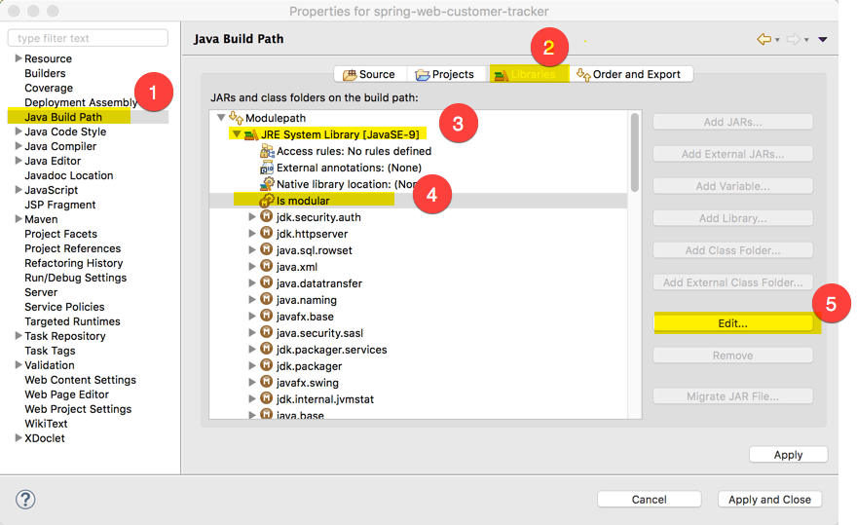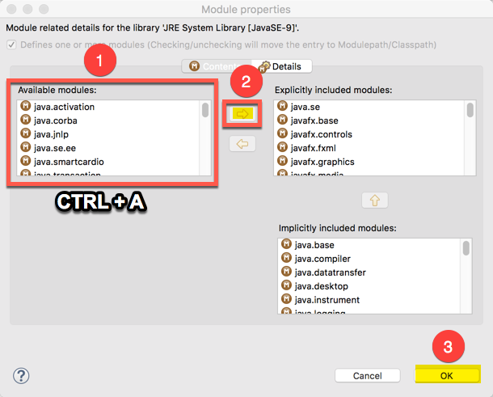

====

Note, if you are using Maven then you can add this to your POM file

<dependency>  
   <groupId>javax.xml.bind</groupId>  
   <artifactId>jaxb-api</artifactId>  
   <version>2.2.8</version>  
</dependency>  
  
<dependency>  
   <groupId>com.sun.xml.bind</groupId>  
   <artifactId>jaxb-core</artifactId>  
   <version>2.2.8</version>  
</dependency>  
  
<dependency>  
   <groupId>com.sun.xml.bind</groupId>  
   <artifactId>jaxb-impl</artifactId>  
   <version>2.2.8</version>  
</dependency>

<dependency>  
   <groupId>com.sun.activation</groupId>  
   <artifactId>javax.activation</artifactId>  
   <version>1.2.0</version>  
</dependency>

---

HEADS UP - JAVA 9 USERS - Eclipse Generate toString() fails.html

**HEADS UP - JAVA 9 USERS - Eclipse Generate toString() fails**

**Problem:**

The Generate toString() process fails in Eclipse with Java 9.

When clicking on Generate toString() an error message pops up saying:-

Cannot Create method Implementations

Reason:

C:\Program Files\Java\jre 9.04\lib\jrt-fs.jar\java.base[java.base is not in project's build path]

====

**Answer**

This is a bug in Eclipse when using Java 9.

It is a known issue and logged here by the Eclipse team.

Bug link: <https://bugs.eclipse.org/bugs/show_bug.cgi?id=521995>

---

As a work around, you will need to manually write the code for toString(). You can move ahead in the video and then pause the video where you see the toString() code.

**FAQ: Why we are using JPA Annotation instead of Hibernate ?**

**QUESTION:**Why we are using JPA Annotation instead of Hibernate ?

For example, why we are not using this org.hibernate.annotations.Entity?

**ANSWER:**JPA is a standard specification. Hibernate is an implementation of the JPA specification.

Hibernate implements all of the JPA annotations.

The Hibernate team recommends the use of JPA annotations as a best practice.

SessionFactory vs session

Xem pdf

<https://drive.google.com/drive/u/3/folders/1sb6eWHCxCrrHKiAOwhieEJvAo5RODq9x>

**SessionFactory**  
Reads the hibernate config file  
Creates Session objects  
Heavy-weight object  
Only create once in your app  
**Session**  
Wraps a JDBC connection  
Main object used to save/retrieve objects  
Short-lived object  
Retrieved from SessionFactory

Deault name: hibernate.cfg.xml

Sửa file config thành để chạy được:

<property name=*"connection.driver\_class"*>com.mysql.jdbc.Driver

</property>

<https://o7planning.org/vi/10201/huong-dan-lap-trinh-java-hibernate-cho-nguoi-moi-bat-dau#a77418>

Primary Keys - Overview

ID Generation Strategies

**GenerationType.AUTO**:

Pick an appropriate strategy for the particular database

**GenerationType.IDENTITY**: Assign primary keys using database identity column => Let mysql handle AUTO\_INCREMENT

**GenerationType.SEQUENCE**: Assign primary keys using a database sequence

**GenerationType.TABLE**: Assign primary keys using an underlying

database table to ensure uniqueness

@Id

@GeneratedValue(strategy=GenerationType.IDENTITY)

@Column(name="id")

private int id;

Primary Keys - Changing the Starting Index(Mysql)

ALERT TABLE hb.student AUTO\_INCREMENT=200

Cách reset

Truncate hn.student

Xem diagram MySQL

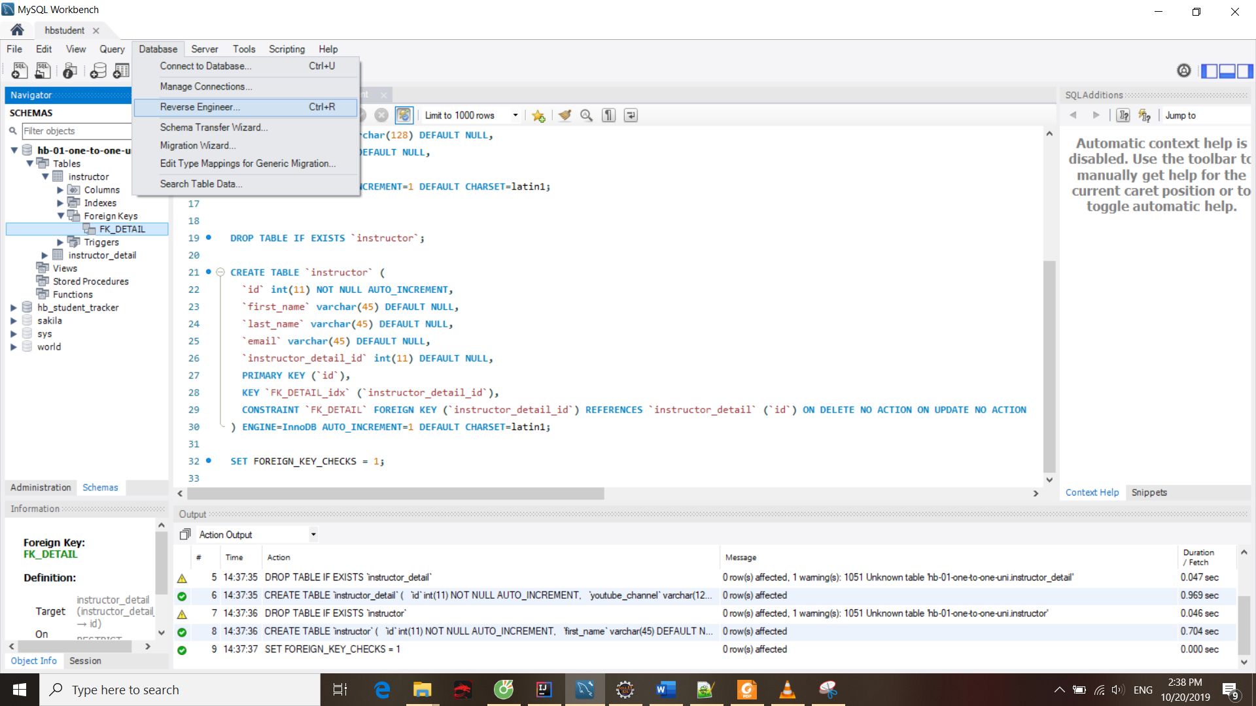

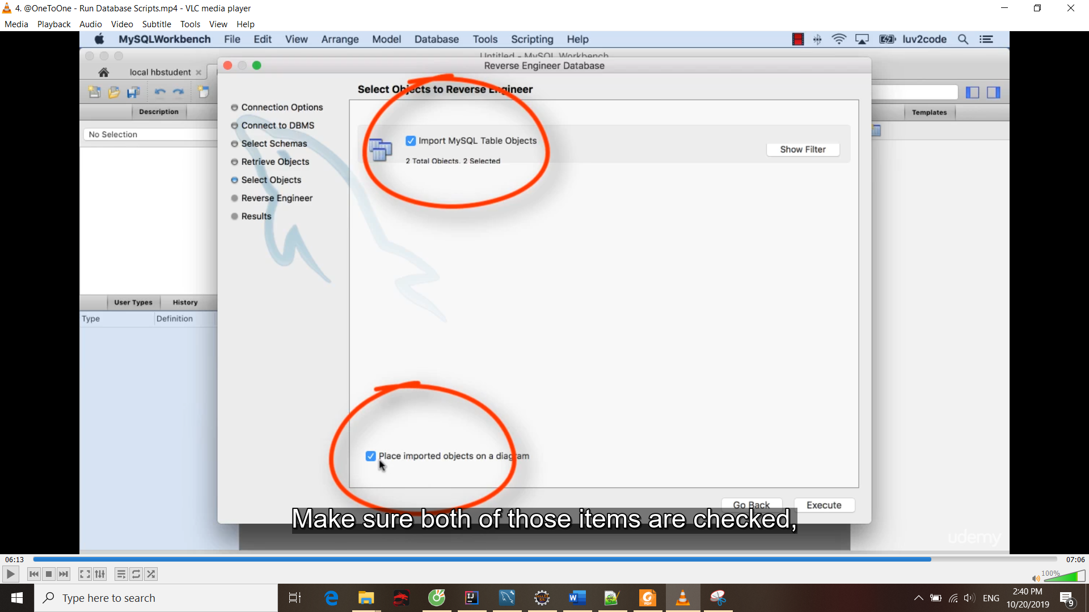

HQL

Xem pdf

If you are using Hibernate 5.2 or higher, then the Query list() method has been deprecated.

In your code you should make the following update:

**Replace**

session.createQuery("from Student").list()

**With**

session.createQuery("from Student").getResultList()

Tạo hàm nhanh

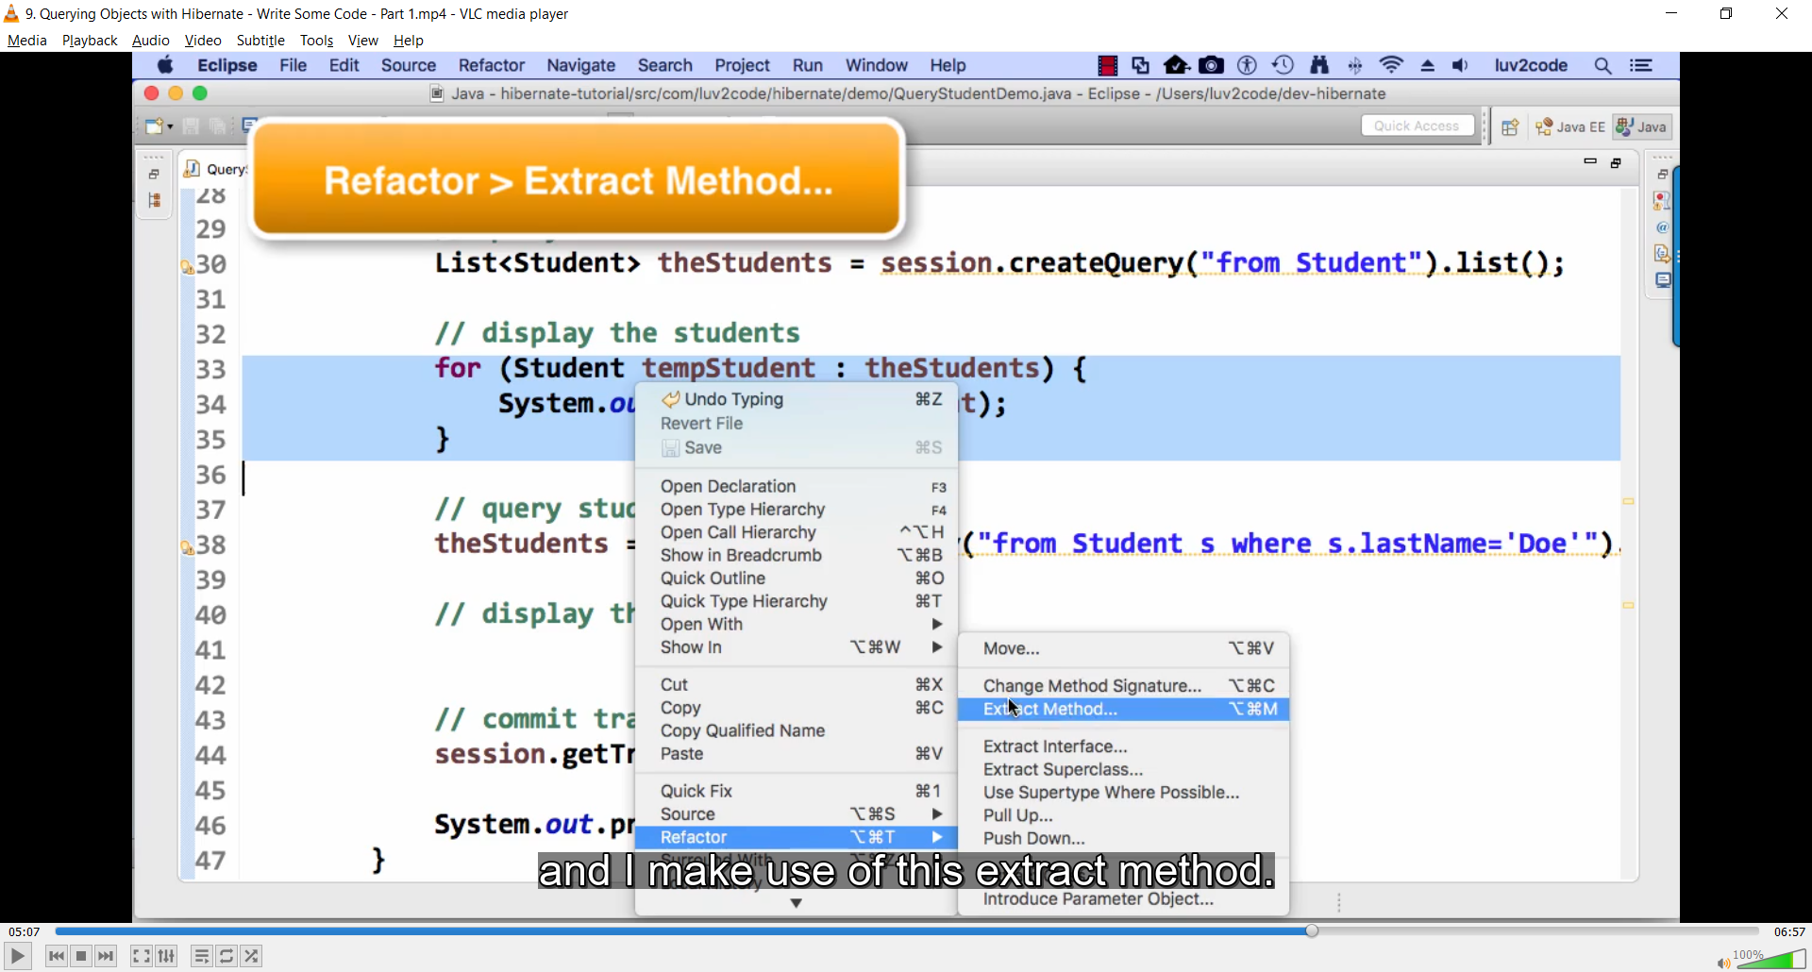

Add log4j

FAQ: How To View Hibernate SQL Parameter Values

**Question:**

I see hibernate printing out the query parameters as ? in the console.Is it possible to printout the value that was actually queried on thedatabase. Asking as this would help in the debugging purpose.

Answer:

When using Hibernate, if you log the Hibernate SQL statements, you will see this:

Hibernate: insert into student (email, first\_name, last\_name, id) values (?, ?, ?, ?)

However, for debugging your application, you want to see the actual parameter values in the Hibernate logs. Basically, you want to get rid of the question marks in the Hibernate logs.

You can view the actual parameters by viewing the low-level trace of the Hibernate logs. This is not set up by default. However, we can add log4j to allow us to see these low-level logs.

#### ****Here is an overview of the process:****

1. Add log4j to your project classpath

2. Add log4j.properties to your “src” directory

#### ****Here are the detailed steps:****

**1. Add log4j to your project classpath**

1a. Download log4j v1.2.17 from this link: – <http://central.maven.org/maven2/log4j/log4j/1.2.17/log4j-1.2.17.jar>

1b. Copy this file to your project’s lib directory

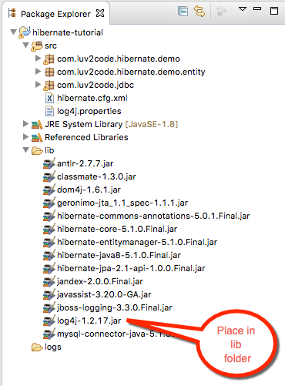

1c. Right-click your Eclipse project and select **Properties**

1d. Select**Build Path > Libraries > Add JARS…**

1e. Select the **log4j-1.2.17.jar** file from the **lib** directory

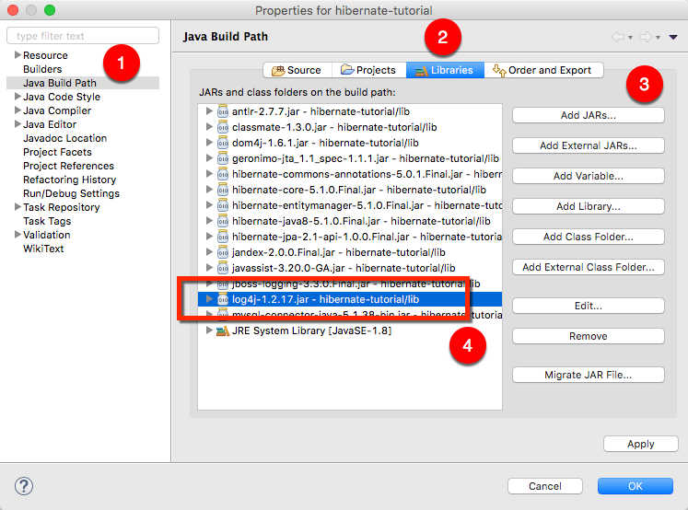

**2. Add log4j.properties to your “src” directory**

2a. Copy the text from below

# Root logger option

log4j.rootLogger=DEBUG, stdout

# Redirect log messages to console

log4j.appender.stdout=org.apache.log4j.ConsoleAppender

log4j.appender.stdout.Target=System.out

log4j.appender.stdout.layout=org.apache.log4j.PatternLayout

log4j.appender.stdout.layout.ConversionPattern=%d{yyyy-MM-dd HH:mm:ss} %-5p %c{1}:%L - %m%n

log4j.logger.org.hibernate=TRACE

2b. Save this file as "log4j.properties" in your “src” directory

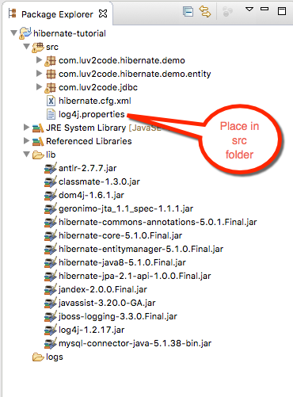

Note: This file has an important setting:

log4j.logger.org.hibernate=TRACE

This allows you see a low-level trace of Hibernate and this allows you see the real SQL parameter values.

Now run your application. You will see a lot of low-level TRACE logs in the Eclipse Console window.

Right-click in the Eclipse Console window and select **Find/Replace…**

Search for: **binding parameter**

or search for: **extracted value**

(the search string changes depending on which version of Hibernate you are using)

You will see the logs with the real parameter values. Congrats!

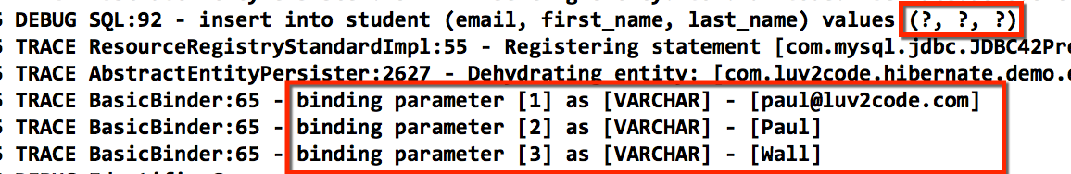

FAQ How to read Dates with Hibernate.html

**FAQ: Handling Dates with Hibernate**

How can I read date strings from the command-line and store them as dates in the database?

**Answer:**

You can make use of a combination of Java's date formatting class and Hibernate annotations.

Sample output:

Student [id=50, firstName=Paul, lastName=Doe, email=paul@luv2code.com, dateOfBirth=null]  
Student [id=51, firstName=Daffy, lastName=Duck, email=daffy@luv2code.com, dateOfBirth=null]  
Student [id=52, firstName=Paul, lastName=Doe, email=paul@luv.com, dateOfBirth=31/12/1998]

**Development Process Overview**

1. Alter database table for student  
2. Add a date utils class for parsing and formatting dates  
3. Add date field to Student class  
4. Add toString method to Student class  
5. Update CreateStudentDemo

----

**Detailed steps**

1. Alter database table for student

We need to alter the database table to add a new column for "date\_of\_birth".

Run the following SQL in your MySQL Workbench tool.

ALTER TABLE `hb\_student\_tracker`.`student`

ADD COLUMN `date\_of\_birth` DATETIME NULL AFTER `last\_name`;

--

2. Add a date utils class for parsing and formatting dates

We need to add a DateUtils class to handle parsing and formatting dates. The source code is here. The class should be placed in the package: com.luv2code.hibernate.demo.

The date formatter uses special symbols for formatting/parsing.

-  dd:  day in month (number)  
-  MM:  month in year (number)  
- yyyy: year

See this link for details: https://docs.oracle.com/javase/tutorial/i18n/format/simpleDateFormat.html

package com.luv2code.hibernate.demo;

import java.text.ParseException;

import java.text.SimpleDateFormat;

import java.util.Date;

public class DateUtils {

// The date formatter

// - dd: day in month (number)

// - MM: month in year (number)

// - yyyy: year

//

// See this link for details: https://docs.oracle.com/javase/tutorial/i18n/format/simpleDateFormat.html

//

//

private static SimpleDateFormat formatter = new SimpleDateFormat("dd/MM/yyyy");

// read a date string and parse/convert to a date

public static Date parseDate(String dateStr) throws ParseException {

Date theDate = formatter.parse(dateStr);

return theDate;

}

// read a date and format/convert to a string

public static String formatDate(Date theDate) {

String result = null;

if (theDate != null) {

result = formatter.format(theDate);

}

return result;

}

}

---

3. Add date field to Student class

We need to add a date field to the Student class. We map this field to the database column, "date\_of\_birth". Also, we make use of the @Temporal annotation. This is a Java annotation for storing dates.

@Column(name="date\_of\_birth")

@Temporal(TemporalType.DATE)

private Date dateOfBirth;

Here's the full source code.

---

package com.luv2code.hibernate.demo.entity;

import java.util.Date;

import javax.persistence.Column;  
import javax.persistence.Entity;  
import javax.persistence.Id;  
import javax.persistence.Table;  
import javax.persistence.Temporal;  
import javax.persistence.TemporalType;

import com.luv2code.hibernate.demo.DateUtils;

@Entity  
@Table(name="student")  
public class Student {  
      
    @Id  
    @Column(name="id")  
    private int id;  
      
    @Column(name="first\_name")  
    private String firstName;  
      
    @Column(name="last\_name")  
    private String lastName;  
      
    @Column(name="email")  
    private String email;  
      
    @Column(name="date\_of\_birth")  
    @Temporal(TemporalType.DATE)      
    private Date dateOfBirth;  
      
    public Student() {  
          
    }

    public Student( String firstName, String lastName, String email, Date theDateOfBirth) {  
          
        this.firstName = firstName;  
        this.lastName = lastName;  
        this.email = email;  
        this.dateOfBirth = theDateOfBirth;  
          
    }

    public int getId() {  
        return id;  
    }

    public void setId(int id) {  
        this.id = id;  
    }

    public String getFirstName() {  
        return firstName;  
    }

    public void setFirstName(String firstName) {  
        this.firstName = firstName;  
    }

    public String getLastName() {  
        return lastName;  
    }

    public void setLastName(String lastName) {  
        this.lastName = lastName;  
    }

    public String getEmail() {  
        return email;  
    }

    public void setEmail(String email) {  
        this.email = email;  
    }

    public Date getDateOfBirth() {  
        return dateOfBirth;  
    }

    public void setDateOfBirth(Date dateOfBirth) {  
        this.dateOfBirth = dateOfBirth;  
    }

    @Override  
    public String toString() {  
        return "Student [id=" + id + ", firstName=" + firstName + ", lastName=" + lastName + ", email=" + email  
                + ", dateOfBirth=" + DateUtils.formatDate(dateOfBirth) + "]";  
    }  
          
}

---

4. Add toString method to Student class

We will make an update to the toString method in our Student class.  It will use the formatter from our DateUtils.class. This code is already included in Student.java from the previous step. I'm just highlighting it here for clarity.

return "Student [id=" + id + ", firstName=" + firstName + ", lastName=" + lastName + ", email=" + email

+ ", dateOfBirth=" + DateUtils.formatDate(dateOfBirth) + "]";

Note the use of DateUtils above.

---

5. Update CreateStudentDemo

Now for the grand finale. In the main program, read the date as a String and parse/convert it to a date. Here's the snippet of code.

String theDateOfBirthStr = "31/12/1998";

Date theDateOfBirth = DateUtils.parseDate(theDateOfBirthStr);

Student temoStudent = new Student("Paully", "Doe", "paul@luv.com", theDateOfBirth);

Here's the full code:

package com.luv2code.hibernate.demo;

import java.text.ParseException;

import java.util.Date;

import org.hibernate.Session;

import org.hibernate.SessionFactory;

import org.hibernate.cfg.Configuration;

import com.luv2code.hibernate.demo.entity.Student;

public class CreateStudentDemo {

public static void main(String[] args) {

// create session factory

SessionFactory factory = new Configuration().configure("hibernate.cfg.xml").addAnnotatedClass(Student.class)

.buildSessionFactory();

// create a session

Session session = factory.getCurrentSession();

try {

// create a student object

System.out.println("creating a new student object ...");

String theDateOfBirthStr = "31/12/1998";

Date theDateOfBirth = DateUtils.parseDate(theDateOfBirthStr);

Student temoStudent = new Student("Paully", "Doe", "paul@luv.com", theDateOfBirth);

// start transaction

session.beginTransaction();

// save the student object

System.out.println("Saving the student ...");

session.save(temoStudent);

// commit transaction

session.getTransaction().commit();

System.out.println("Success!");

} catch (Exception exc) {

exc.printStackTrace();

} finally {

factory.close();

}

}

}

Cascade

If we delete an instructor, we should also delete their instructor\_detail

• This is known as “CASCADE DELETE”

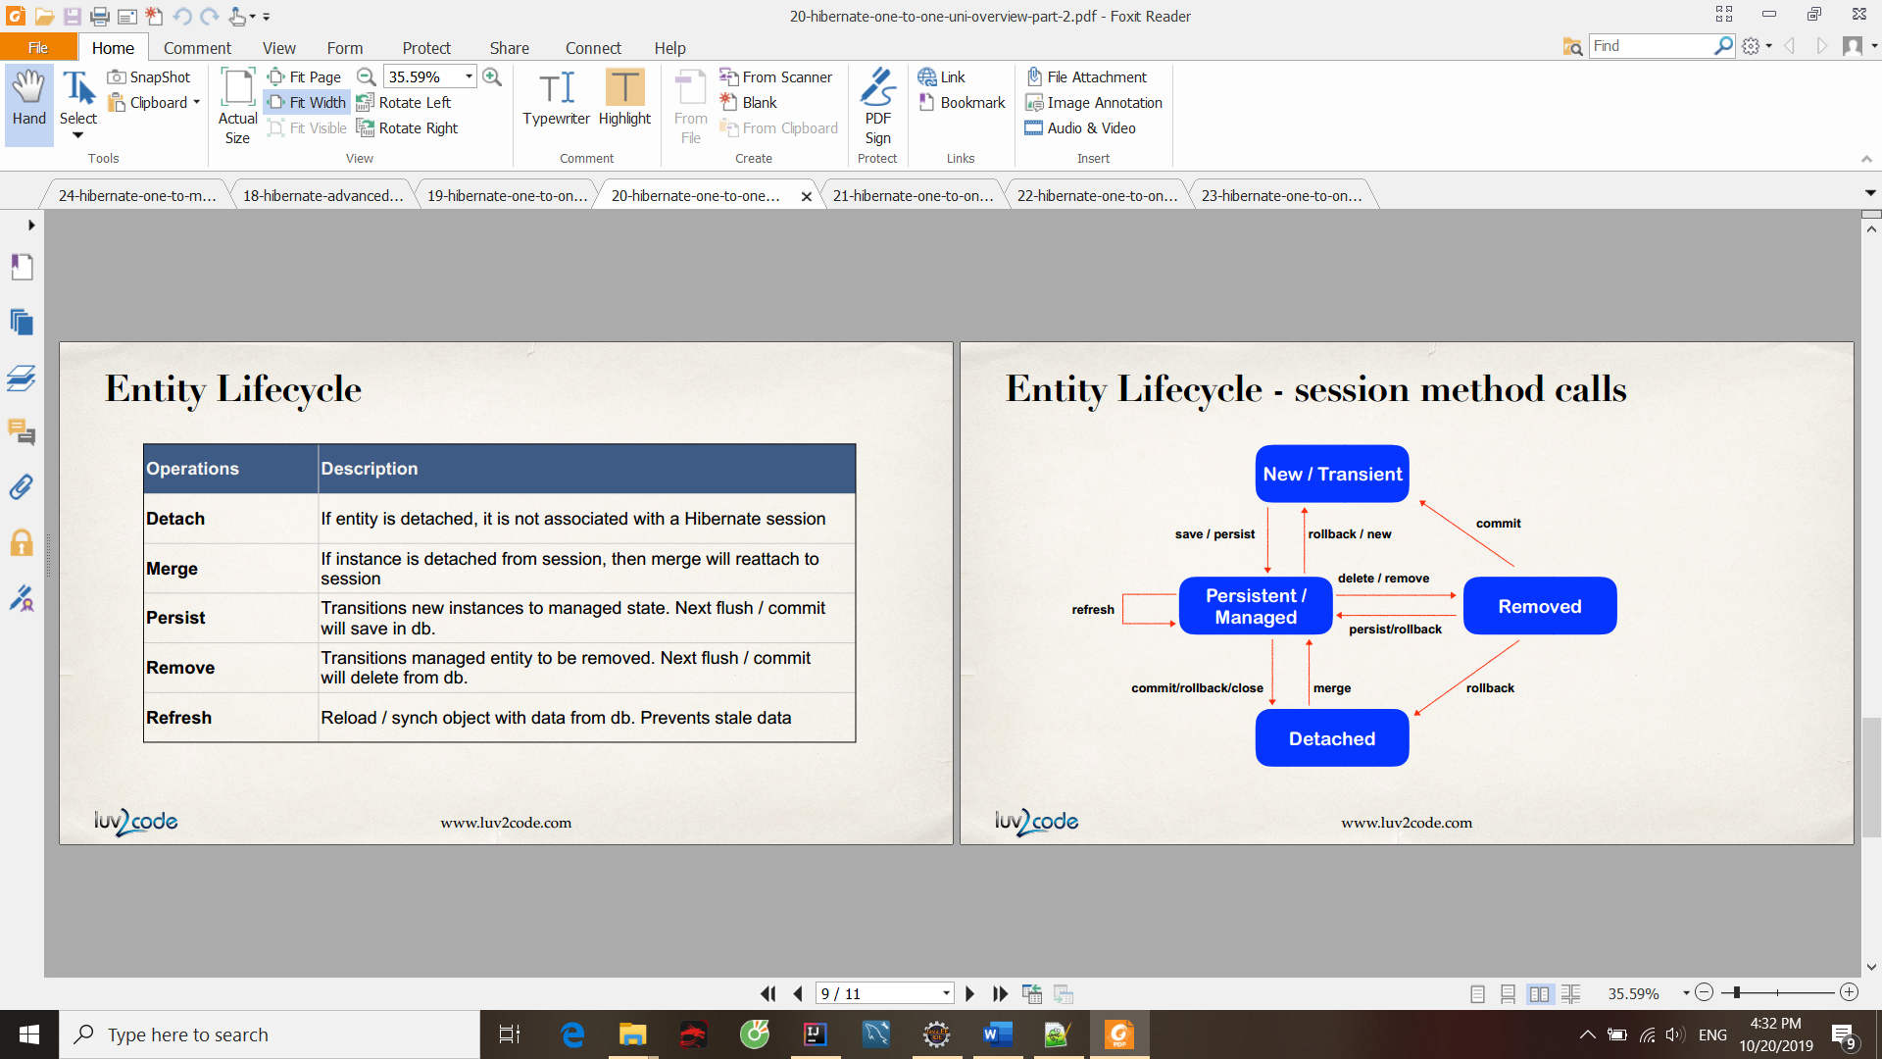

Nếu không chỉ rõ thì k có operation nào được cascaded

Fetch Types: Eager vs Lazy Loading

When we fetch / retrieve data, should we retrieve EVERYTHING?

• Eager will retrieve everything

• Lazy will retrieve on request

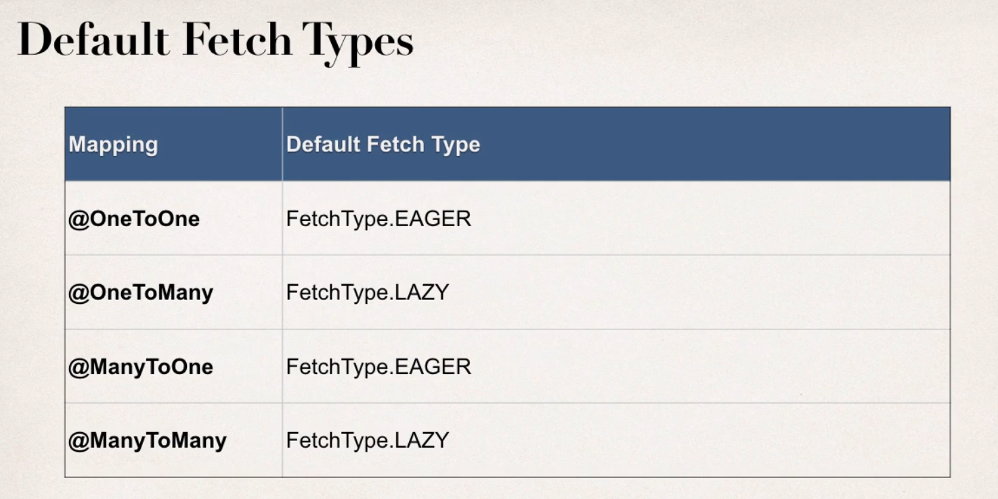

****FAQ: How load the courses at a later time in the application?****

**Question**I've watched your 2 solutions for loading related data after session closing. Both, either getting related courses before closing session and using JOIN FETCH seem to be negating of lazy loading (using those solutions we completely resign of lazy loading.

Is there any good solution to load these data somewhere else in the app? Should I open new session?

---

**Answer**Yes, you can load it later with using a new session, just make use of HQL

Here's the code snippet. Make note of HQL in bold

            session = factory.getCurrentSession();  
              
            session.beginTransaction();  
              
**// get courses for a given instructor  
            Query<Course> query = session.createQuery("select c from Course c "  
                                                    + "where c.instructor.id=:theInstructorId",      
                                                    Course.class);**              
            query.setParameter("theInstructorId", theId);  
              
            List<Course> tempCourses = query.getResultList();  
              
            System.out.println("tempCourses: " + tempCourses);  
---

Here's the full example.

:-)

---

package com.luv2code.hibernate.demo;

import java.util.List;

import org.hibernate.Session;  
import org.hibernate.SessionFactory;  
import org.hibernate.cfg.Configuration;  
import org.hibernate.query.Query;

import com.luv2code.hibernate.demo.entity.Course;  
import com.luv2code.hibernate.demo.entity.Instructor;  
import com.luv2code.hibernate.demo.entity.InstructorDetail;

public class GetCoursesLater {

    public static void main(String[] args) {

        // create session factory  
        SessionFactory factory = new Configuration()  
                                .configure("hibernate.cfg.xml")  
                                .addAnnotatedClass(Instructor.class)  
                                .addAnnotatedClass(InstructorDetail.class)  
                                .addAnnotatedClass(Course.class)  
                                .buildSessionFactory();  
          
        // create session  
        Session session = factory.getCurrentSession();  
          
        try {              
              
            // start a transaction  
            session.beginTransaction();  
                          
            // get the instructor from db  
            int theId = 1;  
            Instructor tempInstructor = session.get(Instructor.class, theId);                      
              
            System.out.println("luv2code: Instructor: " + tempInstructor);      
              
            // commit transaction  
            session.getTransaction().commit();  
              
            // close the session  
            session.close();

            System.out.println("\nluv2code: The session is now closed!\n");

            //  
            // THIS HAPPENS SOMEWHERE ELSE / LATER IN THE PROGRAM

            // YOU NEED TO GET A NEW SESSION  
            //  
              
            System.out.println("\n\nluv2code: Opening a NEW session \n");

            session = factory.getCurrentSession();  
              
            session.beginTransaction();  
              
            // get courses for a given instructor  
            Query<Course> query = session.createQuery("select c from Course c "  
                                                    + "where c.instructor.id=:theInstructorId",      
                                                    Course.class);  
              
            query.setParameter("theInstructorId", theId);  
              
            List<Course> tempCourses = query.getResultList();  
              
            System.out.println("tempCourses: " + tempCourses);  
              
            // now assign to instructor object in memory  
            tempInstructor.setCourses(tempCourses);  
              
            System.out.println("luv2code: Courses: " + tempInstructor.getCourses());  
              
            session.getTransaction().commit();  
              
            System.out.println("luv2code: Done!");  
        }  
        finally {  
              
            // add clean up code  
            session.close();  
              
            factory.close();  
        }  
    }

}

@JoinColumn

**@JoinColum ... where does it find the column?**

**Question**

In the Course class,we have OneToMany relation with reviews with join column course\_id.

But in course table we do not have column course\_id.

Ideally when we say @JoinColumn a new column should be created in course table ... isn't it?

How does @JoinColum know where to find the join column?

---

**Answer**

The JoinColumn is actually fairly complex and it goes through a number of advanced steps to find the desired column.

This info below is from the documentation

Source: http://docs.oracle.com/javaee/7/api/javax/persistence/JoinColumn.html#name--

---

The table in which it is found depends upon the context.

- If the join is for a OneToOne or ManyToOne mapping using a foreign key mapping strategy, the foreign key column is in the table of the source entity or embeddable.

- If the join is for a unidirectional OneToMany mapping using a foreign key mapping strategy, the foreign key is in the table of the target entity.

- If the join is for a ManyToMany mapping or for a OneToOne or bidirectional ManyToOne/OneToMany mapping using a join table, the foreign key is in a join table.

- If the join is for an element collection, the foreign key is in a collection table.

--

So as you can see, it depends on the context.

In our training video, we are using @OneToMany uni-directional (course has one-to-many reviews).

As a result, the join column / foreign key column is in the target entity. In this case, the target entity is the Review class. So, you will find the join column "course\_id" in the "review" table.

**Note**: Thông thường @JoinColumn thường đặt ở khóa ngoại

<http://luv2code.com/hibernate-mapping-database-scripts>

Download db scripts

Source Files for Spring MVC + Hibernate Web App.html

Source Files for Spring MVC + Hibernate Web App

In the following videos, you will need to use some starter files. The starter files include SQL scripts and JAR files.

The files are attached to each video. However, if you'd like, you can also download the entire bundle.

---

You can download the entire source code bundle from this link:

**Section 1, Lecture 5**  
<https://www.udemy.com/spring-hibernate-tutorial/learn/v4/t/lecture/5117038?start=0>

Once you upzip, then you'll have this directory structure.

---

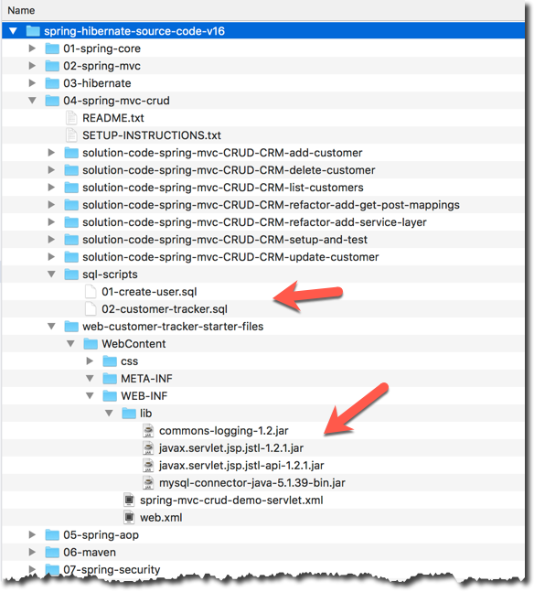

--

Then you can find the files that I use in this directory:

spring-hibernate-source-code-vXX/04-spring-mvc-crud/sql-scripts

and

spring-hibernate-source-code-vXX/04-spring-mvc-crud/web-customer-tracker-starter-files

Regarding the JAR files, they are in

spring-hibernate-source-code-vXX/04-spring-mvc-crud/web-customer-tracker-starter-files/WebContent/WEB-INF/lib

this directory includes commons-logging, jstl and mysql jdbc driver

---

You will still need to add the Spring and Hibernate files separately, but we'll cover that process in later videos. I'll walk you through the process.

Config connection pool

Download c3p0

## Maven

How to Install the m2eclipse Plugin.html

**How To Install Maven m2eclipse Plugin**

*Note: Recent releases of Eclipse (Mar, Neon, Oxygen) already have the m2eclipse plugin installed. Only follow these steps if you don't have the plugin installed.*

1. In Eclipse, select**Help > Install New Software**

This will display the Install dialog

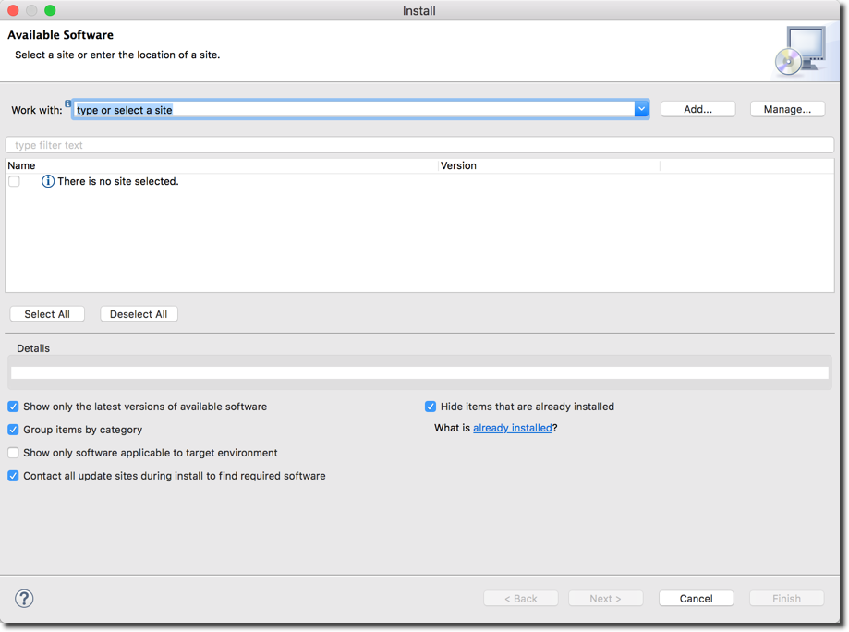

2. Click the **"Add..."** button.

3. In the dialog, enter the following from the screenshow below:

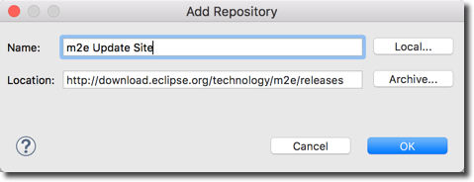

4. Wait for a couple of minutes while Eclipse fetches the files

5. In the dialog, check the box for**"Maven Integration for Eclipse"**

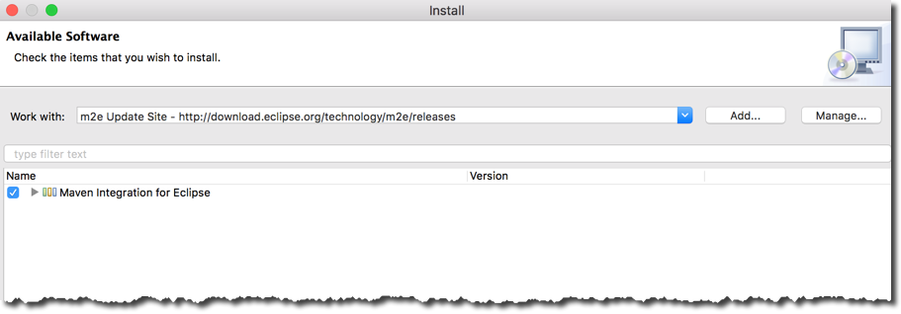

6. Click Next

7. It will show a dialog to review components, Click **Next**

8. Accept the License Agreement, Click **Finish**

9. Once installation is complete, restart Eclipse.

---

**Verify Installation**

10. In Eclipse, select **Help > Install New Software**

11. In bottom right of dialog, you will see a blue link: **What is already installed?**

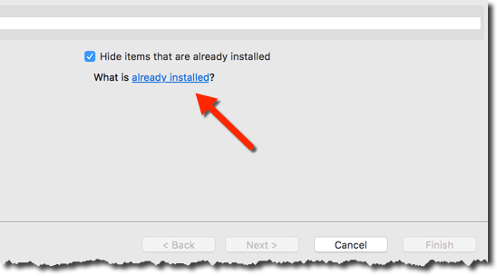

12. Click the link

13. In the dialog, filter on the text: **m2e**

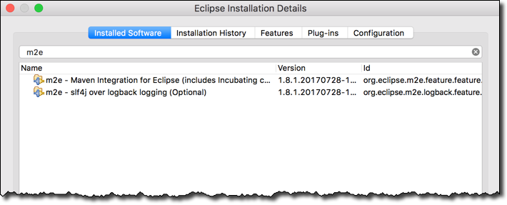  
  
14. If you see the m2e entries, then the plugin was installed successfully :-)

Create maven project

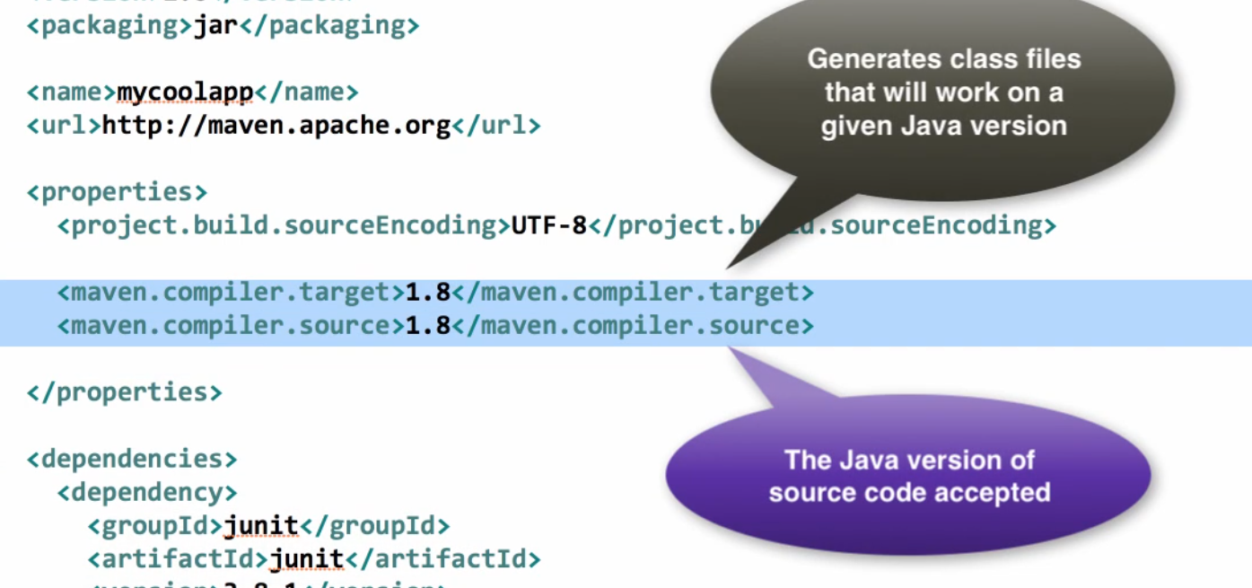

Update maven project:

Project/ Maven/ Update project

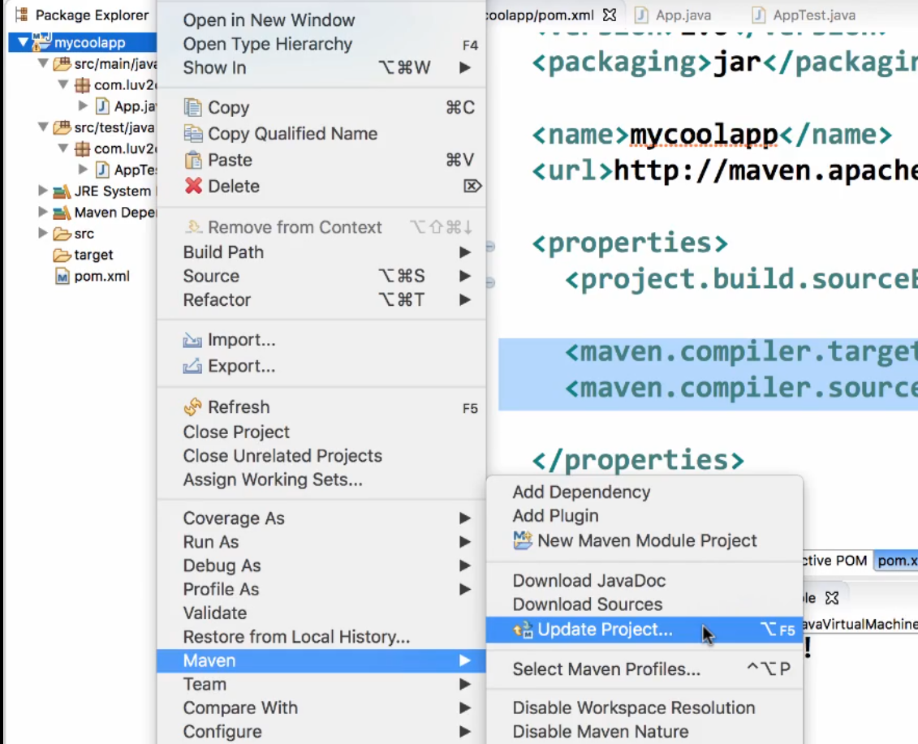

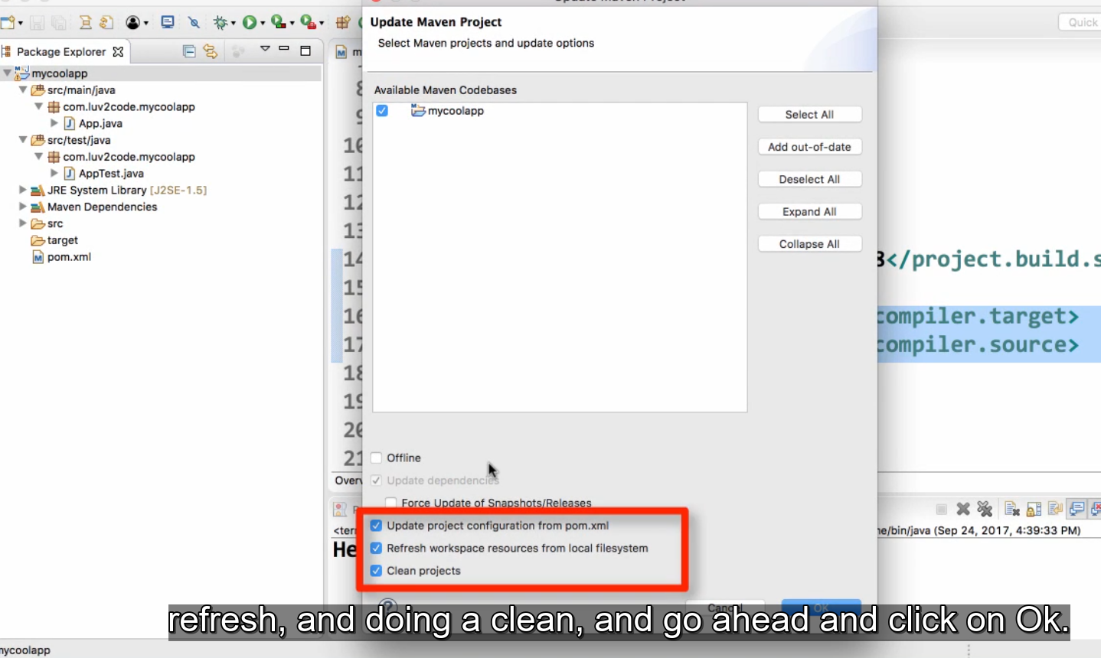

Khi tạo web-app sẽ bị lỗi

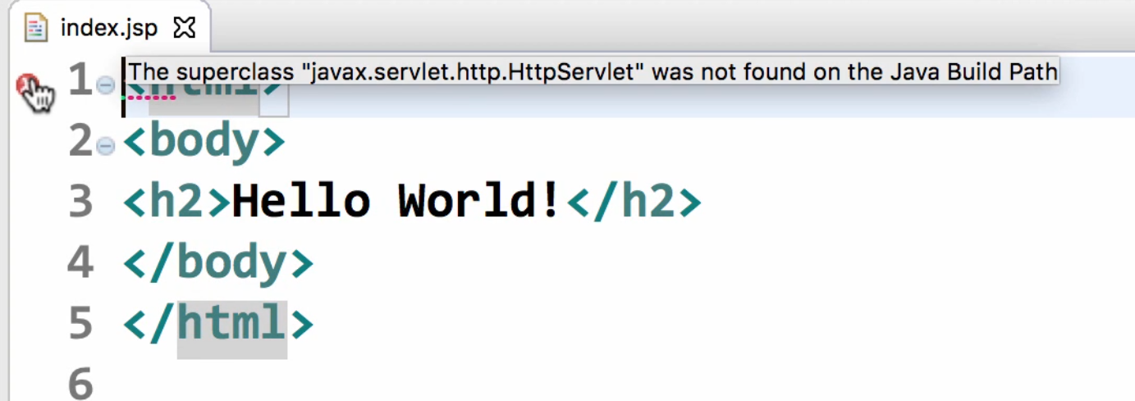

Add them dependencies

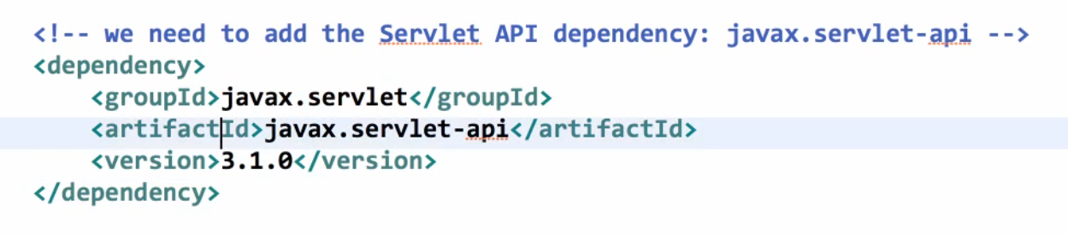

Run as/ Run on server của file index.jsp

Local Repository

• Located on developer’s computer

• MS Windows: c:\Users\<users-home-dir>\.m2\repository

• Mac and Linux: ~/.m2/repository

• Maven will search this local repository first

• Before going to Maven Central Repository

• Your local cache

3. Spring Security - All Java Configuration - Part 1

Custom for no use web.xml

Pom.xml

<project xmlns="http://maven.apache.org/POM/4.0.0" xmlns:xsi="http://www.w3.org/2001/XMLSchema-instance"  
 xsi:schemaLocation="http://maven.apache.org/POM/4.0.0 http://maven.apache.org/xsd/maven-4.0.0.xsd">  
 <modelVersion>4.0.0</modelVersion>  
  
 <groupId>com.luv2code</groupId>  
 <artifactId>spring-security-demo</artifactId>  
 <version>1.0</version>  
 <packaging>war</packaging>  
  
 <name>spring-security-demo</name>  
  
 <properties>  
 <springframework.version>5.0.2.RELEASE</springframework.version>  
  
 <maven.compiler.source>1.8</maven.compiler.source>  
 <maven.compiler.target>1.8</maven.compiler.target>  
 </properties>  
  
 <dependencies>  
  
 <!-- Spring MVC support -->  
 <dependency>  
 <groupId>org.springframework</groupId>  
 <artifactId>spring-webmvc</artifactId>  
 <version>${springframework.version}</version>  
 </dependency>  
  
 <!-- Servlet, JSP and JSTL support -->  
 <dependency>  
 <groupId>javax.servlet</groupId>  
 <artifactId>javax.servlet-api</artifactId>  
 <version>3.1.0</version>  
 </dependency>  
  
 <dependency>  
 <groupId>javax.servlet.jsp</groupId>  
 <artifactId>javax.servlet.jsp-api</artifactId>  
 <version>2.3.1</version>  
 </dependency>  
  
 <dependency>  
 <groupId>javax.servlet</groupId>  
 <artifactId>jstl</artifactId>  
 <version>1.2</version>  
 </dependency>  
  
 <dependency>  
 <groupId>junit</groupId>  
 <artifactId>junit</artifactId>  
 <version>3.8.1</version>  
 <scope>test</scope>  
 </dependency>  
  
 </dependencies>  
  
 <!-- TO DO: Add support for Maven WAR Plugin -->  
  
  
</project>

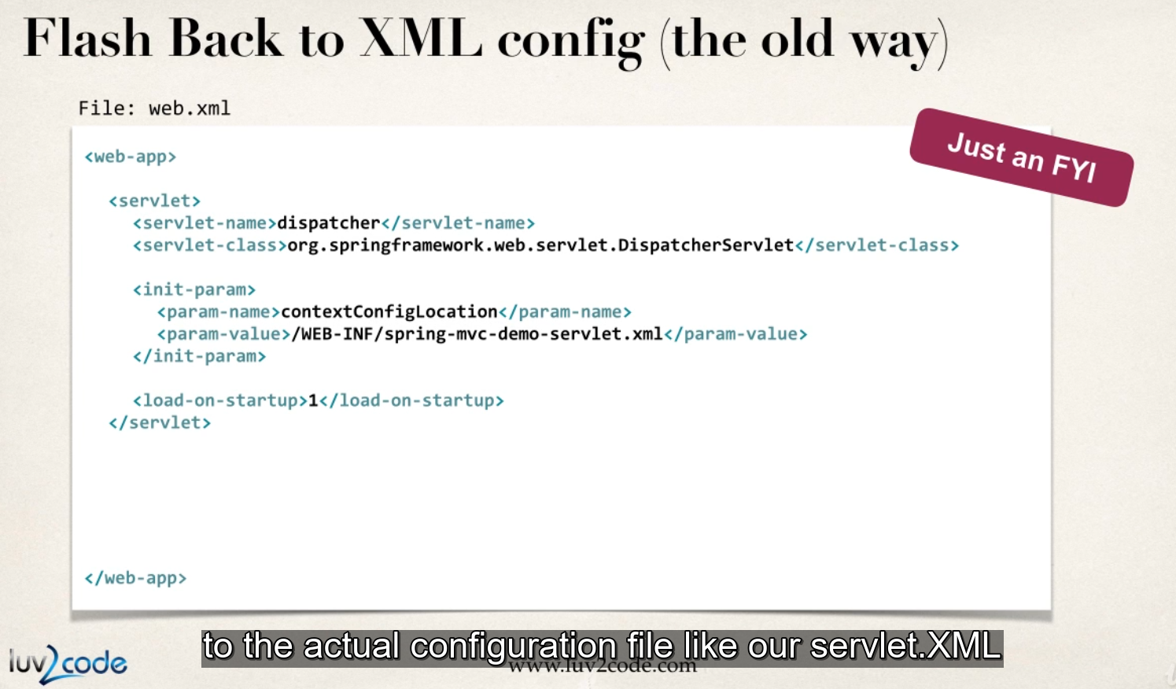

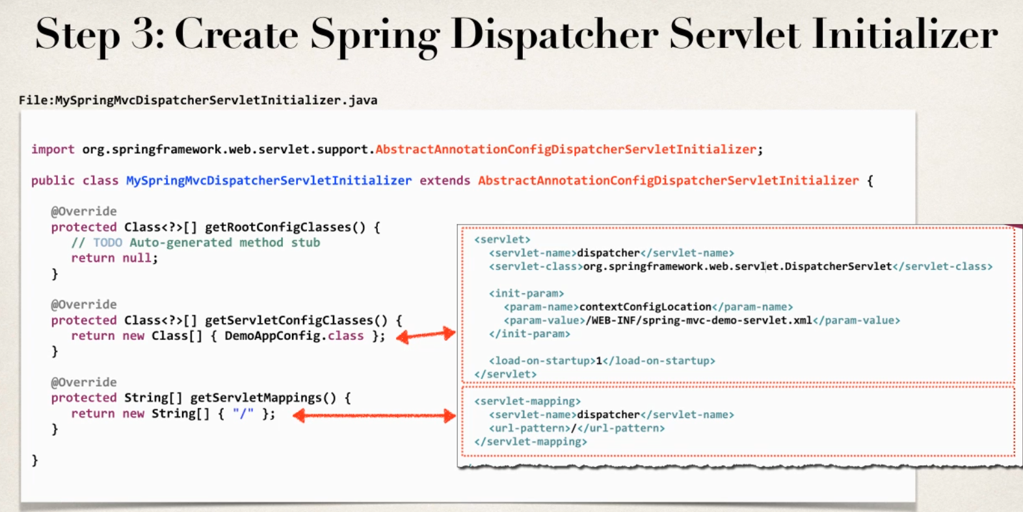

Spring security

spring-security-demo-01-base-app

Import maven project error => fix add

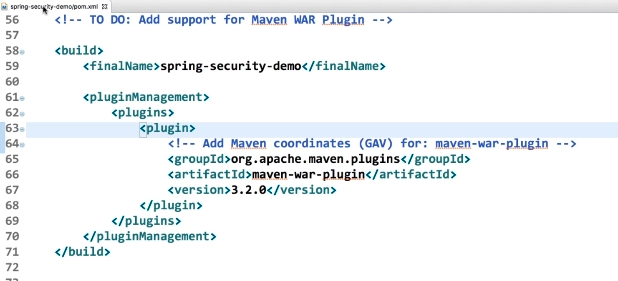

Maven update project

**FAQ:  Maven can't find a class, but it is listed in the pom.xml**

First, double-check that you have the correct Maven coordinates in the file (groupId, artifactId and version). Look for typos.

--

This could be caused by a corrupt local Maven repo. You can resolve it with these steps.

**Option 1:**

1. On your project, right-click: Maven > Update Project

2. In the dialog, check the box: Force Update of Snapshots/Releases

3. Click Ok

Maven will perform a rebuild.

If that doesn't solve your problem then move to option 2

**Option 2:**

1. Delete your local Maven repo, the .m2 directory on your computer

On MS Windows

either    
C:\Documents and Settings\<yourUserName>\.m2  
c:\Users\<yourUserName>\.m2

On Mac/Linux

~/.m2

--

*Note, on your OS, you may need to configure your OS to show hidden files.*

2. Once .m2 directory is deleted, restart Eclipse

3. On your project, right-click: Maven > Update Project

This will resolve your issue.

### 8. Spring Security - Create Spring Java Config class

solution-code-spring-security-demo-01-base-app

package com.luv2code.springsecurity.demo.config;

import org.springframework.context.annotation.Bean;

import org.springframework.context.annotation.ComponentScan;

import org.springframework.context.annotation.Configuration;

import org.springframework.web.servlet.ViewResolver;

import org.springframework.web.servlet.config.annotation.EnableWebMvc;

import org.springframework.web.servlet.view.InternalResourceViewResolver;

@Configuration

@EnableWebMvc

@ComponentScan(basePackages="com.luv2code.springsecurity.demo")

public class DemoAppConfig {

// define a bean for ViewResolver

@Bean

public ViewResolver viewResolver() {

InternalResourceViewResolver viewResolver = new InternalResourceViewResolver();

viewResolver.setPrefix("/WEB-INF/view/");

viewResolver.setSuffix(".jsp");

return viewResolver;

}

}

### 9. Spring Security - Create Spring Initializer class

package com.luv2code.springsecurity.demo.config;

import org.springframework.web.servlet.support.AbstractAnnotationConfigDispatcherServletInitializer;

public class MySpringMvcDispatcherServletInitializer extends AbstractAnnotationConfigDispatcherServletInitializer {

@Override

protected Class<?>[] getRootConfigClasses() {

// TODO Auto-generated method stub

return null;

}

@Override

protected Class<?>[] getServletConfigClasses() {

return new Class[] { DemoAppConfig.class };

}

@Override

protected String[] getServletMappings() {

return new String[] { "/" };

}

}

Version of spring and spring security

**UPDATES - Spring Security 5.1.1**

Spring Security 5.1.1 was released on 16 October 2018. This is a maintenance/bug fix release.

Spring Security 5.1.1 is compatible with Spring Framework 5.1.1

If you want to use the latest version, update your Maven POM file to use the compatible versions below

<springframework.version>5.1.1.RELEASE</springframework.version>

<springsecurity.version>5.1.1.RELEASE</springsecurity.version>

---

**UPDATES - Spring Security 5.1.0**

Spring Security 5.1.0 was released on 27 September 2018. This is a maintenance/bug fix release.

Spring Security 5.1.0 is compatible with Spring Framework 5.1.0

If you want to use the latest version, update your Maven POM file to use the compatible versions below

<springframework.version>5.1.0.RELEASE</springframework.version>

<springsecurity.version>5.1.0.RELEASE</springsecurity.version>

---

**UPDATES - Spring Security 5.0.7**

Spring Security 5.0.7 was released on 26 July 2018. This is a maintenance/bug fix release.

Spring Security 5.0.7 is compatible with Spring Framework 5.0.8

If you want to use the latest version, update your Maven POM file to use the compatible versions below

<springframework.version>5.0.8.RELEASE</springframework.version>

<springsecurity.version>5.0.7.RELEASE</springsecurity.version>

---

**UPDATES - Spring Security 5.0.6**

Spring Security 5.0.6 was released on 13 June 2018. This is a maintenance/bug fix release.

Spring Security 5.0.6 is compatible with Spring Framework 5.0.7

If you want to use the latest version, update your Maven POM file to use the compatible versions below

<springframework.version>5.0.7.RELEASE</springframework.version>

<springsecurity.version>5.0.6.RELEASE</springsecurity.version>

---

**UPDATES - Spring Security 5.0.5**

Spring Security 5.0.5 was released on 8 May 2018. This is a maintenance/bug fix release.

Spring Security 5.0.5 is compatible with Spring Framework 5.0.6

If you want to use the latest version, update your Maven POM file to use the compatible versions below

<springframework.version>5.0.6.RELEASE</springframework.version>

<springsecurity.version>5.0.5.RELEASE</springsecurity.version>

---

**UPDATES - Spring Security 5.0.4**

Spring Security 5.0.4 was released on 5 April 2018. This is a maintenance/bug fix release.

Spring Security 5.0.4 is compatible with Spring Framework 5.0.5

If you want to use the latest version, update your Maven POM file to use the compatible versions below

<springframework.version>5.0.5.RELEASE</springframework.version>

<springsecurity.version>5.0.4.RELEASE</springsecurity.version>

---

**UPDATES - Spring Security 5.0.3**

Spring Security 5.0.3 was released the week of 28 Feb 2018. This is a maintenance/bug fix release.

Spring Security 5.0.3 is compatible with Spring Framework 5.0.4

If you want to use the latest version, update your Maven POM file to use the compatible versions below

<springframework.version>5.0.4.RELEASE</springframework.version>

<springsecurity.version>5.0.3.RELEASE</springsecurity.version>

---

**UPDATES - Spring Security 5.0.2**

Spring Security 5.0.2 was released the week of 20 Feb 2018. This is a maintenance/bug fix release.

Spring Security 5.0.2 is compatible with Spring Framework 5.0.4

If you want to use the latest version, update your Maven POM file to use the compatible versions below

<springframework.version>5.0.4.RELEASE</springframework.version>

<springsecurity.version>5.0.2.RELEASE</springsecurity.version>

**---**

**UPDATES Spring Security 5.0.1**

Spring Security 5.0.1 was released the week of 24 Jan 2018. This is a maintenance/bug fix release.

Spring Security 5.0.1 is compatible with Spring Framework 5.0.3

If you want to use the latest version, update your Maven POM file to use the compatible versions below

<springframework.version>5.0.3.RELEASE</springframework.version>

<springsecurity.version>5.0.1.RELEASE</springsecurity.version>

Fix error run on server when copy from old project

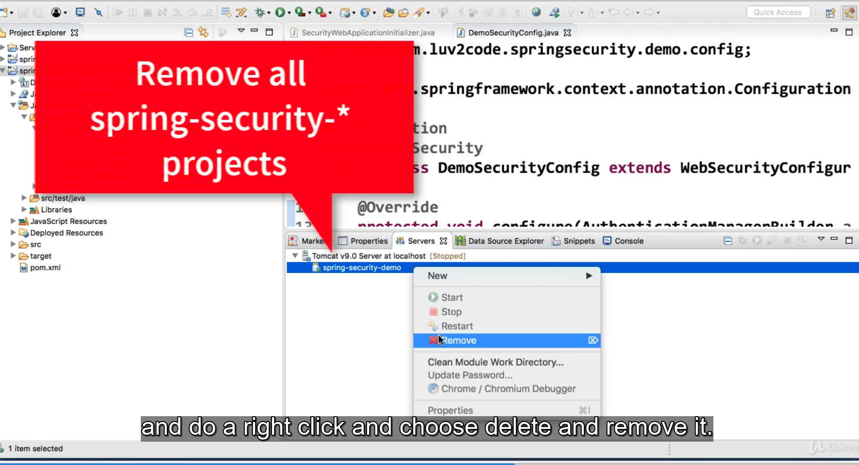

1. Deploying Spring Boot WAR file with JSP to Tomcat.html

**Deploy Spring Boot apps with JSP to Tomcat**

You can deploy a Spring Boot application using JSP to Tomcat. In this scenario, we will create a WAR file and deploy the WAR to the Tomcat server running externally. This is known as a traditional deployment.

**High-level steps**

1. Update main Spring Boot application

2. Update Maven POM file

3. Update application.properties

4. Move JSP view files to WEB-INF/view

5. Create WAR file

6. Deploy to Tomcat

**Spring Boot Reference Manual**

For full details on this process, see the [Spring Boot Reference Manual: Section 92.1 Creating a Deployable WAR file](https://docs.spring.io/spring-boot/docs/current/reference/htmlsingle/#howto-create-a-deployable-war-file)

**Working Example**

I have a full working project. You can download this app and perform test deployments to Tomcat

Download: [deploy-spring-boot-and-jsp-on-tomcat.zip](https://drive.google.com/open?id=1jgjQ1DCpowDJxlFje-dS6rjoQKRcYtCe)

This app is a very simple helloworld example that exposes a "/test" request mapping

package org.demo.bootjsp.controller;

import org.springframework.stereotype.Controller;

import org.springframework.web.bind.annotation.RequestMapping;

@Controller

public class HelloWorldController {

@RequestMapping("/test")

public String sayHello() {

return "hello";

}

}

and a simple JSP page: hello.jsp

<html><body>

<p>

Hello World! Time is <%= new java.util.Date() %>

</p>

<p>

We are running on <%= application.getServerInfo() %>!!!

</p>

</body></html>

----

**Detailed steps**

**1. Update main Spring Boot application**

In your main Spring Boot application, you need to

a. extend the SpringBootServletInitializer

b. override the configure(...) method

Your code should look like this

package org.demo.bootjsp;

import org.springframework.boot.SpringApplication;

import org.springframework.boot.autoconfigure.SpringBootApplication;

import org.springframework.boot.builder.SpringApplicationBuilder;

import org.springframework.boot.web.servlet.support.SpringBootServletInitializer;

@SpringBootApplication

public class DemowebApplication extends SpringBootServletInitializer {

@Override

protected SpringApplicationBuilder configure(SpringApplicationBuilder application) {

return application.sources(DemowebApplication.class);

}

public static void main(String[] args) {

SpringApplication.run(DemowebApplication.class, args);

}

}

**2. Update Maven POM file**

Update your POM.xml to use WAR packaging

<packaging>war</packaging>

In POM.xml, add dependency to be able to compile JSPs

<dependency>

<groupId>org.apache.tomcat.embed</groupId>

<artifactId>tomcat-embed-jasper</artifactId>

</dependency>

Make sure the Tomcat embedded does not interfere with external Tomcat server

<dependency>

<groupId>org.springframework.boot</groupId>

<artifactId>spring-boot-starter-tomcat</artifactId>

<scope>provided</scope>

</dependency>

**3. Update application.properties**

In your application.properties file, you should have

spring.mvc.view.prefix=/WEB-INF/view/

spring.mvc.view.suffix=.jsp

**4. Move JSP view files to WEB-INF/view**

Move your JSP view pages should to src/main/webapp/WEB-INF/view

**5. Create WAR file**

Create the WAR file with the command: mvn clean package

This will generate a WAR file in your project directory:  **target/bootjspdemo.war**

6. In Eclipse, stop all servers you may have running

7. Outside of Eclipse, run your Tomcat server

8. Copy your WAR file to the **<<tomcat-install-dir>>/webapps** directory

Wait for about 15-30 seconds for Tomcat to deploy your app. You will know your app is deployed when you see a new folder created based on your WAR file name. In our example, you will see a new directory named: **bootjspdemo**

9. In a web browser, access your app at: http://localhost:8080/bootjspdemo/test

Replace <<bootjspdemo>> with the name of your WAR file if you are using a different app

If everything is successful, you will see your application's web page.

Congratulations! You deployed a Spring Boot WAR file with JSP on to a Tomcat server :-)

2. Deploy Spring Boot WAR file with Thymeleaf to Tomcat.html

**Deploy Spring Boot apps with Thymeleaf to Tomcat**

You can deploy a Spring Boot application as a WAR file to Tomcat. In this scenario, we will use Thymeleaf as the view template.

We will create a WAR file and deploy the WAR to the Tomcat server. This is known as a traditional deployment.

**High-level steps**

1. Update main Spring Boot application

2. Update Maven POM file

3. Create WAR file

4. Deploy to Tomcat

**Spring Boot Reference Manual**

For full details on this process, see the [Spring Boot Reference Manual: Section 92.1 Creating a Deployable WAR file](https://docs.spring.io/spring-boot/docs/current/reference/htmlsingle/#howto-create-a-deployable-war-file)

**Working Example**

I have a full working project. You can download this app and perform test deployments to Tomcat

Download: [deploy-spring-boot-war-with-thymeleaf-on-tomcat.zip](https://drive.google.com/open?id=1YhrLfvCCNUxJ9CFfFncbtVO3qdbc7FYI)

This app is a very simple helloworld example that exposes a "/test" request mapping

package com.luv2code.deploydemo.controller;

import org.springframework.stereotype.Controller;

import org.springframework.web.bind.annotation.RequestMapping;

@Controller

public class HelloWorldController {

@RequestMapping("/test")

public String sayHello() {

return "hello";

}

}

and a simple Thymeleaf page: hello.html

<!DOCTYPE HTML>

<html lang="en" xmlns:th="http://www.thymeleaf.org">

<body>

<h3>Hello World from Thymeleaf!</h3>

<p>

We are running on <span th:text="${#servletContext.getServerInfo()}"></span>!!!

</p>

</body>

</html>

----

**Detailed steps**

**1. Update main Spring Boot application**

In your main Spring Boot application, you need to

a. extend the SpringBootServletInitializer

b. override the configure(...) method

Your code should look like this

package com.luv2code.deploydemo;

import org.springframework.boot.SpringApplication;

import org.springframework.boot.autoconfigure.SpringBootApplication;

import org.springframework.boot.builder.SpringApplicationBuilder;

import org.springframework.boot.web.servlet.support.SpringBootServletInitializer;

@SpringBootApplication

public class DeploydemoApplication extends SpringBootServletInitializer {

@Override

protected SpringApplicationBuilder configure(SpringApplicationBuilder application) {

return application.sources(DeploydemoApplication.class);

}

public static void main(String[] args) {

SpringApplication.run(DeploydemoApplication.class, args);

}

}

**2. Update Maven POM file**

Update your POM.xml to use WAR packaging

<packaging>war</packaging>

The WAR packaging should appear just after your Maven coordinates (group, artifact, version)

<groupId>com.luv2code</groupId>

<artifactId>deploydemo</artifactId>

<version>0.0.1-SNAPSHOT</version>

<packaging>war</packaging>

Make sure the Tomcat embedded does not interfere with external Tomcat server

<dependency>

<groupId>org.springframework.boot</groupId>

<artifactId>spring-boot-starter-tomcat</artifactId>

<scope>provided</scope>

</dependency>

**3. Create WAR file**

Create the WAR file with the command: mvn clean package

This will generate a WAR file in your project directory:  **target/deploydemo.war**

4. In Eclipse, stop all servers you may have running

5. Outside of Eclipse, run your Tomcat server

6. Copy your WAR file to the **<<tomcat-install-dir>>/webapps** directory

Wait for about 15-30 seconds for Tomcat to deploy your app. You will know your app is deployed when you see a new folder created based on your WAR file name. In our example, you will see a new directory named: **deploydemo**

7. In a web browser, access your app at: http://localhost:8080/deploydemo/test

Replace <<deploydemo>> with the name of your WAR file if you are using a different app

If everything is successful, you will see your application's web page.

Congratulations! You deployed a Spring Boot WAR file with Thymeleaf on a Tomcat server :-)

## Junit 5

<https://howtodoinjava.com/junit5/execute-testcase-eclipse/>

<https://www.eclipse.org/community/eclipse_newsletter/2017/october/article5.php>

[JUnit 5](http://junit.org/junit5/) is out the door as the next generation test framework. It is a fundamentally redesigned version of the most widely used testing library in Java. JUnit 4.0 was first released over a decade ago after the introduction of annotations in Java 5. The world of Java and testing has evolved a lot since then. JUnit 4 was a big ball of mud with a single junit.jar to be used by test developers, testing framework developers, IDE developers, and build tool developers. Over the time, these developers have been accessing internals and duplicating code from JUnit 4 to get things done. This had made it very difficult to maintain and enhance the JUnit framework. So, to take advantage of the new features like lambda expressions from Java 8 and to support the advanced testing needs, JUnit 5 is now available as a modular and extensible test framework for the modern era.

[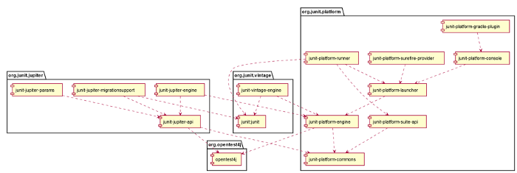](https://www.eclipse.org/community/eclipse_newsletter/2017/october/images/junituserguide.png)

Source: (JUnit 5 User Guide) <http://junit.org/junit5/docs/current/user-guide/#dependency-diagram>

How is JUnit 5 different?

JUnit 5 is composed of several different modules from three different sub-projects.

**JUnit 5 = JUnit Platform + JUnit Jupiter + JUnit Vintage**

* **JUnit Platform** defines Launcher APIs which are used by IDEs and build tools to launch the framework. It also defines TestEngine APIs which are used to develop testing frameworks that run on the platform.
* **JUnit Jupiter** is the combination of the new programming model and extension model for writing tests and extensions in JUnit 5. It also provides a TestEngine for running Jupiter based tests on the platform.
* **JUnit Vintage** provides a TestEngine for running JUnit 3 and JUnit 4 based tests on the platform.

Give JUnit 5 a spin

To give JUnit 5 a spin, you have the tooling support in the Eclipse IDE ready at your disposal. [Download Eclipse Oxygen.1a (4.7.1a)](https://www.eclipse.org/downloads/eclipse-packages/) now and try it out yourself!

Here is a sneak peek into the major interesting features of JUnit Jupiter with Eclipse support for JUnit 5.

[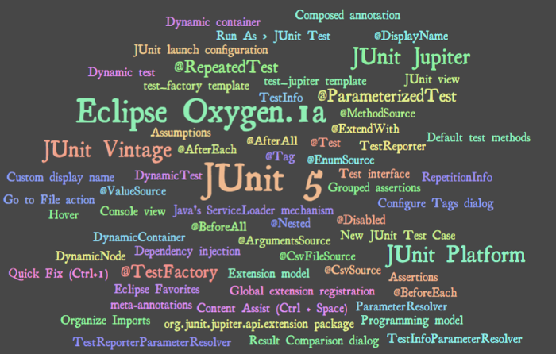](https://www.eclipse.org/community/eclipse_newsletter/2017/october/images/junitwordle.png)

What can I do with JUnit 5?

Create a new JUnit Jupiter test

Create a new JUnit Jupiter test via **New JUnit Test Case** wizard:

[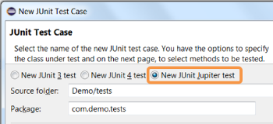](https://www.eclipse.org/community/eclipse_newsletter/2017/october/images/junit_test.png)

On this page, you can specify the lifecycle method stubs to be generated for this test case. It also lets you select a class under test and on the next page, you can select the methods from this class to generate test stubs.

Add JUnit 5 library to the build path

* The new JUnit Test Case wizard offers to add it while creating a new JUnit Jupiter test:

[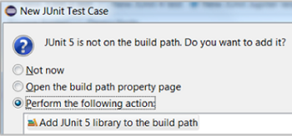](https://www.eclipse.org/community/eclipse_newsletter/2017/october/images/junittestcase.png)

* **Quick Fix (Ctrl+1)** proposal on @Test, @TestFactory, @ParameterizedTest, and @RepeatedTest annotations

[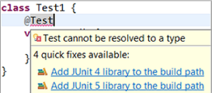](https://www.eclipse.org/community/eclipse_newsletter/2017/october/images/jtestclass.png)

* Add JUnit library in **Java Build Path** dialog:

[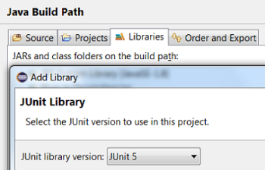](https://www.eclipse.org/community/eclipse_newsletter/2017/october/images/buildpath.png)

JUnit Jupiter test case

Here's a simple JUnit Jupiter test case.

[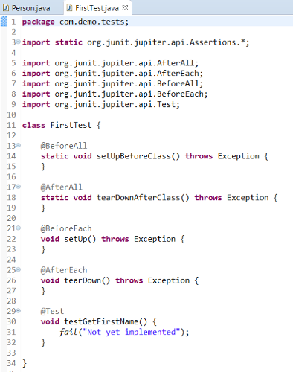](https://www.eclipse.org/community/eclipse_newsletter/2017/october/images/testcase_personjava.png)

In JUnit Jupiter, test classes and methods can have any access modifier (other than private).

Here is a comparison of the annotations in JUnit 4 and JUnit Jupiter:

|  |  |
| --- | --- |
| **JUnit 4** | **JUnit Jupiter** |
| @org.junit.Test | @org.junit.jupiter.api.Test (*No expected* and *timeout* attributes) |
| @BeforeClass | @BeforeAll |
| @AfterClass | @AfterAll |
| @Before | @BeforeEach |
| @After | @AfterEach |
| @Ignore | @Disabled |

JUnit Jupiter test method

Create a JUnit Jupiter test method in the Eclipse IDE with the new **test\_jupiter** template:

[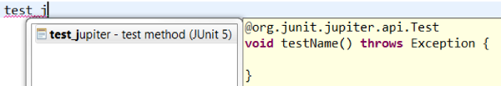](https://www.eclipse.org/community/eclipse_newsletter/2017/october/images/test_jupiter.png)

Assertions and Assumptions

JUnit Jupiter provides assertions and assumptions as static methods in

org.junit.jupiter.api.Assertions class and org.junit.jupiter.api.Assumptions class respectively.

* You can view all the failures from grouped assertions in the **Result Comparison** dialog which can be opened from the Failure Trace section of JUnit view:

[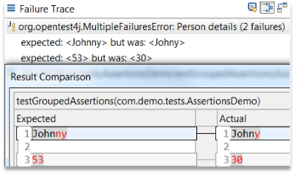](https://www.eclipse.org/community/eclipse_newsletter/2017/october/images/failuretrace.png)

* You can view the number of tests with assumption failures on hover in JUnit view:

[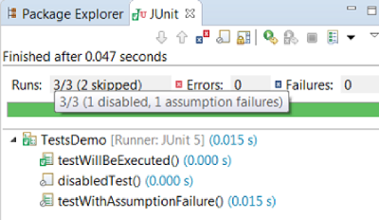](https://www.eclipse.org/community/eclipse_newsletter/2017/october/images/junitview.png)

* JUnit Jupiter’s Assertions, Assumptions, DynamicContainer and DynamicTest classes are now added to **Eclipse Favorites** by default:

[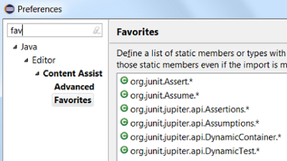](https://www.eclipse.org/community/eclipse_newsletter/2017/october/images/eclipsefavs.png)

This allows you to quickly import static methods in your code from these favorite classes via **Content Assist (Ctrl + Space)** and **Quick Fix (Ctrl + 1)**.

You can also configure the number of static member imports needed in your code before type.\* is used in the **Organize Imports** Preferences:

[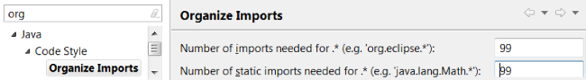](https://www.eclipse.org/community/eclipse_newsletter/2017/october/images/organizeimports.png)

Custom display names

JUnit Jupiter’s @DisplayName annotation allows you to provide custom display names for test classes and test methods which can have spaces, special characters, and even emojis. In Eclipse, you can see the custom test names in JUnit view. You can use the **Go to File** action or you can just double-click on the custom test name to navigate to the corresponding test from JUnit view:

[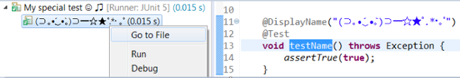](https://www.eclipse.org/community/eclipse_newsletter/2017/october/images/displayname.png)

Nested test classes

In JUnit Jupiter, non-static nested classes (i.e. inner classes) can serve as @Nested test classes for logical grouping of test cases. In Eclipse, you can (re-)run a single nested test class by using the **Run** action in JUnit view or Outline view. You can even right-click on a nested test class name in the editor and use the **Run As → JUnit Test** action:

[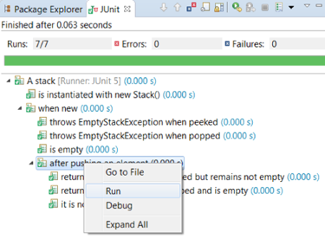](https://www.eclipse.org/community/eclipse_newsletter/2017/october/images/runtest.png)

Test interfaces and default methods

JUnit Jupiter introduces the concept of a **test interface** which allows you to pre-implement some test code as default methods in interfaces. These **default test methods** can be inherited by implementing test classes, thereby enabling multiple inheritance in tests. In Eclipse, you can use the **Go to File** action or double-click on a test method in JUnit view to navigate to the corresponding default method inherited by the test class:

[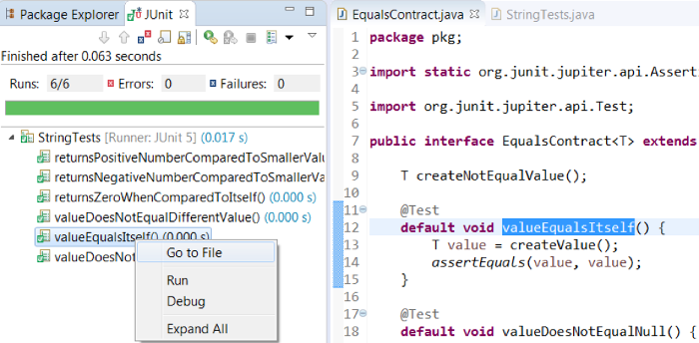](https://www.eclipse.org/community/eclipse_newsletter/2017/october/images/testmethod.png)

Tagging and filtering

You can tag test classes and test methods with your own identifiers using the @Tag annotation in JUnit Jupiter. These tags can later be used to filter test execution. In Eclipse, you can provide tags to be included in or excluded from a test run via the **Configure Tags** dialog in its JUnit launch configuration:

[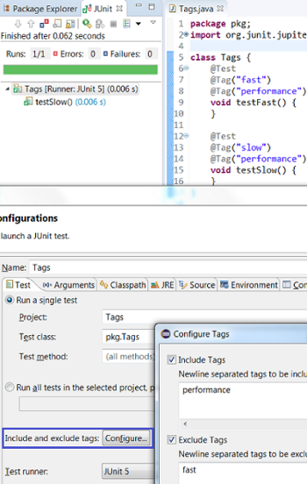](https://www.eclipse.org/community/eclipse_newsletter/2017/october/images/testtags.png)

Meta-annotations and composed annotations

Annotations in JUnit Jupiter can be used as **meta-annotations**. This allows you to create a custom **composed annotation** that will automatically inherit the semantics of its meta-annotations. For example, you can use @Test and @Tag(“performance”) annotations as meta-annotations and create a composed annotation named @PerformaceTest which can be used as a replacement of the other two annotations on tests:

[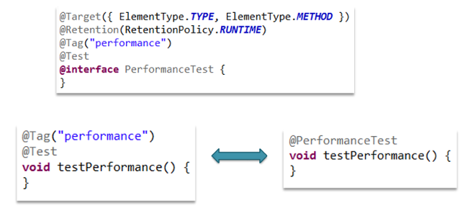](https://www.eclipse.org/community/eclipse_newsletter/2017/october/images/performance.png)

Dynamic tests

JUnit Jupiter introduces a concept of dynamic tests which are generated at runtime by a factory method annotated with @TestFactory annotation. The test factory method returns DynamicNode instances (DynamicContainer and DynamicTest). A **dynamic container** is composed of a display name and a list of dynamic nodes. A **dynamic test** is composed of a display name and an Executable. Note that there are no lifecycle callbacks for individual dynamic tests. Dynamic containers can be used for dynamic nesting of nodes:

[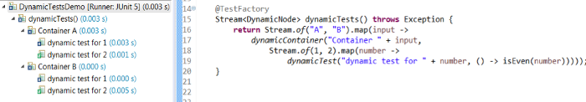](https://www.eclipse.org/community/eclipse_newsletter/2017/october/images/dynamicdemo.png)

In your Eclipse workspace, you can create a test factory method with the new **test\_factory** template:

[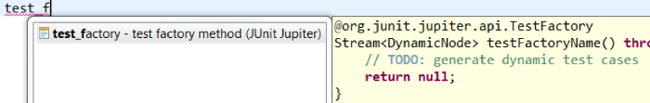](https://www.eclipse.org/community/eclipse_newsletter/2017/october/images/testfactory.png)

Repeated tests

You can repeat a test in JUnit Jupiter by annotating the test method with @RepeatedTest annotation and specifying the number of repetitions. You can optionally specify a custom display name for each repetition and use RepetitionInfo as the test method parameter to get information about the current repetition:

[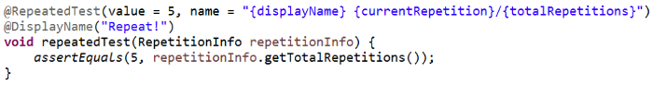](https://www.eclipse.org/community/eclipse_newsletter/2017/october/images/repeatedtestresult.png)

[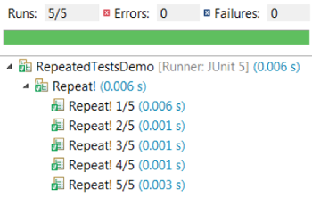](https://www.eclipse.org/community/eclipse_newsletter/2017/october/images/repeatedtest.png)

Parameterized tests

You can run a test multiple times with different arguments by annotating the test method with @ParameterizedTest annotation and declaring at least one source to provide the arguments. You can optionally specify a custom display name for each run. JUnit Jupiter provides various source annotations which can be seen in this example:

[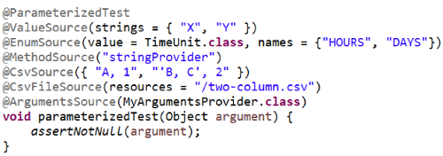](https://www.eclipse.org/community/eclipse_newsletter/2017/october/images/parametrizedtest.png)

[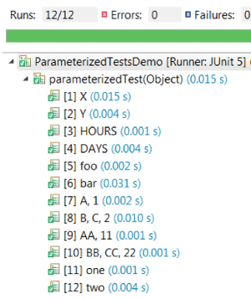](https://www.eclipse.org/community/eclipse_newsletter/2017/october/images/parametrizedtestresults.png)

Dependency injection

**Dependency injection** in JUnit Jupiter allows test constructors and methods to have parameters. These parameters must be dynamically resolved at runtime by a registered parameter resolver. ParameterResolver is the extension API to provide parameter resolvers which can be registered via @ExtendWith annotation. This is where Jupiter’s programming model meets its extension model. JUnit Jupiter provides some built-in resolvers which are registered automatically:

* **TestInfo** (resolved by TestInfoParameterResolver) to access information about the currently executing test:

[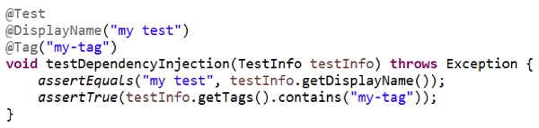](https://www.eclipse.org/community/eclipse_newsletter/2017/october/images/testinfo.png)

* **TestReporter** (resolved by TestReporterParameterResolver) to publish additional data about the current test run which can be seen in the **Console view** in the Eclipse IDE:

[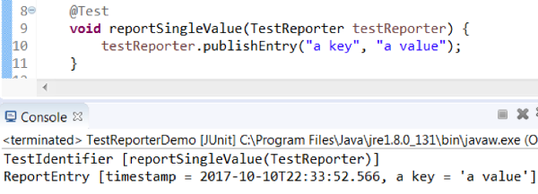](https://www.eclipse.org/community/eclipse_newsletter/2017/october/images/testreporter.png)

In the Eclipse IDE, the **Test Method Selection** dialog in JUnit launch configuration now shows the method parameter types also:

[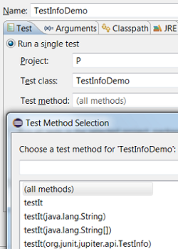](https://www.eclipse.org/community/eclipse_newsletter/2017/october/images/testinfodemo.png)

JUnit Jupiter extension model

JUnit Jupiter’s extension model provides various extension APIs as small interfaces in org.junit.jupiter.api.extension package which can be implemented by extension providers. You can register one or more of these extensions declaratively on a test class, test method, or composed annotation via @ExtendWith annotation. JUnit Jupiter also supports global extension registration via Java’s ServiceLoader mechanism:

[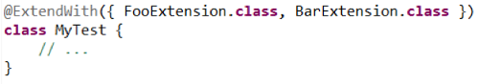](https://www.eclipse.org/community/eclipse_newsletter/2017/october/images/extendwith.png)

Note

* If you are using an Eclipse workspace where you were running your JUnit 5 tests via @RunWith(JUnitPlatform.class) in the Eclipse IDE without JUnit 5 support then you will have JUnit 4 as the test runner in their launch configurations. Before executing these tests in the Eclipse IDE with JUnit 5 support, you should either change their test runner to JUnit 5 or delete them so that new launch configurations are created with JUnit 5 test runner while running the tests:

[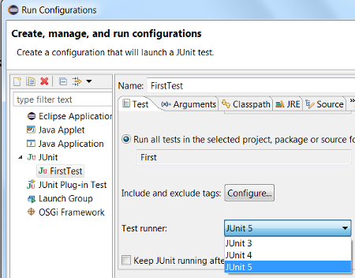](https://www.eclipse.org/community/eclipse_newsletter/2017/october/images/note1.png)

* We do not support running tests in a setup where an old Eclipse build (not having JUnit 5 support) is using a new Eclipse build (having JUnit 5 support) as target. Also, developers who have the JDT JUnit runtime bundles (org.eclipse.jdt.junit.runtime, org.eclipse.jdt.junit4.runtime) checked out and pull the latest changes will run into the above issue. You are expected to use a new Eclipse build for the development.

Resources & References

Eclipse Support for JUnit 5

* [Download Eclipse Oxygen.1a (4.7.1a)](https://www.eclipse.org/downloads/eclipse-packages)
* [Software site repository to update your Eclipse installation](http://download.eclipse.org/releases/oxygen/)
* [Report bugs/enhancements in Eclipse support for JUnit 5](https://bugs.eclipse.org/bugs/enter_bug.cgi?product=JDT&component=UI)

Learn more about the [JUnit 5 Project](http://junit.org/junit5)

* [User Guide](http://junit.org/junit5/docs/current/user-guide)
* [Javadoc](http://junit.org/junit5/docs/current/api)
* [GitHub](https://github.com/junit-team/junit5)
* [Gitter](https://gitter.im/junit-team/junit5)
* [Q&A](http://stackoverflow.com/questions/tagged/junit5)

## Java 8

## Upload image with spring boot

FAQ: Should I Store Images as BLOBs in Database or Files on file system?

**Question**

I'm building a Full Stack application. Should I store images as a BLOBs in the database or as files on filesystem? Also, can you tell me the pros/cons of each approach?

**Answer**

Good question!

In general, processing images stored as BLOBs in the database is slower than images stored on the file system. Of course, the answer really depends on your application requirements.

---

However, if you need to display BLOB images in an Angular app, here is a tutorial that shows you how:

<https://grokonez.com/frontend/angular/angular-4-uploadget-images-tofrom-spring-boot-server>

---

And if you’d like a comparison of the storage methods (BLOB vs file), see the links below. They cover the pros/cons of each approach

<https://teamtreehouse.com/community/storing-image-in-database-compare-with-storing-at-the-folder-server>

<https://habiletechnologies.com/blog/better-saving-files-database-file-system/>

<http://www.webdevdesigns.com/newsroom/blob-vs-file-system/>

Finally, here's a good discussion on this topic on stackoverflow. You can see different viewpoints from other developers

Storing Images in DB - Yea or Nay?

<https://stackoverflow.com/questions/3748/storing-images-in-db-yea-or-nay>

Download the Source Code and PDF Files

**Download Source Code:**

You have two options for downloading the code.

*Option 1: Download zip file*

File: [**full-stack-angular-and-springboot-master.zip**](https://github.com/darbyluv2code/fullstack-angular-and-springboot/archive/master.zip)

\_ Option 2: Download using git command-line\_

You also have the option to download source code using git command-line.

git clone https://github.com/darbyluv2code/fullstack-angular-and-springboot.git

Note: Option 1 and Option 2 both reference the exact same code. You only need to choose one of the options.

--- **Download PDF Files**

All slides which are shown during the course are available also as a reference and can be downloaded here:

<http://www.luv2code.com/download-full-stack-angular-and-springboot-pdf-slides>

## Auto import inteliji

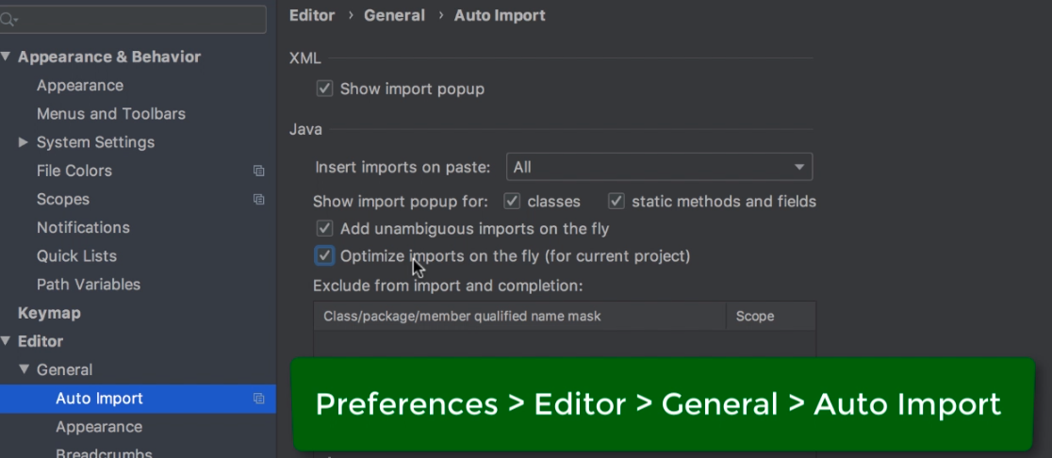

<http://laptrinhjavaweb.com/hoc-java-web-mien-phi-7>